TR180-22 Ngaio Transitional bike and pedestrian improvements.

Kia ora,

This leaflet is to let you know about a change we are proposing to make in your neighbourhood.

Proposal:

Reference | TR180-22 Ngaio Transitional Cycleway. Proposed cycle lanes, new pedestrian crossings and parking changes.
Location – where we propose to make the change | - Kaiwharawhara Road, Old Porirua Road, Ngaio Gorge Road, Kenya Street, Crofton Road, Cameron Street, Sargeson Way, Marsh Way.  - Suburbs of Kaiwharawhara and Ngaio, Wellington.
What we’d like to do | Proposed changes along Kaiwharawhara Road will be made over three stages (2023, 2024, and 2025) to give people using this route and local businesses time to adapt to these proposed changes.  Kaiwharawhara Road  - Install a 4pm-7pm, 7 days Clearway on the southern side of Kaiwharawhara Road for 145 metres (from Hutt Road to No.25 Kaiwharawhara Road) in 2023.  - Install 320 metres of cycle lane from No.25 Kaiwharawhara Road to No.53 Kaiwharawhara Road (Capital Auto Electrics Ltd) in 2023 where there is currently unrestricted parking.  - Install a P10 loading zone with a Clearway from 4pm-7pm, 7 days, for 30 metres outside Nos.53 and 55 Kaiwharawhara Road (Capital Auto Electrics Ltd and Hanging Around) in 2023 where there is currently unrestricted parking.  - Install four P30 carparking spaces with a Clearway from 4pm-7pm, Monday to Sunday on Kaiwharawhara Road (west of the loading zone outside No.57 Kaiwharawhara Road) in 2023 where there are currently unrestricted parking spaces.  - Install a cycle lane and No Stopping Restriction with broken yellow lines, (BYLs) in 2023 from the new P30 carparks on Kaiwharawhara Road along the remainder of the southern side of Kaiwharawhara Road westward to the slip stabilisation work. This work will tie in with 480 metres of cycle lane being built as part of the Ngaio Gorge slip stabilisation work (due for completion in Dec 2022).  - In January/February 2024, we are proposing to extend the Clearway times on the southern side of Kaiwharawhara Road (from Hutt Road to No.25 Kaiwharawhara Road and from Nos.53 to 57 Kaiwharawhara Road from 4pm-7pm to 2pm-9pm to increase the safety benefits to cyclists while continuing to give businesses time to adapt to the changes.

- In January/February 2025, we are proposing to install cycle lanes on the two sections of clearway along Kaiwharawhara Road outlined above (from Hutt Road to No.25 Kaiwharawhara Road and Nos.53 to 57 Kaiwharawhara Road).
- In January/February 2025, install 5metres of No Stopping Restriction (BYLs) section outside No.19 Kaiwharawhara Road where a new pedestrian crossing will be built (2023).
- In January/February 2025, install 8.5metres of No Stopping Restriction (BYLs) section outside No.24-28 Kaiwharawhara Road where a new pedestrian crossing will be built (2023).

Old Porirua Road
- Install No Stopping Restriction (BYLs) for 8 metres extending from the limit line where Old Porirua Road meets Kaiwharawhara Road (2023).

Ngaio Gorge Road
- Install an uphill cycle lane with No Stopping Restriction (BYLs) for 950 metres from the bottom of Ngaio Gorge Road to the intersection with Trelissick Cres at Kenya Street (2023).
- Install a raised pedestrian crossing between No.5 and No.7 Ngaio Gorge Road (2023).

Kenya Street and Crofton Road (2023)
- Install 700 metres of cycle lane in the uphill direction, from Waikowhai Street roundabout westward to Crofton Road and extending along Kenya Street (heading towards the city).
- Install No Stopping Restriction (BYLs) for 36 metres on the bend outside Nos.54, 56, and 58 Kenya Street extending to the existing bus stop by removing 4 unrestricted carparks.
- Install No Stopping Restriction (BYLs) to replace an existing P30 carpark outside No.2 Kenya Street outside a Takeaways shop.
- Convert one unrestricted carpark space to a P10 carpark outside No.6 Kenya Street.
- Extend the Ngaio Village 30 kph speed limit zone by 337 metres from No.11 Ottawa Road to No.6 Kenya Street.

Cameron Street (2023)
- Convert four unrestricted carparks outside No.6 Cameron St to four P60 carparks.
- Convert seven unrestricted carparks outside Nos.8 – 14 Cameron Street to six P120 carparks
- Convert two metres of kerb space to a no stopping section at the existing kerb ramp in front of 10 Cameron Street (opposite Fore St).
- Convert 39 unrestricted carparks from Nos.16 – 60 Cameron Street to 39 P24hr carparks.

- Install No Stopping Restriction (BYLs)
  - around the corner of Cameron Street into Sargeson Way for a length of 15 metres and
  - around the corner of Sargeson Way into Marsh Way for a length of 15 metres and
  - around the corner of Marsh Way into Cameron Street for a length of 14 metres.
- Install No Stopping Restriction (BYLs) on both sides of the narrow section of Cameron St from No.60 Cameron Street to Brasch Way for a length of 35 metres.
- Convert four angle P60 carparks at the bottom of Cameron Street on the western side to 2 parallel P60 carparks.
Why we are proposing the change | - This primary bike route is part of the Wellington Bike Network, which was approved by council in March 2022.  - This route will support the strategic goals outlined in the Long-Term Plan, the Regional Land Transport Plan and Te Atakura by improving safety, improving travel options and enabling a reduction in transport-generated carbon emissions.  - This proposal connects the Hutt Road Cycleway to the suburbs of Ngaio, Crofton Downs and Khandallah.  - These changes will make it safer for more people to bike/scoot between these suburbs and Wellington City and walk locally.  - It takes approximately 20 minutes to ride into the CBD from Ngaio, and 25-30 minutes from the CBD to Ngaio.  - The route improvements include safer pedestrian facilities across Kaiwharawhara Road, Ngaio Gorge Road and Crofton Road.  - A new solid median pedestrian refuge will be installed on Kaiwharawhara Road for pedestrians to cross near Cameron St.  - There will be a new raised pedestrian zebra crossing installed at the top of Ngaio Gorge Road near the bus stops.  - The existing pedestrian zebra crossing at the bus stop on Crofton Road will be raised.  - The changes on Kaiwharawhara Road will be made over three stages – mid-2023, early-2024, and early-2025 – to give residents and businesses time to adjust to the relocation and removal of carparks on one side of the road.  - Affected landowners will be notified two weeks before the work in 2023, 2024 and 2025 begins.  - These changes have been developed through the business case process and have involved initial engagement with residents and businesses along the route.

Impact | - Net parking impact  - removal of 51 carparking spaces on Kaiwharawhara Road (five P30 and 26 unrestricted), taking maximum occupancy from a current peak of 84% to a predicted new peak of 100%.  - removal of one P30 parking space on Kenya Street  - installation of one P10 parking space on Kenya Street  - removal of 59 unrestricted parking spaces on Kenya Street, taking maximum occupancy from a current peak of 41% to a predicted new peak of 87%.  removal of 16 unrestricted parking spaces on Crofton Road (assessed low impact).  - removal of two P60 car parks on Cameron Street  - convert four unrestricted carparks to four P60 carparks on Cameron Street  - convert seven unrestricted carparks to six P120 carparks on Cameron Street  - convert 39 unrestricted carparks to 39 P24hr carparks on Cameron Street  - Note: Cameron St is not expected to exceed 85% occupancy  - removal of one unrestricted car park at the bottom of Old Porirua Road.  - The impact on people driving along this principal route will be improved traffic efficiency and safety.  - Pedestrian impact is positive: The impact on pedestrians will be improved safety and accessibility due to two new crossings and one existing crossing being upgraded.  - Business impact will vary depending on where they are:  - On Crofton Road the impact will be low as parking will be retained directly outside the businesses and alternative parking is available nearby.  - Kaiwharawhara Road businesses in the uphill (Ngaio bound) direction will have the on-street parking adjacent to their premises removed between 2023 and 2025. The staged approach to delivery of this project is aimed at minimising the impact to businesses and giving them time to find alternative parking, including optimising private land in the area, make any operational changes that reduce the need for on-street parking and consider how staff and customers can access premises via other modes of transport.  - The impact on public transport will be improved access to bus stops and improved efficiency for buses, which currently have difficulty on narrow parts of Kenya Street when cars are parked on both sides of the street leaving less than 6 metres width for two lanes of traffic.  - Impact on parking revenue will be none.  - The impact on people cycling or wanting to cycle will be a safer and more attractive route.

How this relates to the parking policy | - Supports mode shift to using active modes (e.g., walking and cycling) and public transport through improved street design and parking management  - Supports safe movement – facilitates the safe and efficient movement of people and goods by focusing on people moving along transport corridors rather than people parking or storing stationary vehicles.  - A parking management plan was undertaken to inform the design of these changes and feedback from the community has subsequently been incorporated into the proposed parking changes.  - As outlined in the Parking Policy 2020, short term and residents parking has been prioritised over commuter parking which is the lowest priority for road space allocation.
Additional Information | - This Ngaio to City project is a key initiative to deliver on several strategic plans for the city, including the Long-Term Plan, Te Atakura (Climate Action Plan) and Paneke Pōneke (Wellington Bike Network Plan)  - The improvements are being made using lower cost, adaptable materials that can be tweaked based on public feedback, and data, once these initial installations are in place.  - Designs were developed by technical experts and with input from the community. A technical working group helped to ensure project objectives were met without compromising road safety, within a constrained road corridor.  - Average daily traffic count – 12,400 AADT on Kaiwharawhara Road, 9,800 AADT on Ngaio Gorge Road, 8,000 AADT on Kenya Street, 690 AADT on Cameron Street.  - It is proposed that these changes will be complemented by an extension of the existing 30kph zone on Ottawa Road in Ngaio Village, to Ngaio Roundabout and up Crofton Road. The existing 30kph zone is 305 metres long, and the proposed extension is 320 metres long. This speed change is being consulted on as part of this Traffic Resolution process, but will follow the alternative method for setting speed limits outlined in the Setting the Speed Limit Rule 2022. Submissions received on the speed limit change will be considered before a final decision by the Director of Land Transport, Waka Kotahi is made on the proposed speed limit change.  - It is also proposed to reduce the speed limit from 50kph to 30kph on the whole of Cameron Street (525 metres long). This speed change is being consulted on as part of this Traffic Resolution process, but will follow the alternative method for setting speed limits outlined in the Setting the Speed Limit Rule 2022. Submissions received on the speed limit change will be considered before a final decision by the Director of Land Transport, Waka Kotahi is made on the proposed speed limit change.  - Annual parking revenue impact - none  - To view the legal description for this Traffic Resolution, an electronic copy of the report will be available on the Council’s website from 9.00am Monday 31 October 2022 at https://www.letstalk.wellington.govt.nz/ or you can call (04) 499 4444 and we will send one out to you.  - The improvements proposed in this Traffic Resolution are the result of an options analysis. The options analysis report, along with other supporting material such as a parking management plan, safety audits, etc, can be found here: https://www.transportprojects.org.nz/current/ngaio-connection/
Feedback | - If you would like to provide us with specific feedback, which will be added to the Traffic Resolution following consultation and made public in full, you can do so by filling out an online submission form, downloading a printable submission form on https://www.letstalk.wellington.govt.nz/ or emailing us at ngaioconnections@wcc.govt.nz  Please note if you are giving feedback the consultation period opens at 9.00 am Monday 31 October 2022 and finishes at 5.00 pm Monday 21 November 2022.  - What we do with your personal information:  All submissions (including your name, but not contact details) are provided in their entirety to elected members and made available to the public on our website and at our office.
 | - Personal information (including contact details) will also be used for the administration of the consultation process including informing you of the outcome of the consultation. All information collected will be held by Wellington City Council, 113 The Terrace, Wellington, with submitters having the right to access and correct personal information.
Next Steps | - Feedback will be collated, and the proposal will be presented to a Council committee in December 2022.  - The committee meeting date and time will be confirmed after 17 November. Council Officers will update submitters on the committee meeting details.  - If approved, the proposal will be installed within the following three years.

Traffic Resolution Plan: TR180-22 Ngaio Transitional bike and pedestrian improvements

Kaiwharawhara Road – Stage 1 (2023)
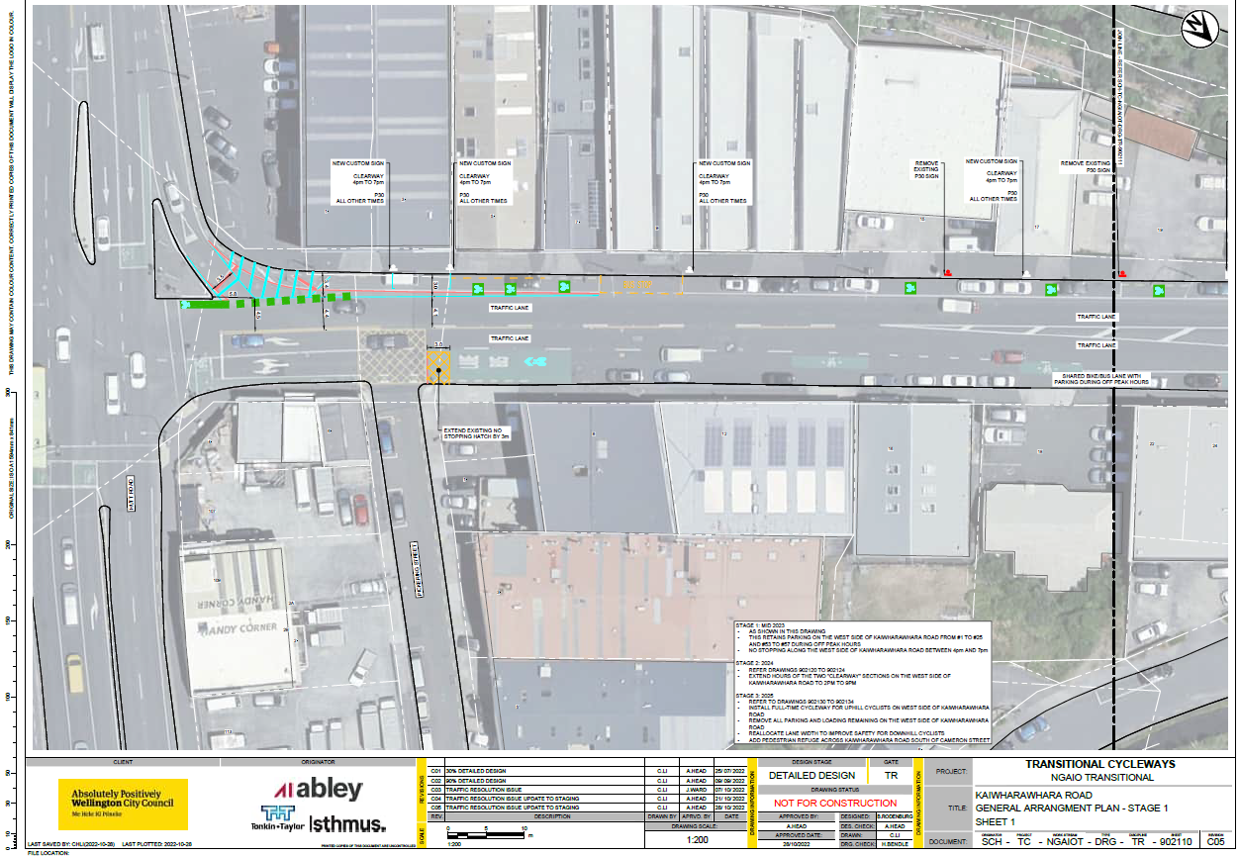

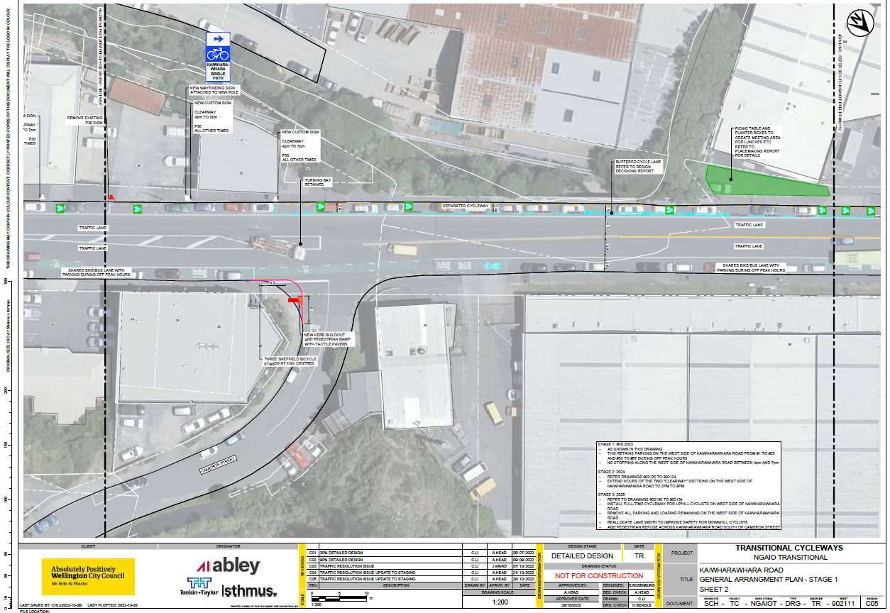

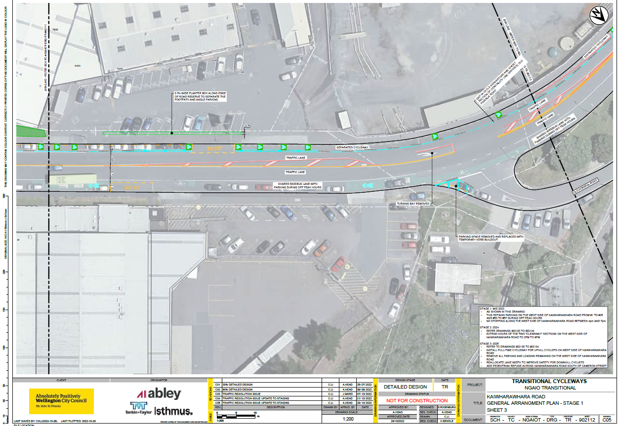

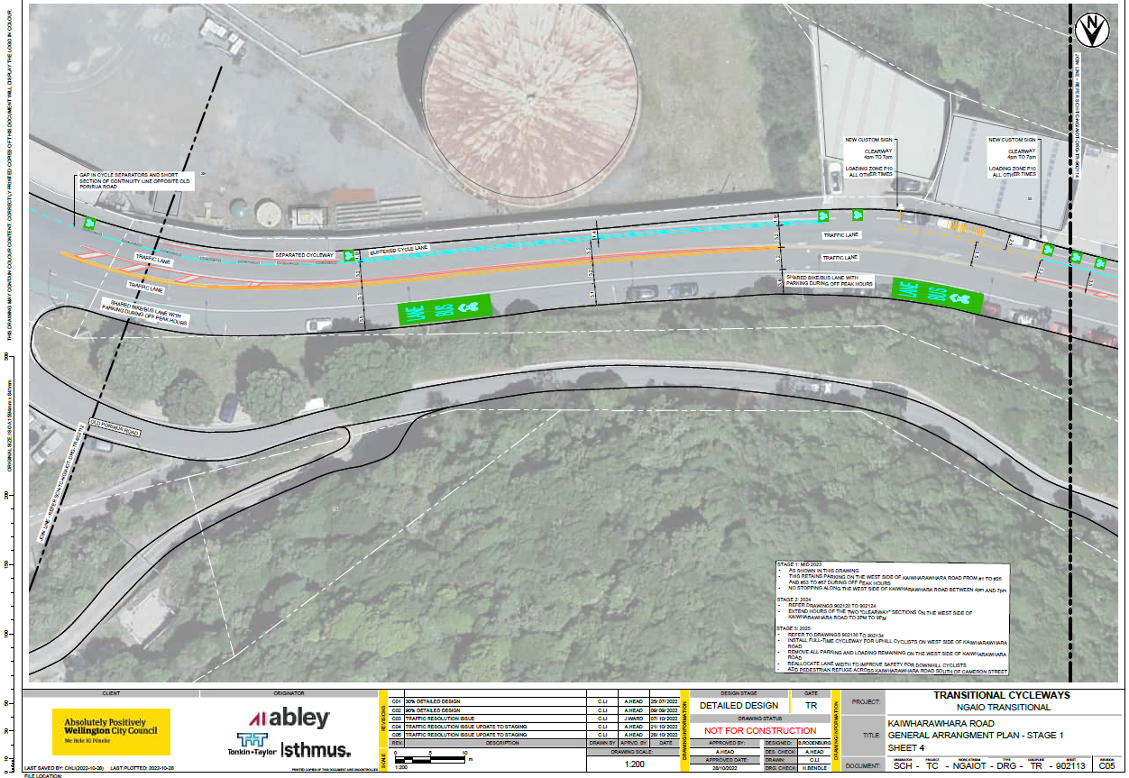

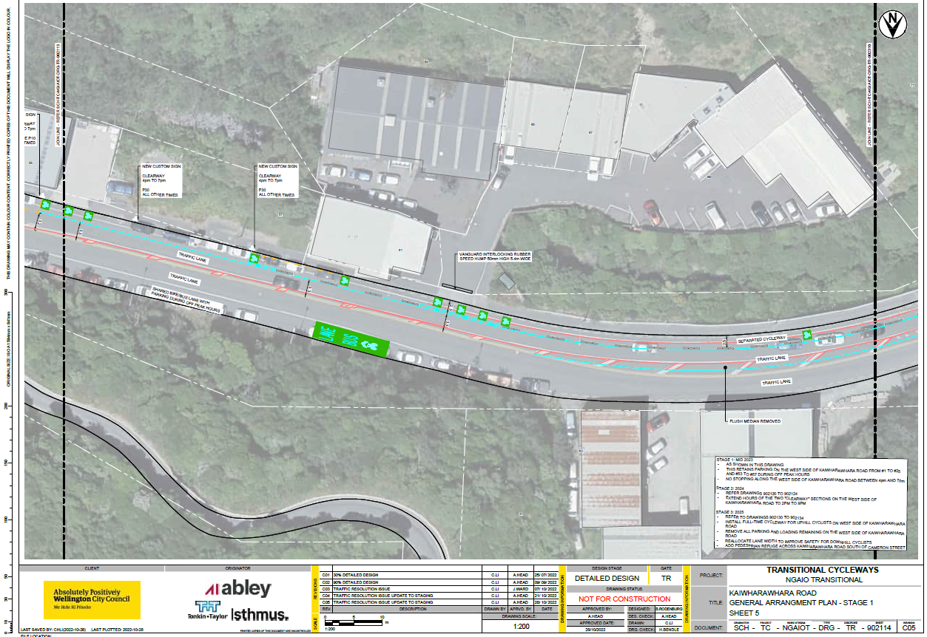

Kaiwharawhara Road Stage 2 (2024)
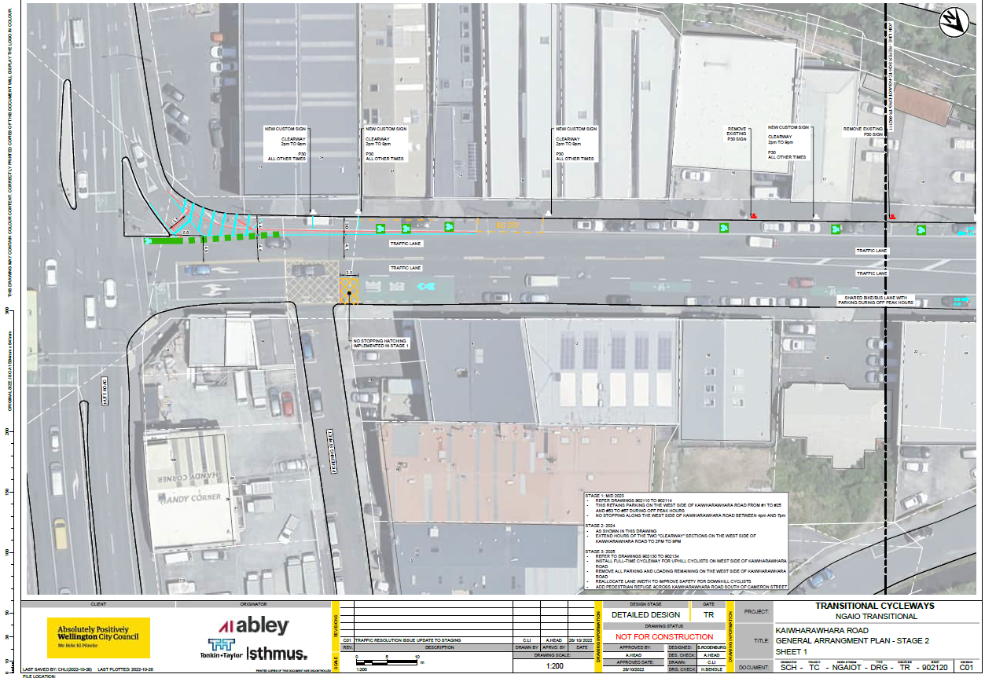

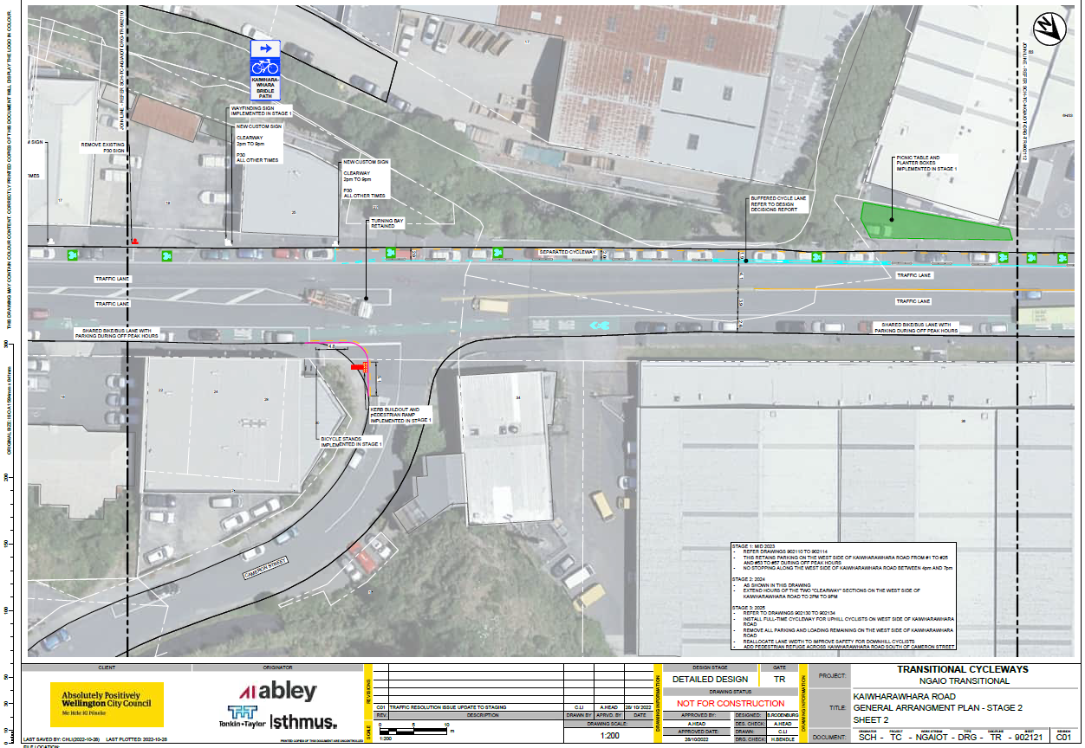

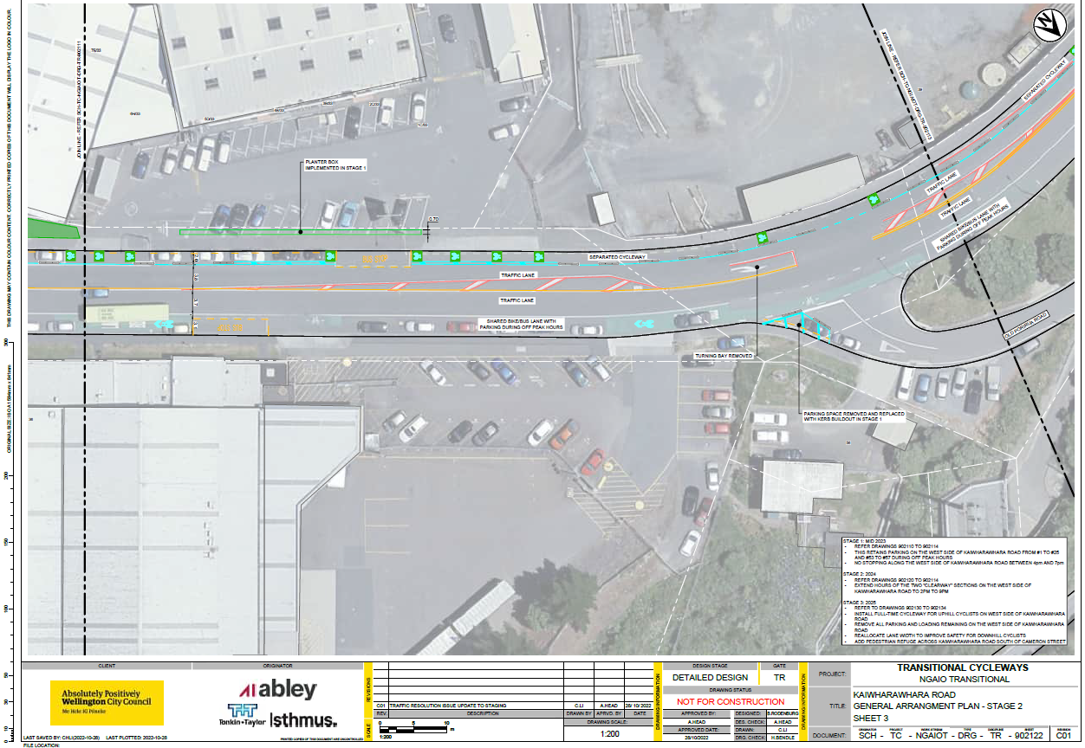

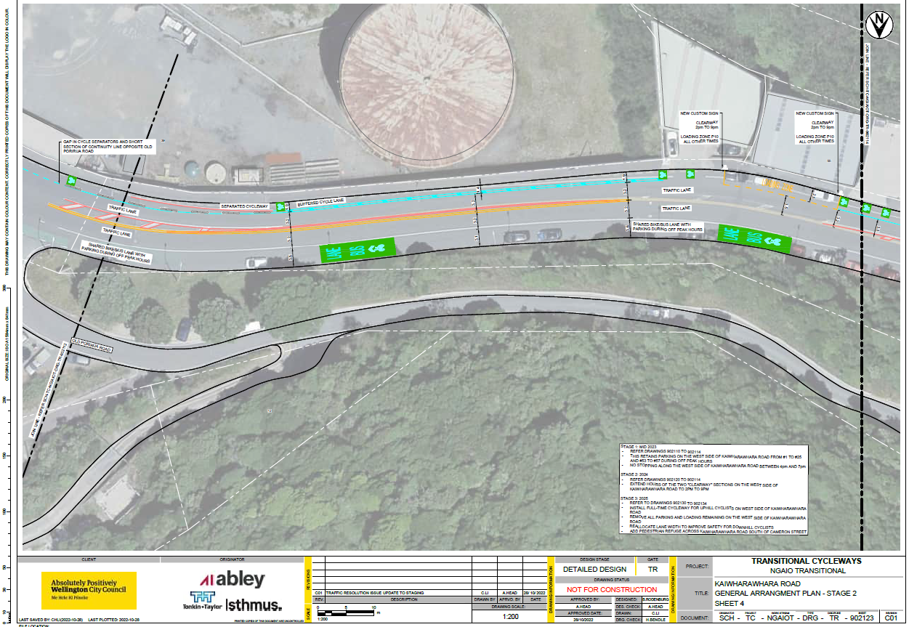

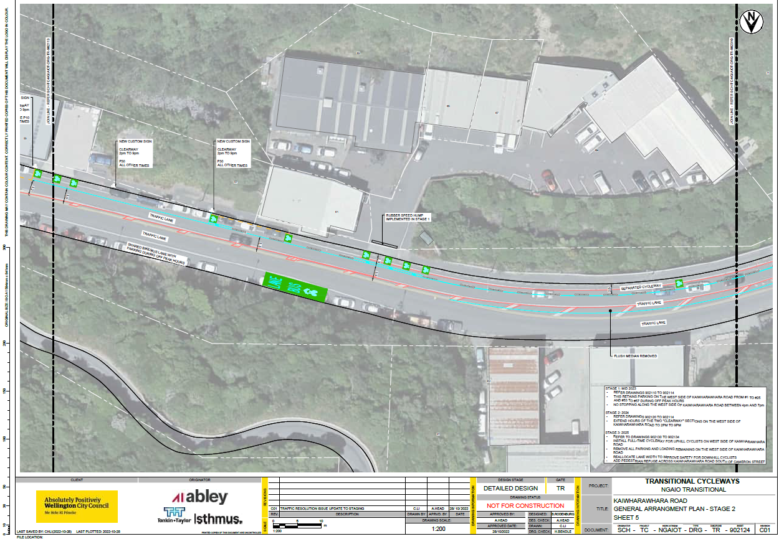

Kaiwharawhara Road Stage 3 (early 2025 onwards)
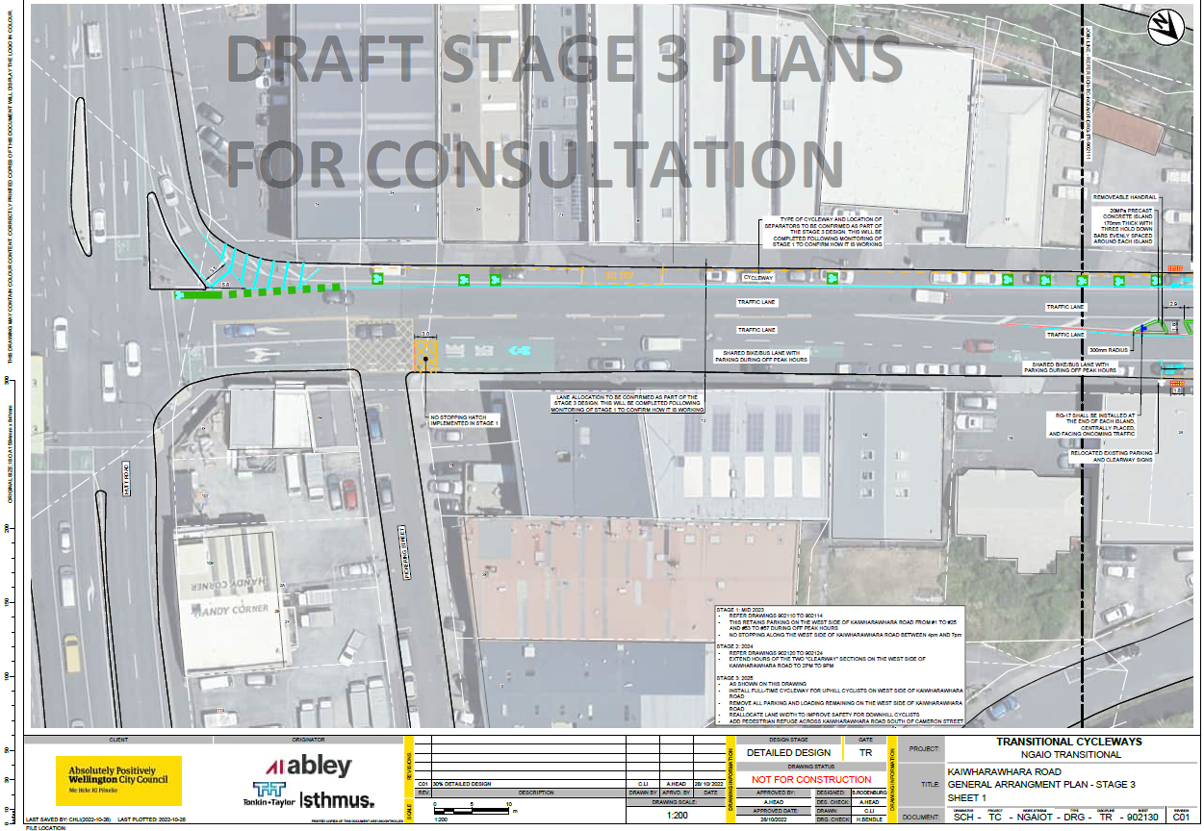

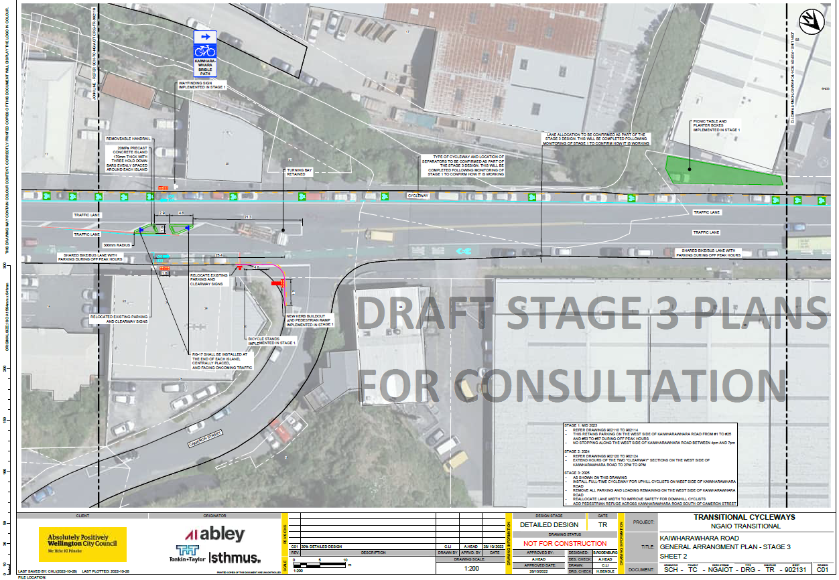

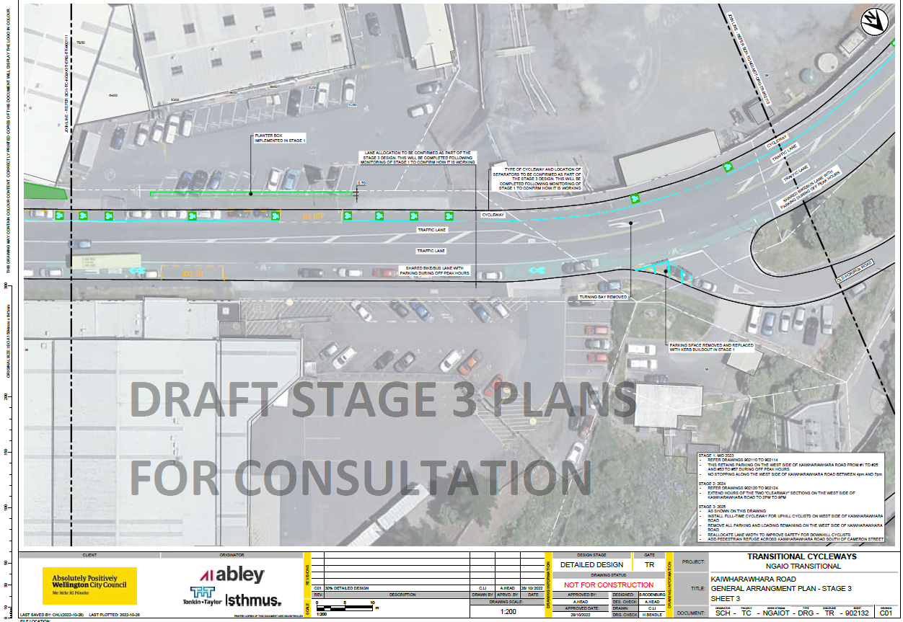

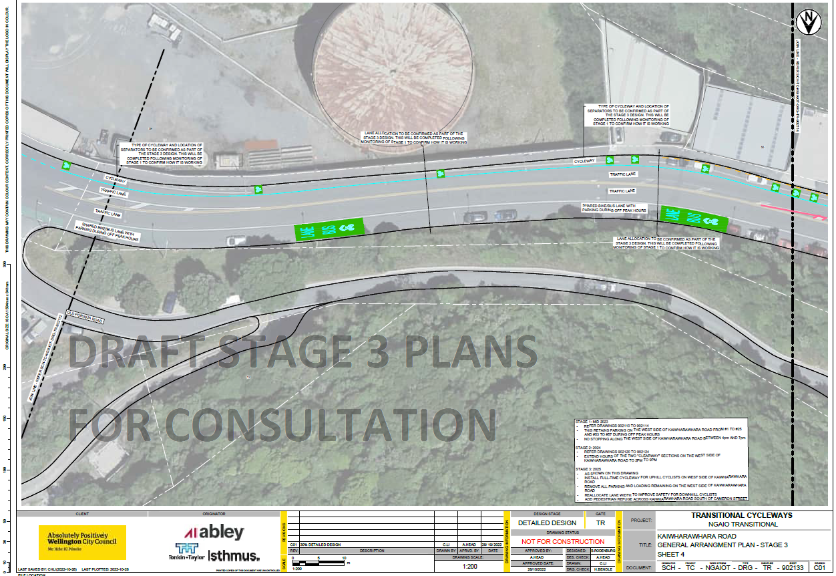

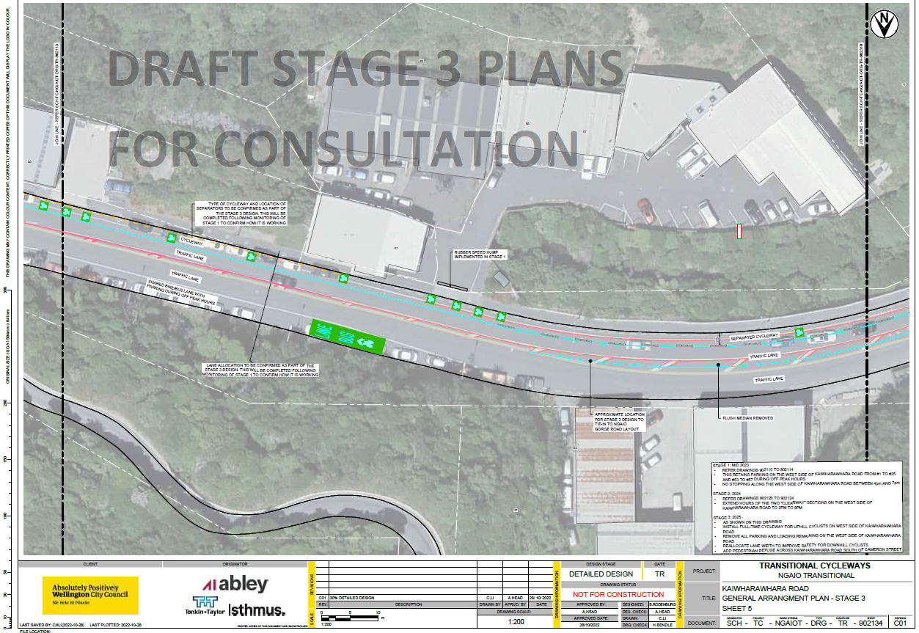

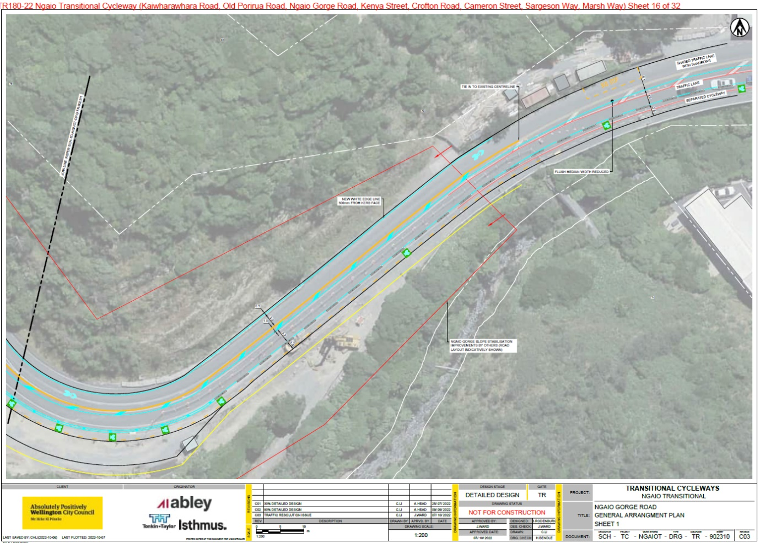
All plans below are Stage 1 (2023 onwards)

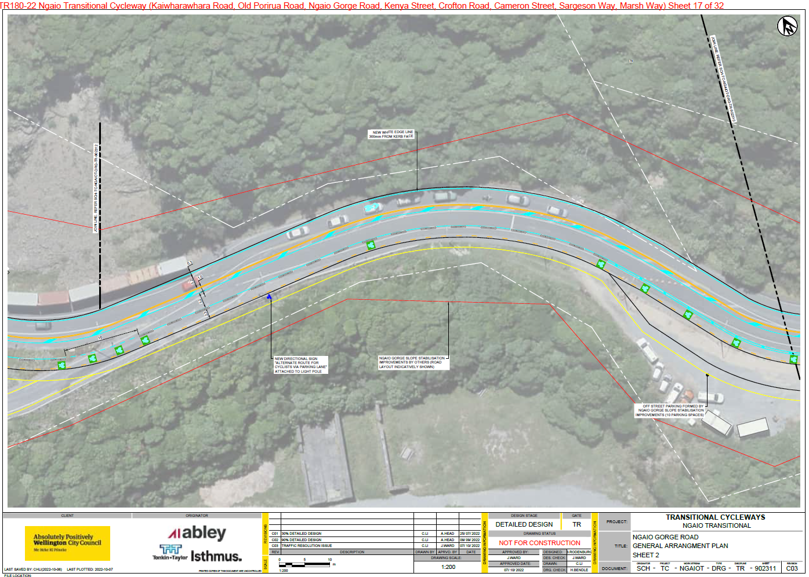

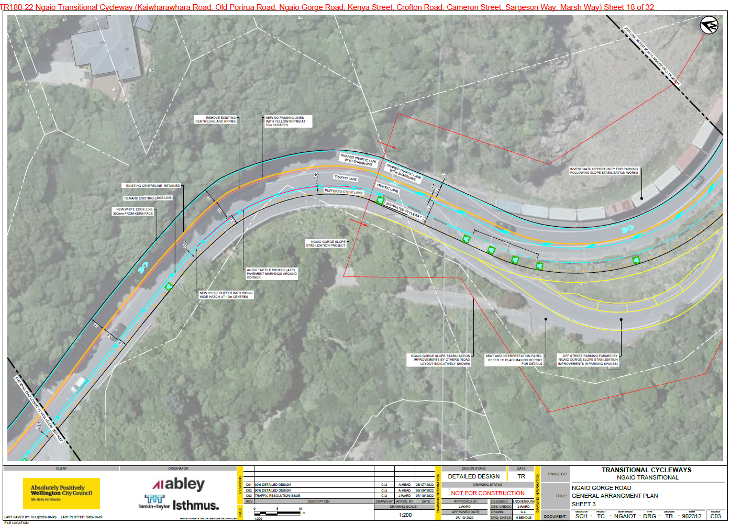

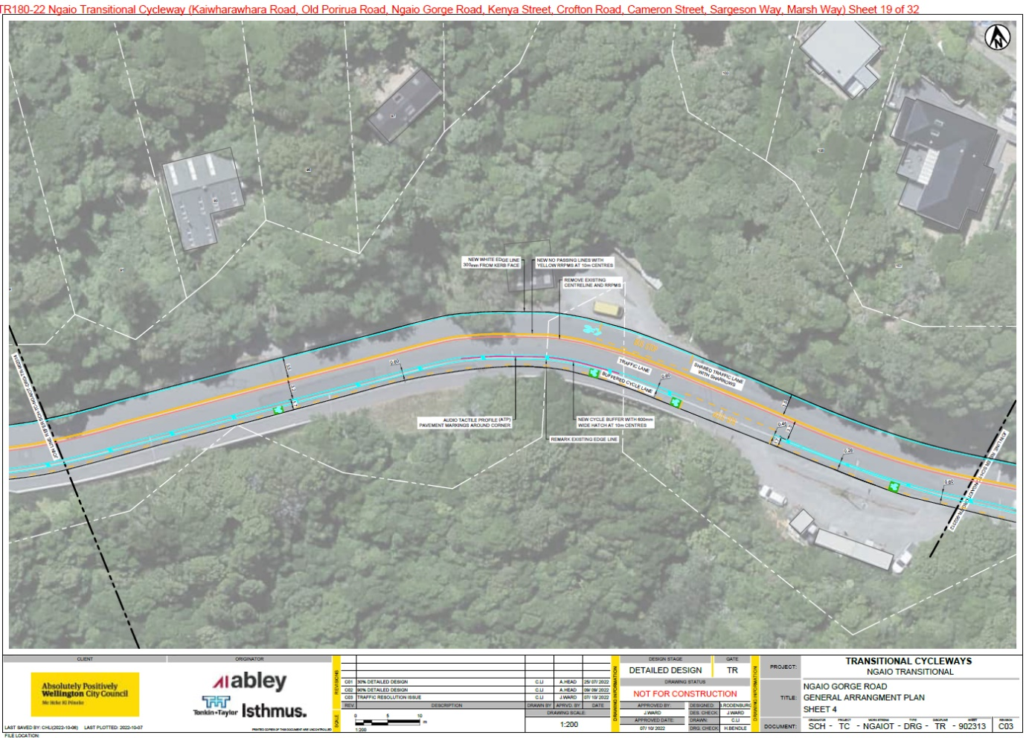

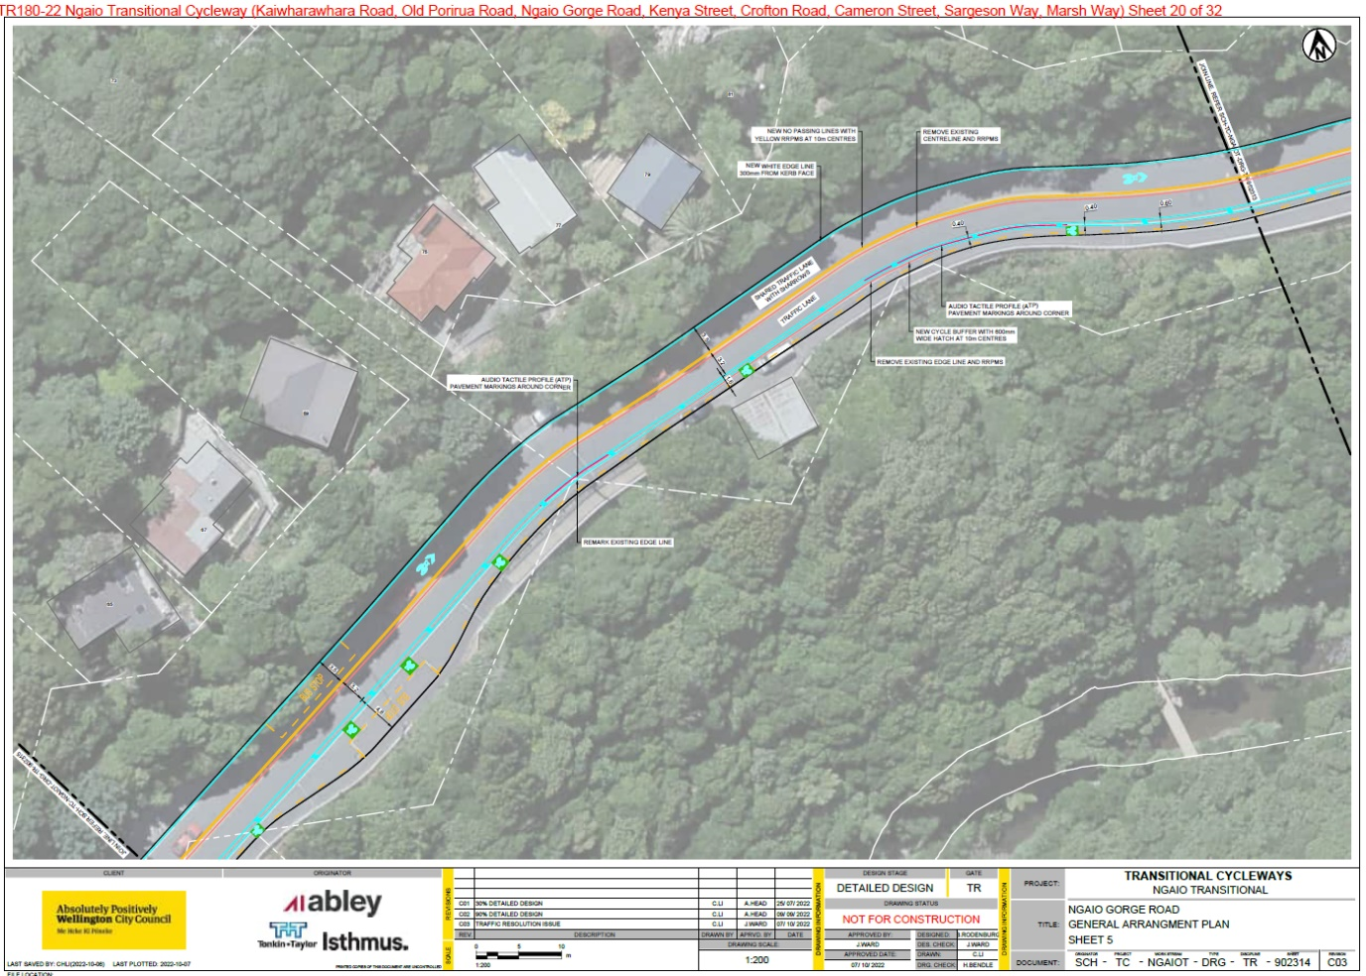

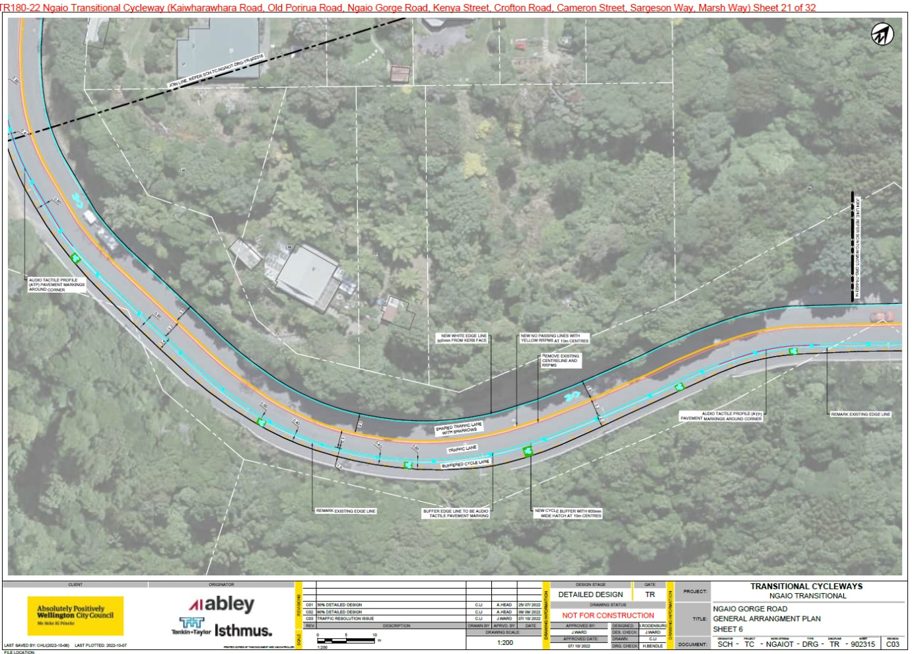

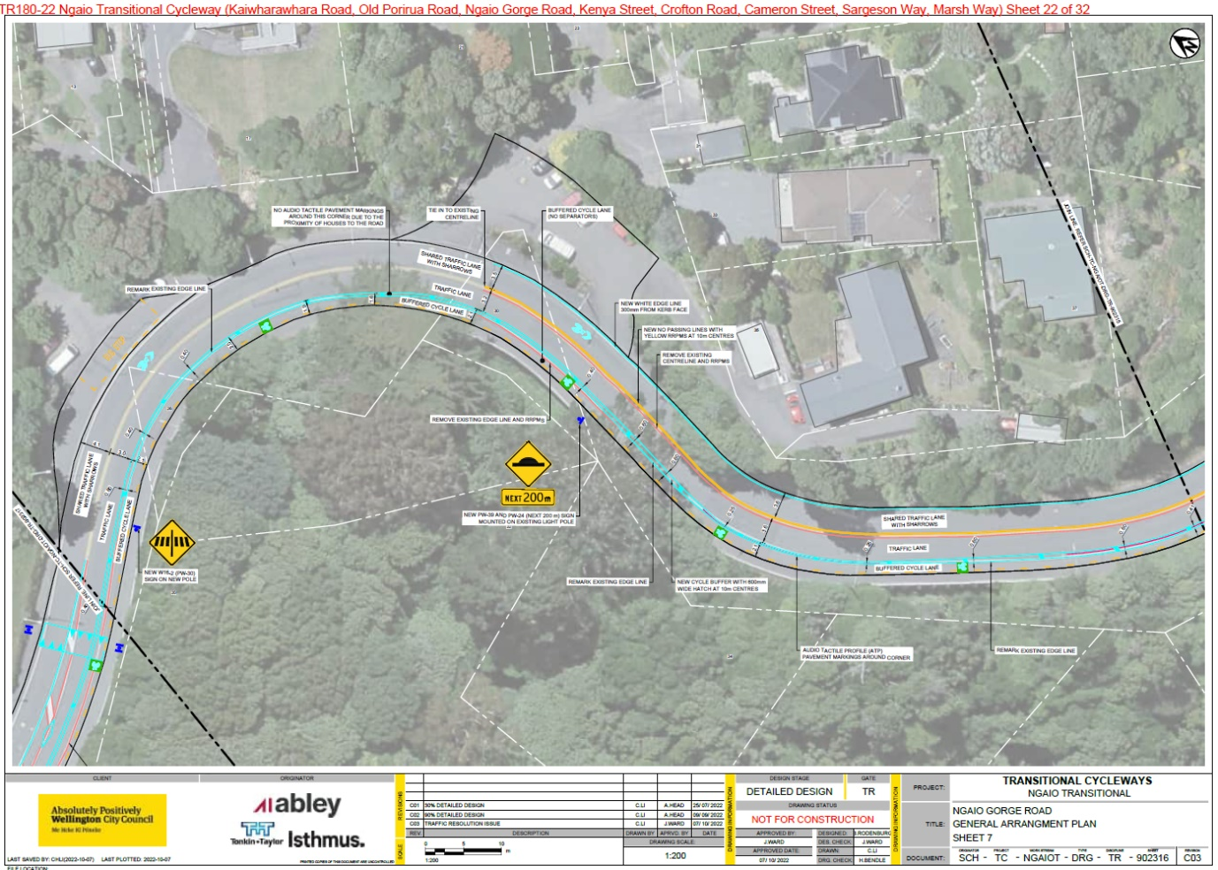

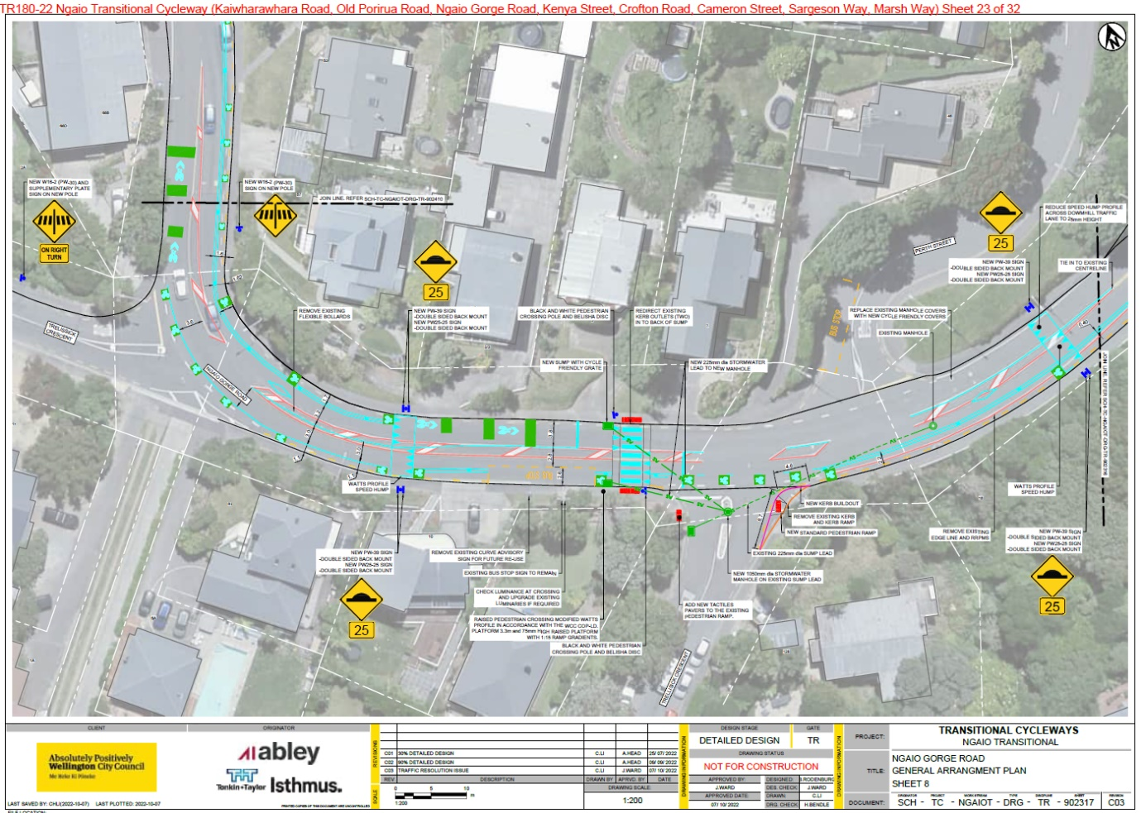

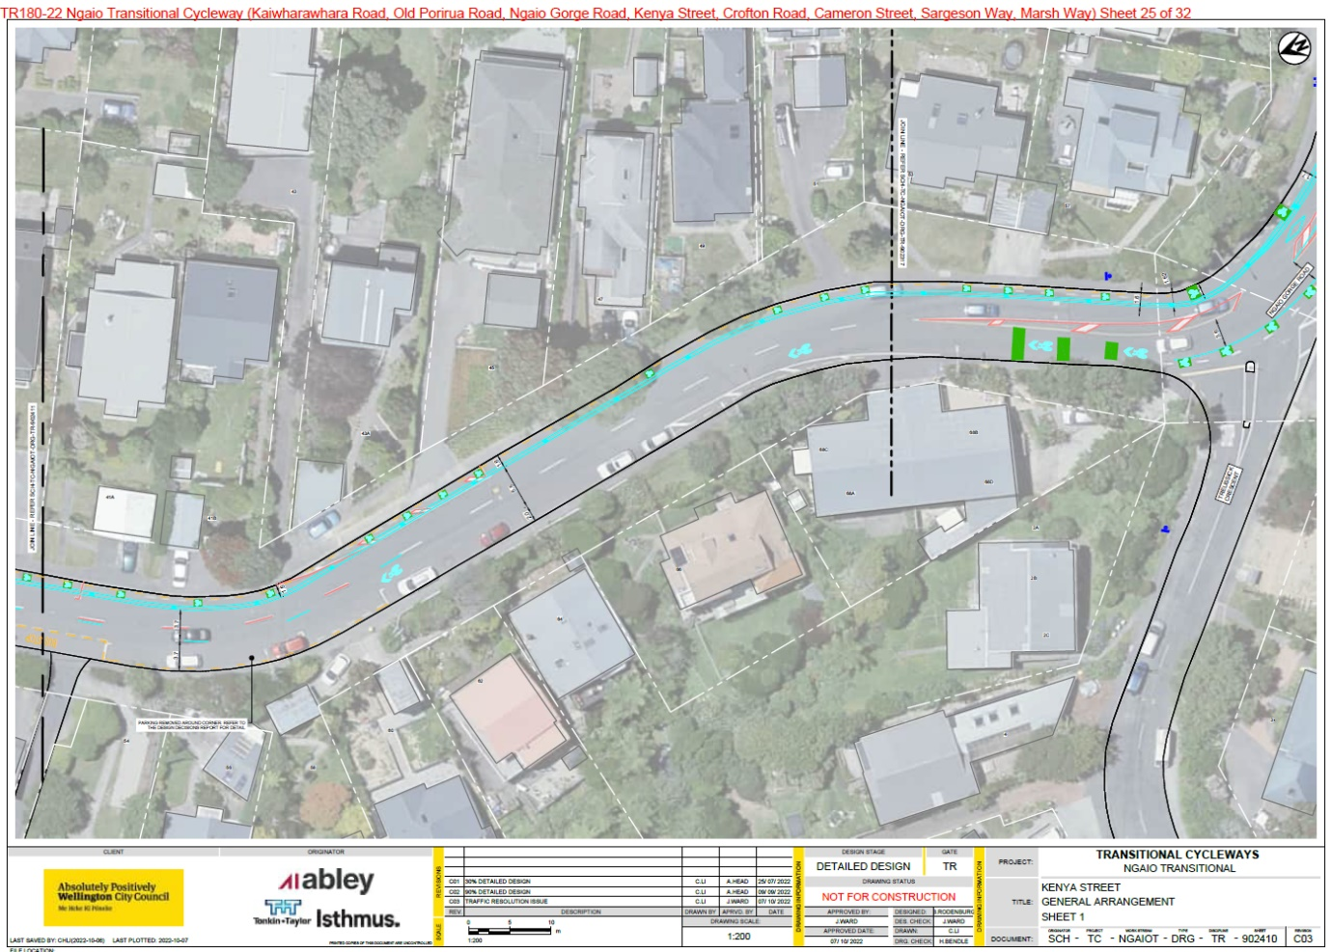

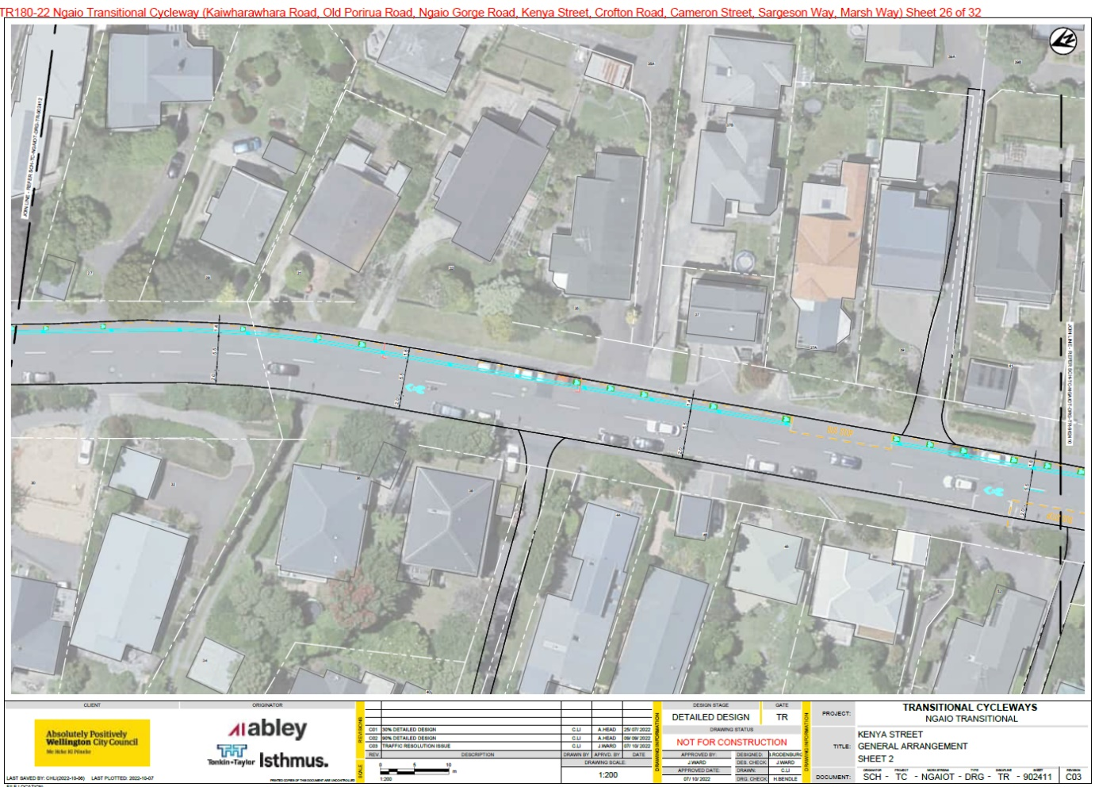

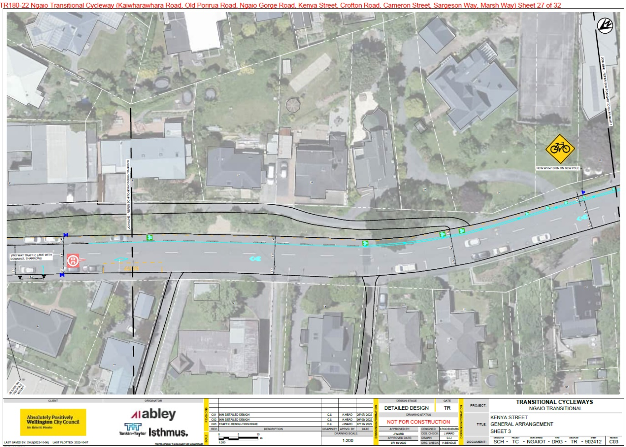

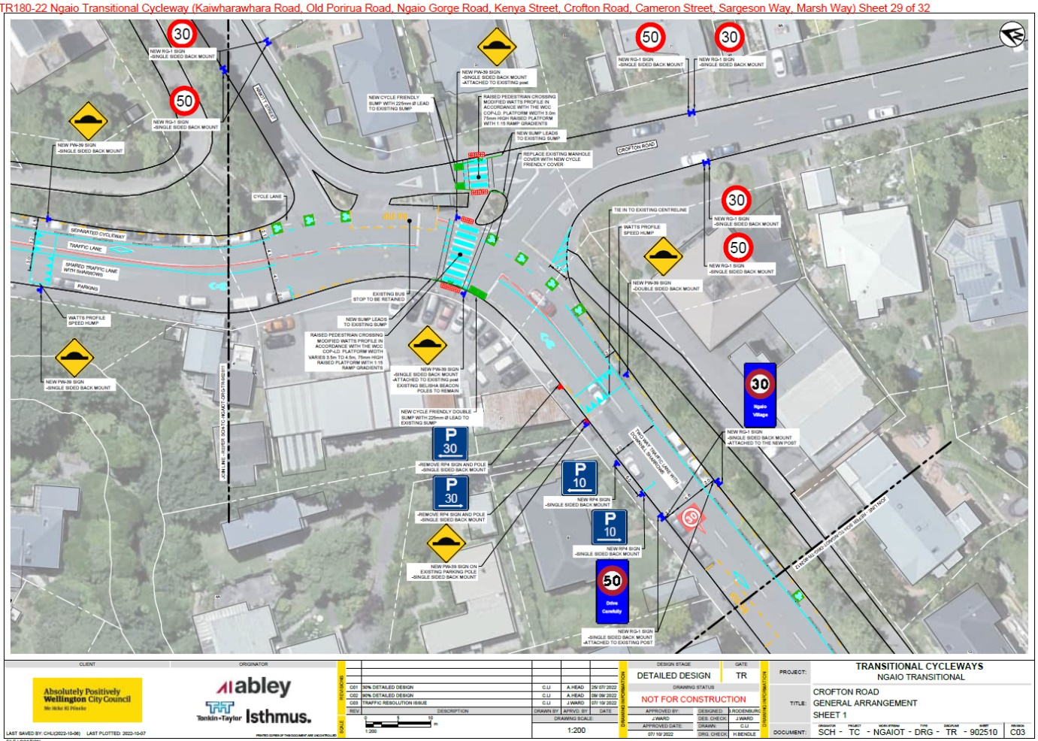
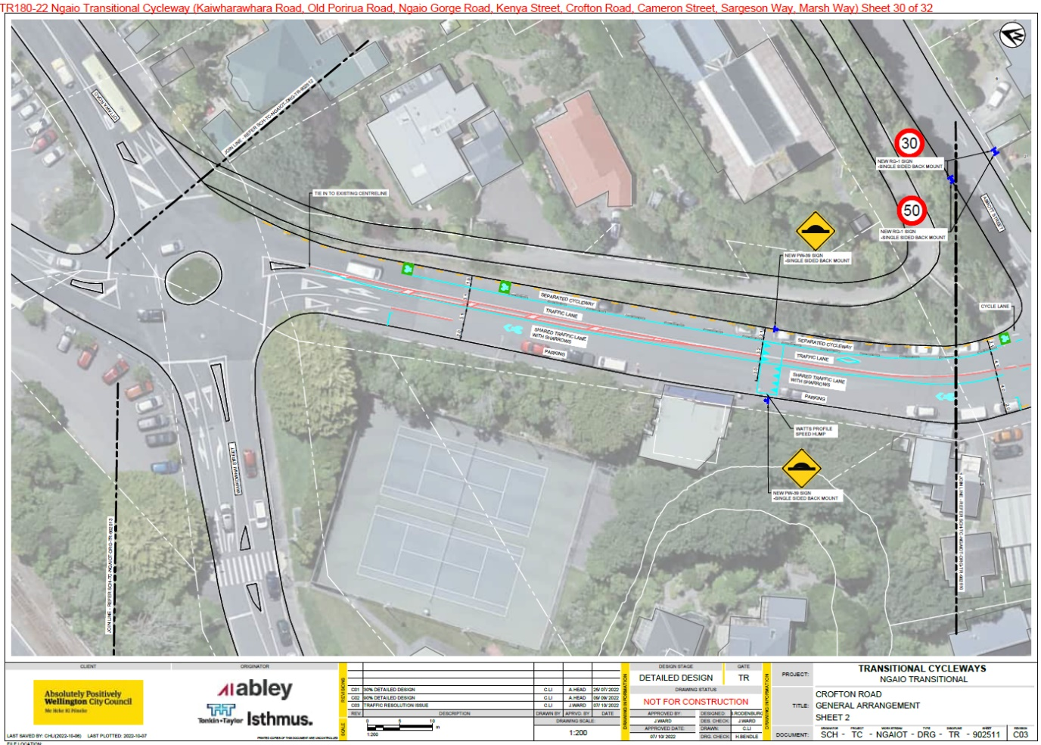

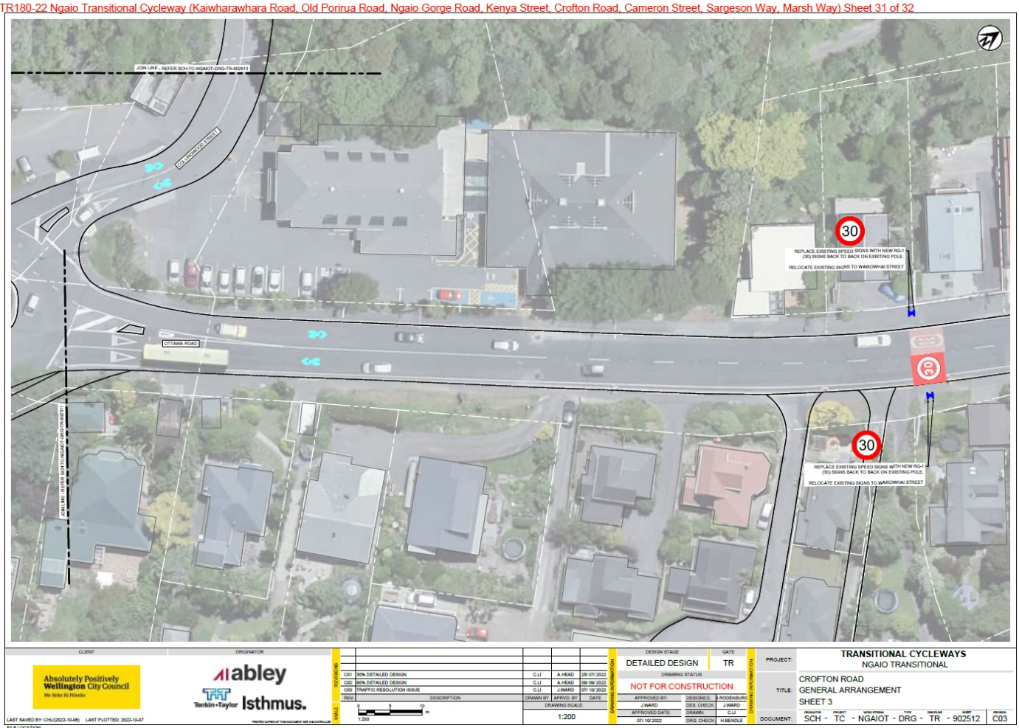

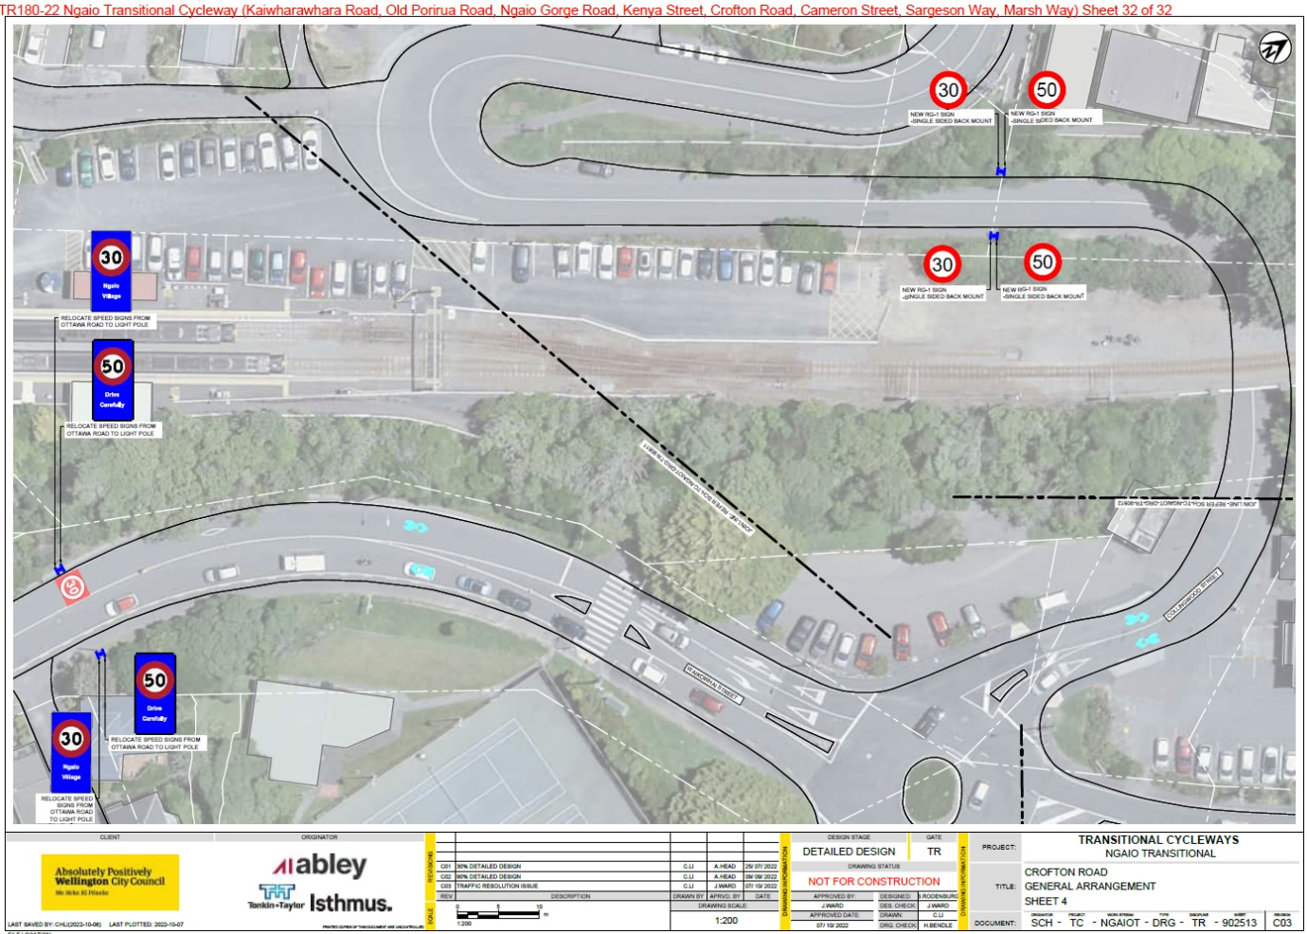

Cameron Street

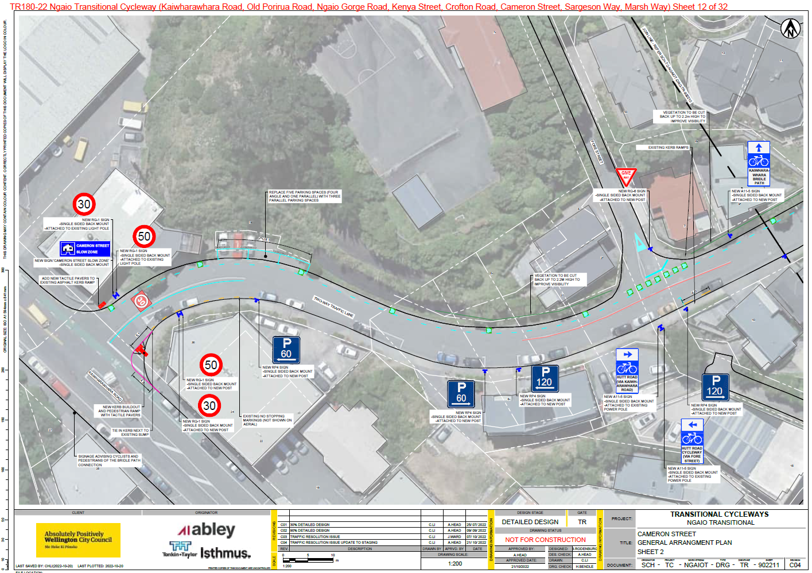

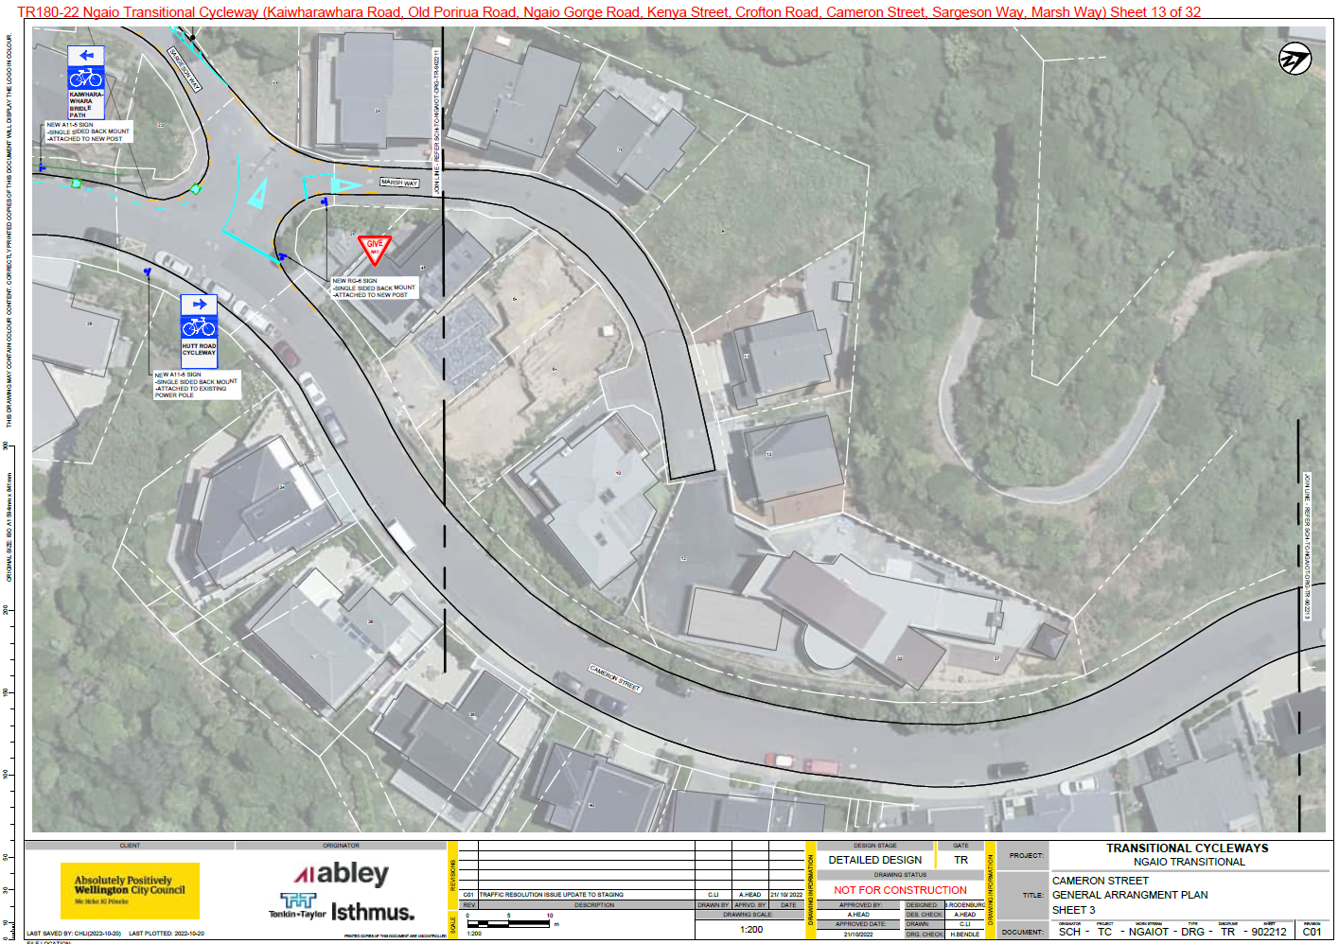

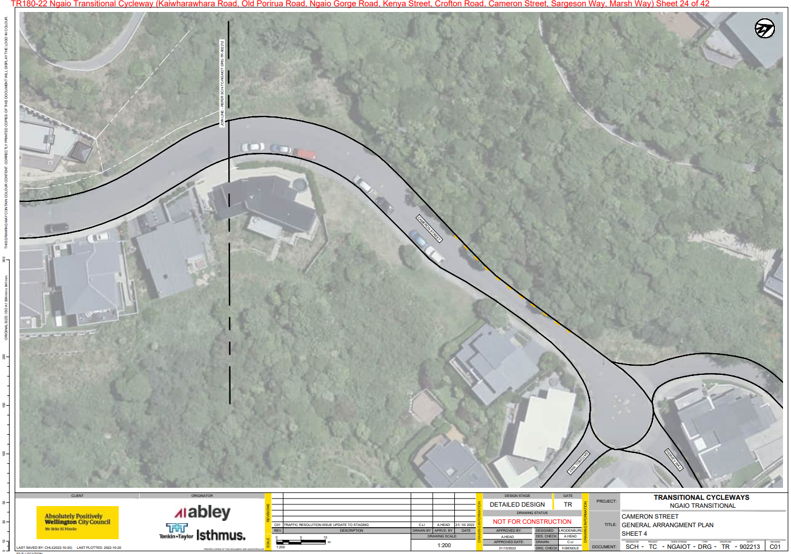

Legal Description:

Delete from Schedule A (Time limited) of the Traffic Restrictions Schedule

Column One | Column Two | Column Three
Kaiwharawhara Road | P30 | South side, commencing 98 metres west of its intersection with Hutt Road and extending in a westerly direction following the southern kerbline for 5.5 metres.
Kaiwharawhara Road | P30 | South side, commencing 108 metres west of its intersection with Hutt Road and extending in a westerly direction following the southern kerbline for 5.5 metres.
Kaiwharawhara Road | P30, Monday - Sunday, 9:00am - 6:00pm | North side, commencing 6 metres from its intersection with Cameron Street and extending in an easterly direction following the northern kerbline for 32 metres.
Cameron Street | P60 | North side, commencing 30 metres east of its intersection with Kaiwharawhara Road (Grid Coordinates x= 1749805.8 m, y= 5430949.9 m), and extending in a south-easterly direction following the northern kerbline for 19 metres. (4 angle and 1 parallel parking space)
Kenya Street | P30 | East side, commencing 16 metres south of its intersection with Crofton Rd and extending in a southerly direction for 7 metres

Add to Schedule A (Time limited) of the Traffic Restrictions Schedule

Column One | Column Two | Column Three
Kaiwharawhara Road (Stage 1, 2023) | P30, Monday - Sunday, 7:00pm - 4:00pm (next day) | West side, commencing 23m northwest of its intersection with Hutt Road (Grid Coordinates X = 1749912.06m, Y = 5430822.44m and extending in a northwesterly direction following the western kerbline for 8 metres.
Kaiwharawhara Road (Stage 1, 2023) | P30, Monday - Sunday, 7:00pm - 4:00pm (next day) | West side, commencing 61 metres northwest of its intersection with Hutt Road (Grid Coordinates X = 1749912.06m, Y = 5430822.44m and extending in a northwesterly direction following the western kerbline for 58 metres.

Kaiwharawhara Road (Stage 1, 2023) | P30, Monday - Sunday, 7:00pm - 4:00pm (next day) | West side, commencing 128.5 metres northwest of its intersection with Hutt Road (Grid Coordinates X = 1749912.06m, Y = 5430822.44m and extending in a northwesterly direction following the western kerbline for 20.5 metres.
Kaiwharawhara Road (Stage 1, 2023) | P30, Monday - Sunday, 7:00pm - 4:00pm (next day) | West side, commencing 531 metres northwest of its intersection with Hutt Road (Grid Coordinates X = 1749912.06m, Y = 5430822.44m and extending in a northwesterly direction following the western kerbline for 23.5 metres.
Kaiwharawhara Road (Stage 2, 2024) | P30, Monday - Sunday, 9:00pm - 2:00pm (next day) | West side, commencing 23m northwest of its intersection with Hutt Road (Grid Coordinates X = 1749912.06m, Y = 5430822.44m and extending in a northwesterly direction following the western kerbline for 8 metres.
Kaiwharawhara Road (Stage 2, 2024) | P30, Monday - Sunday, 9:00pm - 2:00pm (next day) | West side, commencing 61 metres northwest of its intersection with Hutt Road (Grid Coordinates X = 1749912.06m, Y = 5430822.44m and extending in a northwesterly direction following the western kerbline for 58 metres.
Kaiwharawhara Road (Stage 2, 2024) | P30, Monday - Sunday, 9:00pm - 2:00pm (next day) | West side, commencing 128.5 metres northwest of its intersection with Hutt Road (Grid Coordinates X = 1749912.06m, Y = 5430822.44m and extending in a northwesterly direction following the western kerbline for 20.5 metres.
Kaiwharawhara Road (Stage 2, 2024) | P30, Monday - Sunday, 9:00pm - 2:00pm (next day) | West side, commencing 531 metres northwest of its intersection with Hutt Road (Grid Coordinates X = 1749912.06m, Y = 5430822.44m and extending in a northwesterly direction following the western kerbline for 23.5 metres.
Kaiwharawhara Road (Stage 1 and 2, 2023 and 2024) | P30, Monday - Sunday, 9:00am - 6:00pm | East side, commencing 8.5 metres southeast of its intersection with Cameron Street (Grid Coordinates X = 1749812.587m, Y = 5430942.588m) and extending in a southeasterly direction following the eastern kerbline for 32 metres.

Kaiwharawhara Road (Stage 3, 2025) | P30, Monday - Sunday, 9:00am - 6:00pm | East side, commencing 25.5 metres southeast of its intersection with Cameron Street (Grid Coordinates X = 1749812.587m, Y = 5430942.588m) and extending in a southeasterly direction following the eastern kerbline for 15 metres.
Cameron Street | P60 | South side, commencing 31 metres east of its intersection with Kaiwharawhara Road (Grid Coordinates X = 1749812.587m, Y = 5430942.588m) and extending in an easterly direction following the southern kerbline for 48 metres.
Cameron Street | P120 | South side, commencing 84 metres east of its intersection with Kaiwharawhara Road (Grid Coordinates X = 1749812.587m, Y = 5430942.588m) and extending in an easterly direction following the southern kerbline for 36 metres.
Cameron Street | P24hr | South side, commencing 144 metres east of its intersection with Kaiwharawhara Road (Grid Coordinates X = 1749812.587m, Y = 5430942.588m) and extending in an easterly direction following the southern kerbline for 367 metres.
Cameron Street | P24hr | North Side, commencing 75m east of its intersection with Marsh Way (Grid coordinates x=1750015.56 y=5431061.32) and extending in an easterly direction following the northern kerb line for 146 metres.
Cameron Street | P60 | North side, commencing 30 metres east of its intersection with Kaiwharawhara Road  (Grid Coordinates x= 1749805.8 m,  y= 5430949.9 m) and extending in a south-easterly direction following the northern kerbline for 19 metres.
Kenya Street | P10 | North side, commencing 38.5 metres southwest of its intersection with Crofton Road (Grid Coordinates X = 1748584.45m, Y = 5431770.779m) and extending in a southwesterly direction following the northern kerbline for 6 metres.

Delete from Schedule B (Class restricted) of the Traffic Restrictions Schedule

Column One | Column Two | Column Three
Kaiwharawhara Road | Bus Stop – At All Times | South side 296.5m from its intersection with Hutt Road and extending in a westerly direction for 12m
Kenya Street | Bus Stop – At All Times | East side, commencing 190 metres north of its intersection with Ngaio Gorge Road and extending in a northerly direction following the eastern kerbline for 24.5 metres.
Kenya Street | Bus Stop – At All Times | West side, commencing 148.5 metres north of its intersection with Trelissick Cres and extending in a northerly direction following the western kerbline for 14.5 metres.

Add to Schedule B (Class restricted) of the Traffic Restrictions Schedule

Column One | Column Two | Column Three
Kaiwharawhara Road | Bus Stop – At All Times | West side, commencing 50 metres northwest of its intersection with Hutt Road (Grid Coordinates X = 1749912.06m, Y = 5430822.44m and extending in a northwesterly direction following the western kerbline for 11 metres.
Kaiwharawhara Road | Bus Stop – At All Times | West side, commencing 289 metres northwest of its intersection with Hutt Road (Grid Coordinates X = 1749912.06m, Y = 5430822.44m and extending in a northwesterly direction following the western kerbline for 11.5 metres.
Kaiwharawhara Road  (Stage 1, 2023) | Loading Zone P10,  Monday - Sunday, 7:00pm - 4:00pm (next day) | West side, commencing 488.5 metres northwest of its intersection with Hutt Road (Grid Coordinates X = 1749912.06m, Y = 5430822.44m and extending in a northwesterly direction following the western kerbline for 21.5 metres.
Kaiwharawhara Road  (Stage 2, 2024) | Loading Zone P10,  Monday - Sunday, 9:00pm - 2:00pm (next day) | West side, commencing 488.5 metres northwest of its intersection with Hutt Road (Grid Coordinates X = 1749912.06m, Y = 5430822.44m and extending in a northwesterly direction following the western kerbline for 21.5 metres.

Ngaio Gorge Road | Bus Stop – At All Times | South side, commencing 134.5 metres west of its intersection with Kaiwharawhara Road (Grid Coordinates X = 1749066.529m, Y = 5431182.391m) and extending in a westerly direction following the southern kerbline for 15 metres.
Ngaio Gorge Road | Bus Stop – At All Times | South side, commencing 364 metres west of its intersection with Kaiwharawhara Road (Grid Coordinates X = 1749066.529m, Y = 5431182.391m) and extending in a westerly direction following the southern kerbline for 13 metres.
Ngaio Gorge Road | Bus Stop – At All Times | South side, commencing 14 metres west of its intersection with Trelissick Crescent (Grid Coordinates X = 1748444.224m, Y = 5431277.491m) and extending in a westerly direction following the southern kerbline for 15 metres.
Kenya Street | Bus Stop – At All Times | North side, commencing 143.5 metres north of its intersection with Trelissick Crescent (Grid Coordinates X = 1748383.625m, Y = 5431327.364m) and extending in a northerly direction following the northern kerbline for 15 metres.
Kenya Street | Bus Stop – At All Times | South side, commencing 178.5 metres north of its intersection with Ngaio Gorge Road (Grid Coordinates X = 1748394.214m, Y = 5431321.551m) and extending in a northerly direction following the southern kerbline for 14.5 metres.

Add to Schedule C (Direction, Placement and Lane Use) of the Traffic Restrictions Schedule

Column One | Column Two | Column Three
Kaiwharawhara Road  (Stage 1, 2023) | Clearway, Monday to Friday, 4:00pm - 7:00pm | West side, commencing at its intersection with Hutt Road (Grid Coordinates X = 1749912.06m, Y = 5430822.44m and extending in a northwesterly direction following the western kerbline for 50 metres.
Kaiwharawhara Road  (Stage 1, 2023) | Clearway, Monday to Friday, 4:00pm - 7:00pm | West side, commencing 61 metres northwest of its intersection with Hutt Road (Grid Coordinates X = 1749912.06m, Y = 5430822.44m and extending in a northwesterly direction following the western kerbline for 228 metres.

Kaiwharawhara Road  (Stage 1, 2023) | Clearway, Monday to Friday, 4:00pm - 7:00pm | West side, commencing 300.5 metres northwest of its intersection with Hutt Road (Grid Coordinates X = 1749912.06m, Y = 5430822.44m and extending in a northwesterly direction following the western kerbline for 390.5 metres.
Kaiwharawhara Road  (Stage 2, 2024) | Clearway, Monday to Friday, 2:00pm - 9:00pm | West side, commencing at its intersection with Hutt Road (Grid Coordinates X = 1749912.06m, Y = 5430822.44m and extending in a northwesterly direction following the western kerbline for 50 metres.
Kaiwharawhara Road  (Stage 2, 2024) | Clearway, Monday to Friday, 2:00pm - 9:00pm | West side, commencing 61 metres northwest of its intersection with Hutt Road (Grid Coordinates X = 1749912.06m, Y = 5430822.44m and extending in a northwesterly direction following the western kerbline for 228 metres.
Kaiwharawhara Road  (Stage 2, 2024) | Clearway, Monday to Friday, 2:00pm - 9:00pm | West side, commencing 300.5 metres northwest of its intersection with Hutt Road (Grid Coordinates X = 1749912.06m, Y = 5430822.44m and extending in a northwesterly direction following the western kerbline for 390.5 metres.

Delete from Schedule D (No Stopping) of the Traffic Restrictions Schedule

Column One | Column Two | Column Three
Kaiwharawhara Road | No Stopping – At All Times | West side, commencing 43.5 metres north of its intersection with Hutt Road (Grid coordinates x= 1,749,909.8 m, y= 5,430,820.5m), and extending in a northerly direction following the western kerb line for 7.5 metres.
Kaiwharawhara Road | No Stopping – At All Times | South side, commencing at a point 580 metres west of its intersection with Hutt Road and extending in a westerly direction following the southern kerbline for 154 metres.
Kaiwharawhara Road | No Stopping – At All Times | West side, commencing 149.5 metres north of its intersection with Hutt Road (Grid coordinates x= 1,749,913.1m, y= 5,430,822.8 m), and extending in a northerly direction following the western kerb line for 8.5 metres."

Kaiwharawhara Road | No Stopping – At All Times | South side 308.5m from its intersection with Hutt Road and extending in a westerly direction for 105.5m
Cameron Street | No Stopping – At All Times | Southeast side, commencing from its intersection with Kaiwharawhara Road (Grid Coordinates X=1,749,813.33m Y=5,430,941.57m) and extending in a north-easterly direction, following the southeastern kerb line for 18 metres
Cameron Street | No Stopping – At All Times | North Side, commencing 43.67 metres east of its intersection with Marsh Way (Grid coordinates x=1750011.04 y=5431057.11) and extending in an easterly direction following the northern kerb line for 31 metres.
Ngaio Gorge Road | No Stopping – At All Times | Northwest side, commencing at its intersection with Ngaio Gorge Road and extending in a southwesterly direction following the northwestern kerbline for 24.5 metres.
Ngaio Gorge Road | No Stopping – At All Times | Southeast side, commencing at its intersection with Ngaio Gorge Road and extending in a southwesterly direction following the southeastern kerbline for 24.5 metres.
Kenya Street | No Stopping – At All Times | West side, commencing from its intersection with Crofton Road and extending in a southerly direction following the western kerbline for 26 metres.
Kenya Street | No Stopping – At All Times | East side, commencing from its intersection with Ngaio Gorge Road and extending in a northerly direction following the eastern kerbline for 33.5 metres.
Kenya Street | No Stopping – At All Times | East side, commencing 97.5 metres north of its intersection with Ngaio Gorge Road and extending in a northerly direction following the eastern kerbline for 9.5 metres.
Kenya Street | No Stopping – At All Times | East side, commencing 127.5 metres north of its intersection with Ngaio Gorge Road and extending in a northerly direction following the eastern kerbline for 24 metres.

Kenya Street | No Stopping – At All Times | Northeast side, commencing 6 metres from its intersection with Kenya Street and extending in a northwesterly direction following the northeastern kerbline for 14 metres.
Crofton Road | No Stopping – At All Times | West side, commencing at its intersection with Kenya Street and extending in a northerly direction following the western kerbline for 3 metres.
Crofton Road | No Stopping – At All Times | South side, commencing 5.5 metres west of its intersection with Kenya Street and extending in a westerly direction following the western kerbline for 12 metres.
Crofton Road | No Stopping – At All Times | North side, commencing at its intersection with Abbott St and extending in an westerly direction following the northern kerbline for 7 metres.

Add to Schedule D (No Stopping) of the Traffic Restrictions Schedule

Column One | Column Two | Column Three
Kaiwharawhara Road  (Stages 1 and 2, 2023 to 2024) | No Stopping – At All Times | West side, commencing at its intersection with Hutt Road (Grid Coordinates X = 1749912.06m, Y = 5430822.44m and extending in a northwesterly direction following the western kerbline for 23 metres.
Kaiwharawhara Road  (Stages 1 and 2, 2023 to 2024) | No Stopping – At All Times | West side, commencing 31m northwest of its intersection with Hutt Road (Grid Coordinates X = 1749912.06m, Y = 5430822.44m and extending in a northwesterly direction following the western kerbline for 19 metres.
Kaiwharawhara Road  (Stages 1 and 2, 2023 to 2024) | No Stopping – At All Times | West side, commencing 107 metres northwest of its intersection with Hutt Road (Grid Coordinates X = 1749912.06m, Y = 5430822.44m and extending in a northwesterly direction following the western kerbline for 26.5 metres.

Kaiwharawhara Road  (Stages 1 and 2, 2023 to 2024) | No Stopping – At All Times | West side, commencing 149 metres northwest of its intersection with Hutt Road (Grid Coordinates X = 1749912.06m, Y = 5430822.44m and extending in a northwesterly direction following the western kerbline for 140 metres.
Kaiwharawhara Road  (Stages 1 and 2, 2023 to 2024) | No Stopping – At All Times | West side, commencing 300.5 metres northwest of its intersection with Hutt Road (Grid Coordinates X = 1749912.06m, Y = 5430822.44m and extending in a northwesterly direction following the western kerbline for 187.5 metres.
Kaiwharawhara Road  (Stages 1 and 2, 2023 to 2024) | No Stopping – At All Times | West side, commencing 554.5 metres northwest of its intersection with Hutt Road (Grid Coordinates X = 1749912.06m, Y = 5430822.44m and extending in a northwesterly direction following the western kerbline for 146.5 metres.
Kaiwharawhara Road  (Stage 3, 2025) | No Stopping – At All Times | West side, commencing at its intersection with Hutt Road (Grid Coordinates X = 1749912.06m, Y = 5430822.44m and extending in a northwesterly direction following the western kerbline for 50 metres.
Kaiwharawhara Road  (Stage 3, 2025) | No Stopping – At All Times | West side, commencing 61 metres northwest of its intersection with Hutt Road (Grid Coordinates X = 1749912.06m, Y = 5430822.44m and extending in a northwesterly direction following the western kerbline for 228 metres.
Kaiwharawhara Road  (Stage 3, 2025) | No Stopping – At All Times | West side, commencing 300.5 metres northwest of its intersection with Hutt Road (Grid Coordinates X = 1749912.06m, Y = 5430822.44m and extending in a northwesterly direction following the western kerbline for 390.5 metres.
Kaiwharawhara Road (Stages 1 and 2, 2023 to 2024) | No Stopping – At All Times | East side, commencing at its intersection with Cameron Street (Grid Coordinates X = 1749812.587m, Y = 5430942.588m and extending in a southeasterly direction following the eastern kerbline for 6 metres.

Kaiwharawhara Road (Stage 3, 2025) | No Stopping – At All Times | East side, commencing at its intersection with Cameron Street (Grid Coordinates X = 1749812.587m, Y = 5430942.588m and extending in a southeasterly direction following the eastern kerbline for 25.5 metres.
Cameron Street | No Stopping – At All Times | South side, commencing 130 metres east of its intersection with Kaiwharawhara Road (Grid Coordinates X = 1749812.587m, Y = 5430942.588m and extending in an easterly direction following the southern kerbline for 6 metres.
Cameron Street | No Stopping – At All Times | South side, commencing at its intersection with Kaiwharawhara Road (Grid Coordinates X = 1749812.587m, Y = 5430942.588m and extending in an easterly direction following the southern kerbline for 31 metres.
Cameron Street | No Stopping – At All Times | North side, commencing at its intersection with Marsh Way (Grid coordinates x=1750011.04 y=5431057.11) and extending in an easterly direction following the northern kerb line for 75 metres.
Cameron Street | No Stopping – At All Times | North Side, commencing 221m east of its intersection with Marsh Way (Grid coordinates x=1750015.56 y=5431061.32) and extending in an easterly direction following the northern kerb line for 35 metres.
Marsh Way | No Stopping – At All Times | South side, commencing at its intersection with Marsh Way (Grid coordinates x=1750015.56 y=5431061.32) and extending in an easterly direction following the southern kerb line for 8 metres.
Marsh Way | No Stopping – At All Times | North side, commencing at its intersection with Sargeson Way (Grid coordinates x=1750008.14 y=5431066.07) and extending in an easterly direction following the northern kerb line for 12 metres.
Sargeson Way | No Stopping – At All Times | South side, commencing at its intersection with Marsh Way (Grid coordinates x=1750011.04 y=5431057.11) and extending in a westerly direction following the southern kerb line for 27 metres.
Sargeson Way | No Stopping – At All Times | North side, commencing at its intersection with Marsh Way (Grid coordinates x=1750008.14 y=5431066.07) and extending in a westerly direction following the northern kerb line for 10 metres.
Old Porirua Road | No Stopping – At All Times | North side, commencing at its intersection with Kaiwharawhara Road (Grid Coordinates X = 1749650.973m, Y = 5431089.75m and extending in a westerly direction following the northern kerbline for 8 metres.
Ngaio Gorge Road | No Stopping – At All Times | South side, commencing at its intersection with Kaiwharawhara Road (Grid Coordinates X = 1749066.529m, Y = 5431182.391m) and extending in a westerly direction following the southern kerbline for 133.5 metres.
Ngaio Gorge Road | No Stopping – At All Times | South side, commencing 149.5 metres west of its intersection with Kaiwharawhara Road (Grid Coordinates X = 1749066.529m, Y = 5431182.391m) and extending in a westerly direction following the southern kerbline for 214 metres.
Ngaio Gorge Road | No Stopping – At All Times | South side, commencing at its intersection with Trelissick Crescent (Grid Coordinates X = 1748458.814m, Y = 5431272.233m) and extending in an easterly direction following the southern kerbline for 432 metres.
Ngaio Gorge Road | No Stopping – At All Times | South side, commencing 29 metres west of its intersection with Trelissick Crescent (Grid Coordinates X = 1748444.224m, Y = 5431277.491m) and extending in a westerly direction following the southern kerbline for 36 metres.
Ngaio Gorge Road | No Stopping – At All Times | North side, commencing at its intersection with Kenya Street (Grid Coordinates X = 1748394.214m, Y = 5431321.551m) and extending in an easterly direction following the northern kerbline for 83 metres.
Kenya Street | No Stopping – At All Times | North side, commencing 107.5 metres north of its intersection with Trelissick Crescent (Grid Coordinates X = 1748383.625m, Y = 5431327.364m) and extending in a northerly direction following the northern kerbline for 36 metres.
Kenya Street | No Stopping – At All Times | North side, commencing at its intersection with Crofton Road (Grid Coordinates X = 1748584.45m, Y = 5431770.779m) and extending in a westerly direction following the northern kerbline for 38 metres.
Kenya Street | No Stopping – At All Times | South side, commencing at its intersection with Ngaio Gorge Road (Grid Coordinates X = 1748394.214m, Y = 5431321.551m) and extending in a northerly direction following the southern kerbline for 178.5 metres.
Kenya Street | No Stopping – At All Times | South side, commencing at its intersection with Crofton Road (Grid Coordinates X = 1748587.606m, Y = 5431757.751m) and extending in a southwesterly direction following the southern kerbline for 300 metres.
Crofton Road | No Stopping – At All Times | West side, commencing at its intersection with Kenya Street (Grid Coordinates X = 1748584.45m, Y = 5431770.779m) and extending in a northerly direction following the western kerbline for 26 metres.
Crofton Road | No Stopping – At All Times | East side, commencing at its intersection with Ottawa Road (Grid Coordinates X = 1748563.806m, Y = 5431918.344m) and extending in a southeasterly direction following the eastern kerbline for 115 metres.

Add to Schedule G (Give Way and Stop) of the Traffic Restrictions Schedule

Column One | Column Two | Column Three
Marsh Way | Give Way | West bound, at its intersection with Sargeson Way.
Marsh Way | Give Way | South bound, at its intersection with Cameron Street.
Fore Street | Give Way | South bound, at its intersection with Cameron Street.

Add to Schedule H (Pedestrian crossing) of the Traffic Restrictions Schedule

Column One | Column Two | Column Three
Ngaio Gorge Road | Pedestrian Crossing | South side, commencing 7.5 metres west of its intersection with Trelissick Crescent (Grid Coordinates X = 1748444.224m, Y = 5431277.491m) and extending in a westerly direction following the southern kerbline for 3.5 metres.

Add to Schedule I (Cycle lane) of the Traffic Restrictions Schedule

Column One | Column Two | Column Three
Kaiwharawhara Road  (Stage 3, 2025) | Cycle Lane | West side, commencing at its intersection with Hutt Road (Grid Coordinates X = 1749912.06m, Y = 5430822.44m and extending in a northwesterly direction following the western kerbline for 50 metres.
Kaiwharawhara Road  (Stage 3, 2025) | Cycle Lane | West side, commencing 61 metres northwest of its intersection with Hutt Road (Grid Coordinates X = 1749912.06m, Y = 5430822.44m and extending in a northwesterly direction following the western kerbline for 228 metres.
Kaiwharawhara Road  (Stage 3, 2025) | Cycle Lane | West side, commencing 300.5 metres northwest of its intersection with Hutt Road (Grid Coordinates X = 1749912.06m, Y = 5430822.44m and extending in a northwesterly direction following the western kerbline for 390.5 metres.
Ngaio Gorge Road | Cycle Lane | South side, commencing at its intersection with Kaiwharawhara Road (Grid Coordinates X = 1749066.529m, Y = 5431182.391m) and extending in a westerly direction following the southern kerbline for 133.5 metres.
Ngaio Gorge Road | Cycle Lane | South side, commencing 149.5 metres west of its intersection with Kaiwharawhara Road (Grid Coordinates X = 1749066.529m, Y = 5431182.391m) and extending in a westerly direction following the southern kerbline for 214 metres.
Ngaio Gorge Road | Cycle Lane | South side, commencing at its intersection with Trelissick Crescent (Grid Coordinates X = 1748458.814m, Y = 5431272.233m) and extending in an easterly direction following the southern kerbline for 432 metres.
Ngaio Gorge Road | Cycle Lane | South side, commencing 29 metres west of its intersection with Trelissick Crescent (Grid Coordinates X = 1748444.224m, Y = 5431277.491m) and extending in a westerly direction following the southern kerbline for 36 metres.
Ngaio Gorge Road | Cycle Lane | North side, commencing at its intersection with Kenya Street (Grid Coordinates X = 1748394.214m, Y = 5431321.551m) and extending in an easterly direction following the northern kerbline for 26 metres.
Kenya Street | Cycle Lane | South side, commencing at its intersection with Ngaio Gorge Road (Grid Coordinates X = 1748394.214m, Y = 5431321.551m) and extending in a northerly direction following the southern kerbline for 178.5 metres.
Kenya Street | Cycle Lane | South side, commencing 27.5 metres southwest of its intersection with Crofton Road (Grid Coordinates X = 1748587.606m, Y = 5431757.751m) and extending in a southwesterly direction following the southern kerbline for 272.5 metres.
Crofton Road | Cycle Lane | East side, commencing at its intersection with Ottawa Road (Grid Coordinates X = 1748563.806m, Y = 5431918.344m) and extending in a southeasterly direction following the eastern kerbline for 115 metres.

Prepared By: | Jonathan Kennett | (Project Lead, Transitional Cycleways)
Approved By: | Brad Singh | (Manager Transport & Infrastructure)
Date:

