TR179-22 Aro Valley Bike, Bus and Pedestrian Improvements

Kia ora,

This leaflet is to let you know about change we are proposing to make in your neighbourhood.
Proposal:

Reference | TR179-22 Aro Valley Bike, Bus and Pedestrian Improvements.  Proposed cycle lanes, shared paths, parking changes, bus stop changes
Location – where we propose to make the change | Aro Street, Raroa Road, Raroa Cres, Holloway Road, Epuni Street, Ohiro Road, Aro Park, Little Palmer Street
What we’d like to do | Implement the Aro Valley Bike, Bus and Pedestrian Improvements, which extends along Aro Street (from the intersection with Willis Street), along Raroa Road and Raroa Crescent, and ends at the intersection with Chaytor Street. There is also a supplementary section through Holloway Road towards Aro Street, which will be converted into residential parking spaces.  Aro Street  - Install a 150-metre-long cycleway, with adjacent kerb side No Stopping Restriction (broken yellow lines - BYLs) along Aro Street from Willis Street to Alameda Terrace. This will remove 18 resident carparks and four coupon carparks.  - Install a 450-metre-long uphill separated cycleway, with adjacent kerb side No Stopping Restriction (broken yellow lines, BYLs) along Aro Street from No.117 Aro Street to Holloway Road on the southern side. This will remove 48 coupon carparks.  - Relocate the bus stop #6782 12 metres to the east on Aro Street.  - Remove bus stop #6783 outside No.47 Aro Street.  - Relocate bus stop #6786 outside Waimapihi Reserve 5 metres to the west on Aro Street.  - Convert one P20 carpark to bicycle parking outside No.85 Aro Street.  - Change 16 P20 carparks in the shopping area from ‘Monday to Saturday’ to seven days.  - Install 15 metres of No Stopping Restriction (BYLs) outside No.1/9 Aro Street  Epuni Street  - Convert two unrestricted carparks at Nos.1-3 Epuni Street to two carshare parks at all times (operated by CityHop).  - Convert one unrestricted carpark at north end of Epuni Street (beside No.107 Aro Street) to a mobility car park at all times.  Raroa Road  - Install 1300 metres of uphill cycle lane/cycle shoulder with adjacent kerb side No Stopping Restriction (BYLs) along Raroa Road extending from Holloway Road to Plunket Street.

- Install 400 metres of cycleway on Raroa Road with adjacent kerb side No Stopping Restriction (BYLs) towards Karori extending from Plunket Street to Moana Road.
- Install a new bus stop on Raroa Road at the bottom of the path from Harrold Street (opposite No.125 Raroa Road).
- Relocate bus stop #4940 outside No.35 Raroa Road 15 metres east to outside No.37 Raroa Road.
- Relocate bus stop #5940 outside No.38 Raroa Road 10 metres east to outside No.40 Raroa Road.
- Convert 14 metres of existing footpath to Shared Path (north of Holloway Road intersection).

Holloway Road
- Add Holloway Road to the Te Aro parking zone.
- Convert 33 unrestricted carparks on Holloway Road to combined Resident and P120 carparks.
- Convert 35 unrestricted carparks on Holloway Road to Resident Only carparks
- Note that the remainder of Holloway Road will retain its unrestricted parking spaces.

Ohiro Road
- Convert 20 coupon carparks on the northern end of Ohiro Road to Resident Only carparks.

Palmer Street
- Install 6 metres of No Stopping Restriction (BYLs) to remove one Resident Only parking space at the end of Little Palmer Street (immediately west of 26 Palmer Street).

Abel Smith Street
- Install 6 metres of No Stopping Restriction (BYLs) to remove one Resident Only parking space at the end of Little Palmer Street (immediately west of 127 Abel Smith Street).

Little Palmer Street (between Palmer Street and Abel Smith Street)
- Change existing footpath to Shared Path (after widening to 2.5 metres)

Aro Park
- Change existing footpath to Shared Path (after widening to 2.5metres)

Adams Terrace
- Install No Stopping Restriction (BYLs) on both sides of the southern end of Adams Terrace extending from Aro Street for 6 metres.

Why we are proposing the change | - This primary bike route is part of the Wellington Bike Network, which was approved by Council in March 2022.  - This route will support the strategic goals outlined in the Long-Term Plan, the Regional Land Transport Plan and Te Atakura by improving safety, improving travel options and enabling a reduction in transport-generated carbon emissions.  - This cycle route leads from Willis Street to the suburbs of Highbury, Northland and Karori.  - The change will make it safer for more people to bike/scoot between these suburbs and Wellington City.  - This proposal includes improvements for pedestrians to cross Aro Street.  - The route will also make it easier for buses to navigate with oncoming traffic along these narrow streets.  - The existing pedestrian zebra crossing at Aro Park will be raised to improve safety and accessibility in the area.
Impact | - Net parking impact  - Removal of 18 residents parking spaces  - Removal of 52 coupon parking spaces  - Removal of 71 unrestricted parking spaces  - Removal of one P20 parking space  - Addition of 55 residents parking spaces  - Addition of 33 resident parking P120 parking spaces  - Addition of six bike parking spaces  - Addition of two car share parking spaces  - Addition of one mobility parking space  - These changes will have a high negative impact on commuters and short stay visitors on Aro Street, Durham Street and Adams Tce. And a low negative impact on Holloway Road.  - On Raroa Road there will be moderate negative impact on residents and visitors when kerbside parking is removed on the uphill side where there are currently between 34 to 44 cars regularly park on this side and these cars will have to park on the other side of the road, or off-street, or on side streets.  - The impact on people travelling along this principal route will be improved efficiency and safety.  - Pedestrian impact is positive: The impact on pedestrians will be improved safety and accessibility due to one pedestrian zebra crossing being raised.  - Business impact will be minimal. All short-term carparks in the shopping area will be retained, except for changing one P20 carpark to six bike parks.  - The impact on public transport will be improved efficiency for buses, which currently have difficulty negotiating the narrow sections of Aro Street and Raroa Road where cars are parked on both sides of the street leaving less 2.5 metres traffic lane widths in certain places. Four bus stops will be relocated short distances to improve access for bus users.

- One bus stop will be removed to improve efficiency of the bus service and safety of people using the pedestrian crossing just ahead of the bus stop. One new bus stop will be introduced on Raroa Road where there is a long gap between bus stops.
- Impact on parking revenue will be none.
- With bike and scooter trips made safer and more attractive, this project will provide improved transport options between Highbury and the city.
- The impact on people with disabilities will be positive as a new mobility park will be installed and buses will be better able to pull alongside the kerb.
- The impact on people choosing to reduce car ownership will be improved as two car share parking spaces will be installed in Aro Valley.
- The changes on Aro Street will be made over three stages – 2023, 2024, and 2025 – to give residents time to adjust to the removal and relocation of carparks on one side of the road. The uphill cycleway from 117 to 171 Aro Street and from 197 to 229 Aro Street is proposed to be installed in early 2024. The uphill cycleway from 1 to 69 Aro Street is proposed to be installed in early 2025. All other changes will be made in 2023.
How this relates to the parking policy | - Support shift in type of transport used – facilitate a shift to using active (e.g., walking and cycling) and public transport through re-allocating street space and parking management, to move more people with fewer vehicles.  - Support safe movement – facilitate the safe and efficient movement of people and goods by focusing on people moving along transport corridors rather than people parking or storing stationary vehicles.  - A parking management plan was undertaken to inform the design of these changes and feedback from the community has subsequently been incorporated into the proposed parking changes.  - As outlined in the Parking Policy 2020, short term and residents parking has been prioritised over commuter parking which is the lowest priority for road space allocation.
Additional Information | - This project is a key initiative to deliver on several strategic plans for the city, including the Long-Term Plan, Te Atakura (Climate Action Plan) and Paneke Pōneke (Wellington Bike Network Plan).  - The improvements will be made using lower cost, adaptable materials that can be adjusted based on public feedback, and information collated, once these initial installations are in place.  - These changes have been developed through the Council business case process and have involved initial engagement with residents and businesses along the route.  - Designs were developed by technical experts and with input from the community. A technical working group helped to ensure the project objectives were met without compromising road safety, within a constrained road corridor.

- It is proposed that these changes will be complemented by an extension of the existing 30kph zone on Aro Street, down to Willis Street. The existing 30kph zone is 260 metres long, and the proposed extension is 150 metres long. This speed change is being consulted on as part of this Traffic Resolution process, but will follow the alternative method for setting speed limits outlined in the Setting the Speed Limit Rule 2022. Submissions received on the speed limit change will be considered, before a final decision by the Director of Land Transport, Waka Kotahi is made on the proposed speed limit change.
- Average daily traffic count – 10,220 AADT on Aro Street, 8,050 AADT on Raroa Road, 7,097 AADT on Raroa Cres. 220 AADT on Palmer Street, 2,790 AADT on Abel Smith St, and 570 AADT on Buller St.
- Annual parking revenue impact – no loss of revenue from removing residents and coupon parks on Aro Street as new residents' parks will be installed on side streets to cater for demand.
- One carpark in Aro Valley will be replaced with six bike parks to complement the overall changes.
- To view the legal description for this Traffic Resolution, an electronic copy of the report will be available on the Council’s website from 9.00am Monday 31 October 2022 at https://www.letstalk.wellington.govt.nz/ or you can call (04) 499 4444 and we will send one out to you.
- The improvements proposed in this Traffic Resolution are the result of an options analysis. The options analysis, along with other supporting material such as a parking management plan, safety audits, etc, can be found here: https://www.transportprojects.org.nz/current/aro-valley-connection/
Feedback | - If you would like to provide us with specific feedback, which will be added to the Traffic Resolution following consultation and made public in full, you can do so by filling out an online submission form, downloading a printable submission form on https://www.letstalk.wellington.govt.nz/ or emailing us at arovalleyconnections@wcc.govt.nz  Please note if you are giving feedback the consultation period opens at 9.00 am Monday 31 October 2022 and finishes at 5.00 pm Monday 21 November 2022.  - What we do with your personal information:  All submissions (including your name, but not contact details) are provided in their entirety to elected members and made available to the public on our website and at our office. Personal information (including contact details) will also be used for the administration of the consultation process including informing you of the outcome of the consultation. All information collected will be held by Wellington City Council, 113 The Terrace, Wellington, with submitters having the right to access and correct personal information.
Next Steps | - Feedback collated and the proposal will be presented to a Council committee in December 2022.  - The committee meeting date and time will be confirmed after 17 November. Council Officers will update submitters on the committee meeting details.  - If approved, the proposal will be installed within the following three years.

Traffic Resolution Plan: TR179-22 Aro Valley Bike, Bus and Pedestrian Improvements
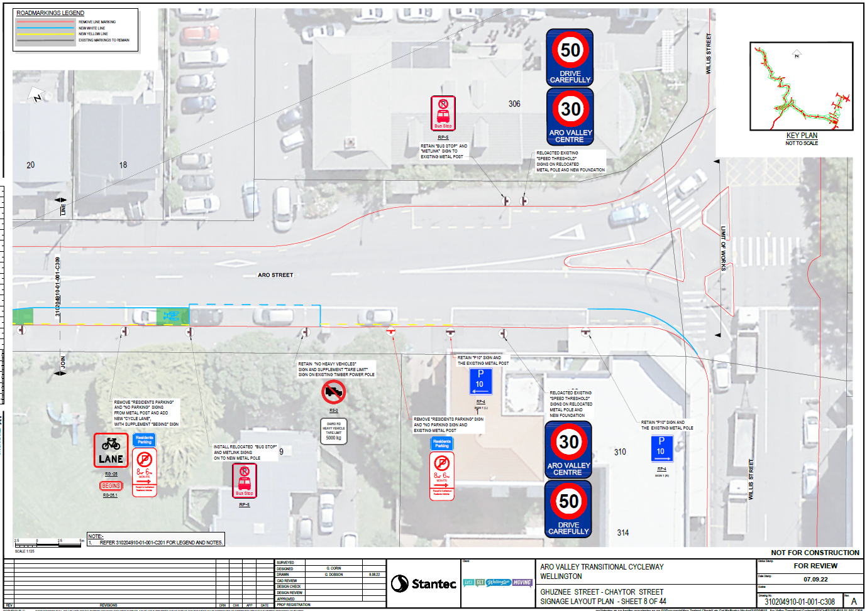

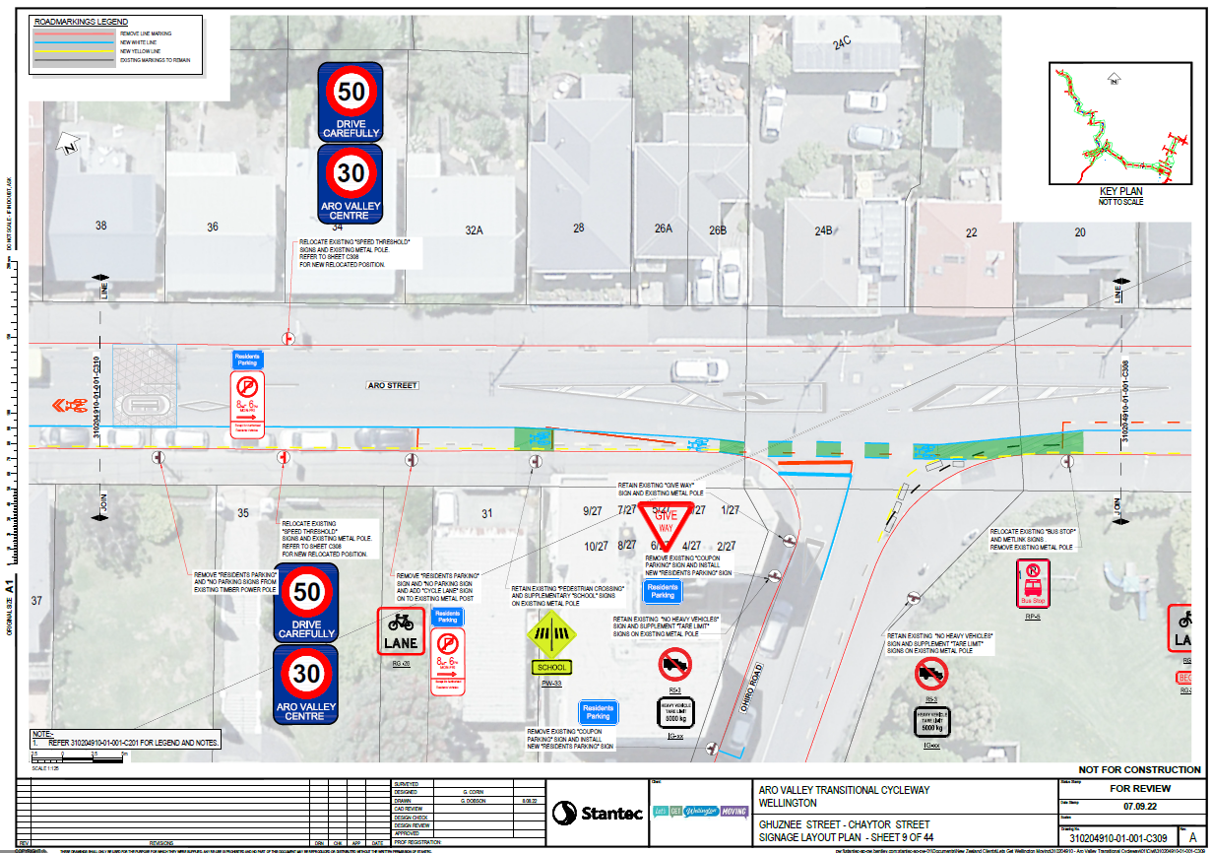

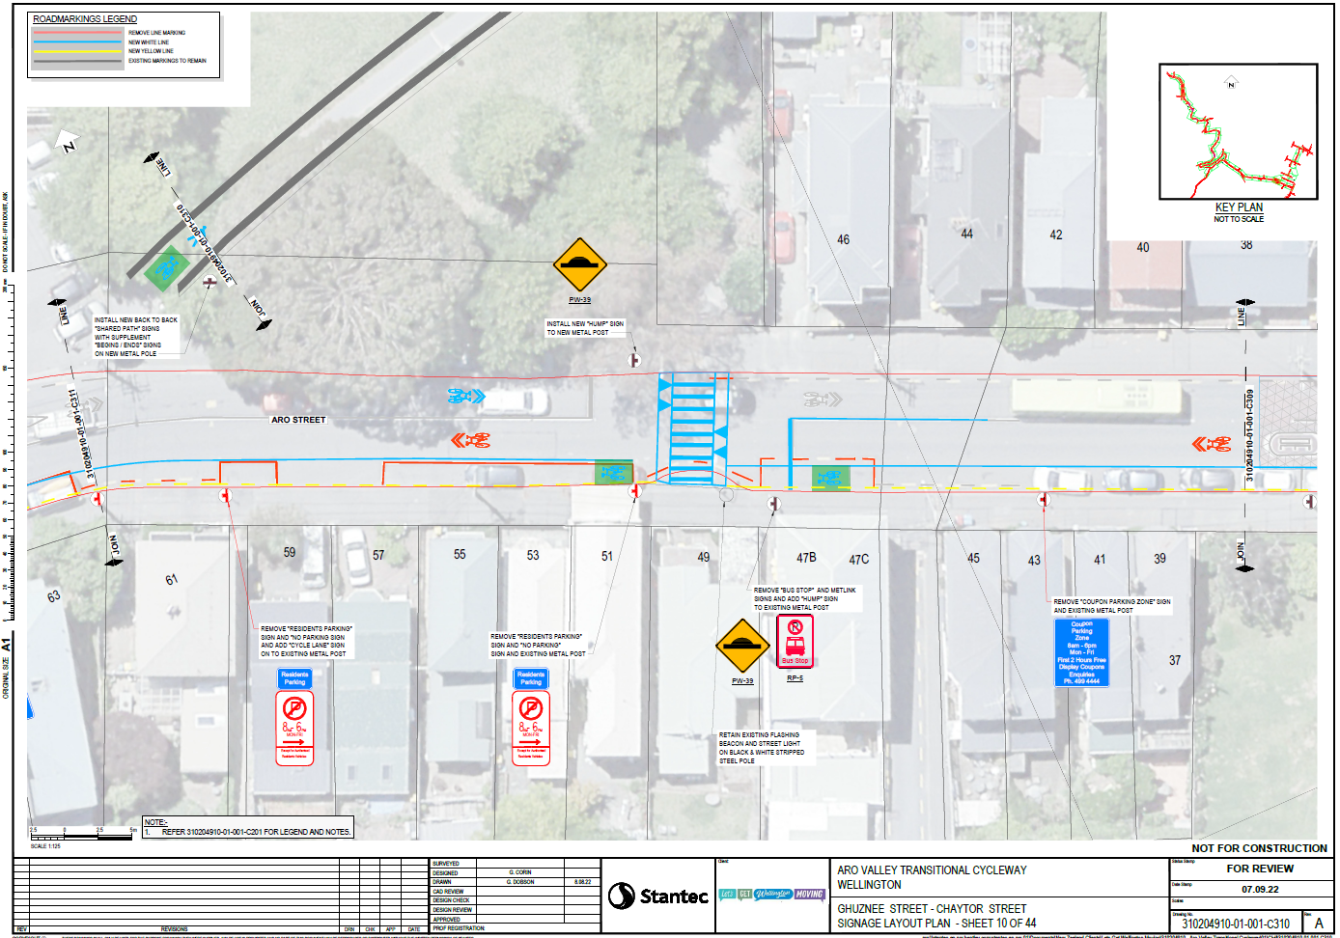
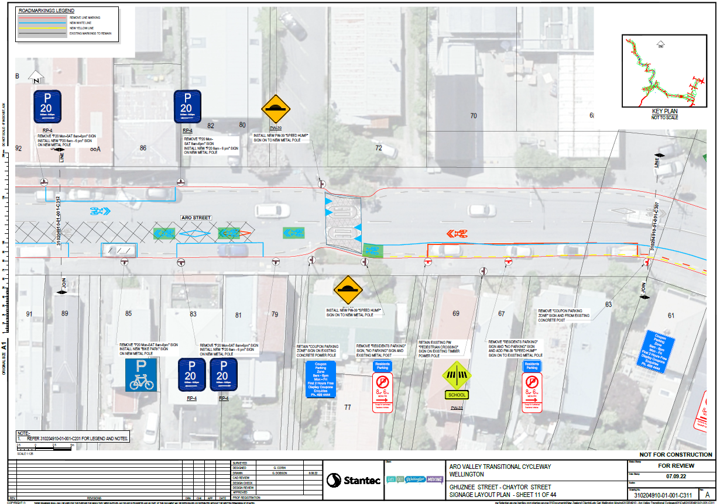
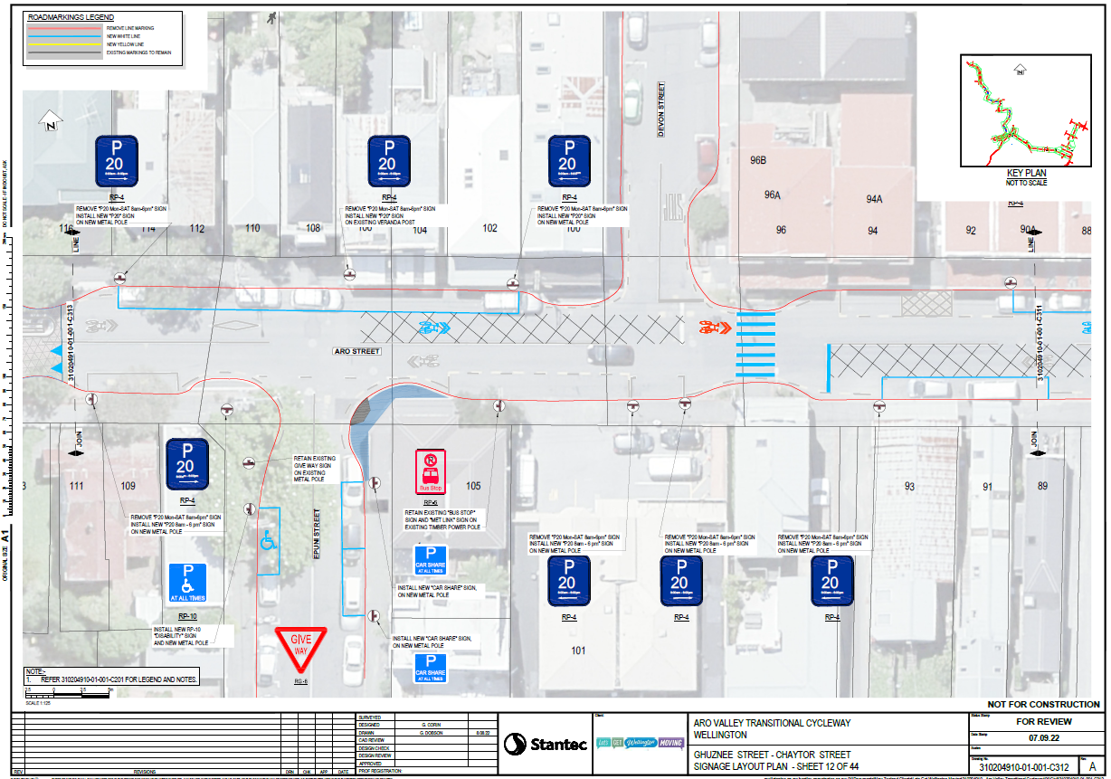
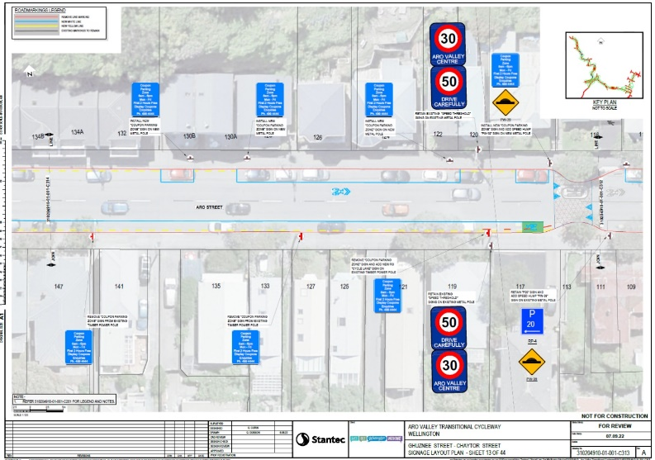

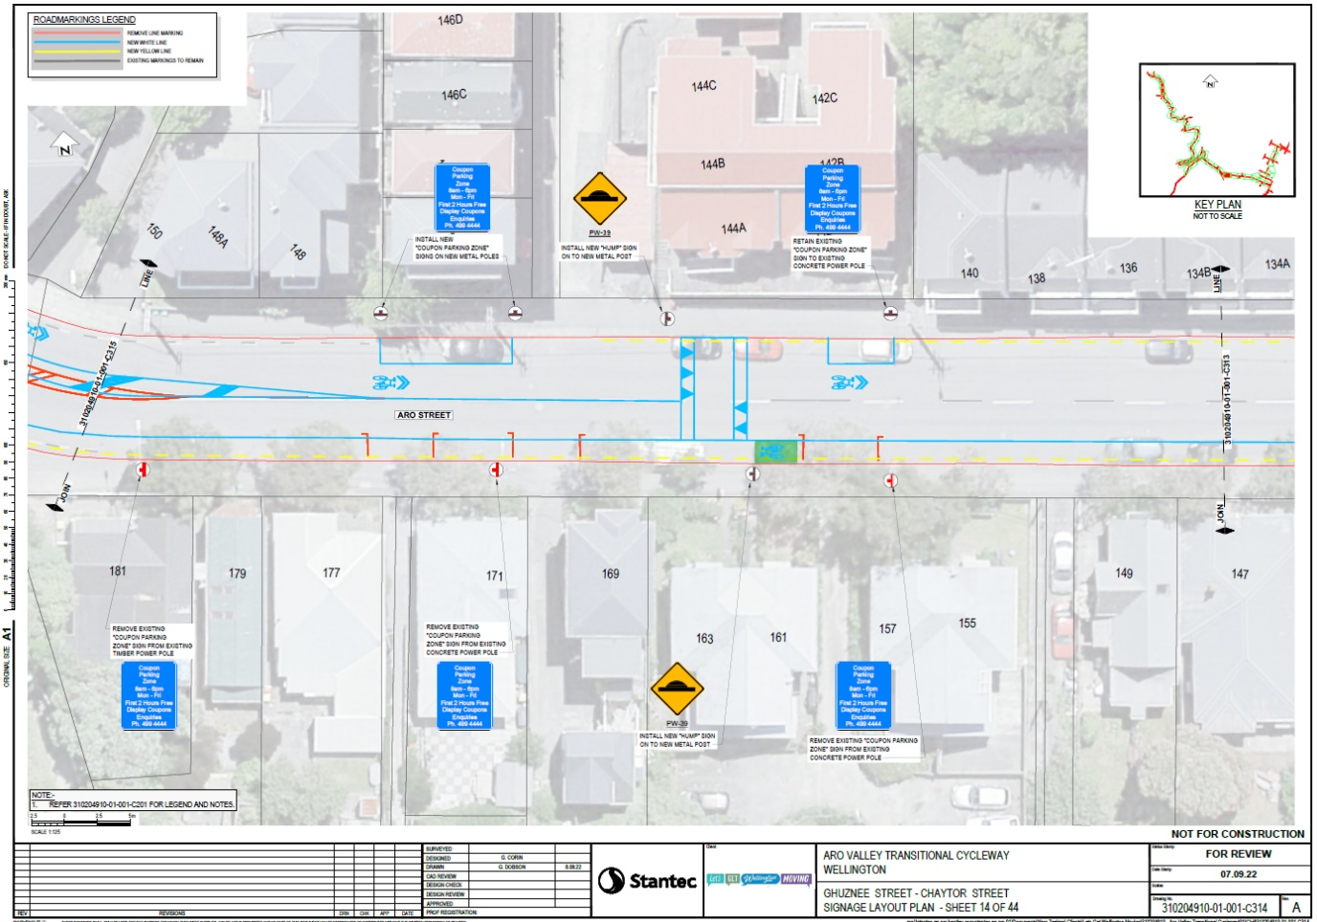
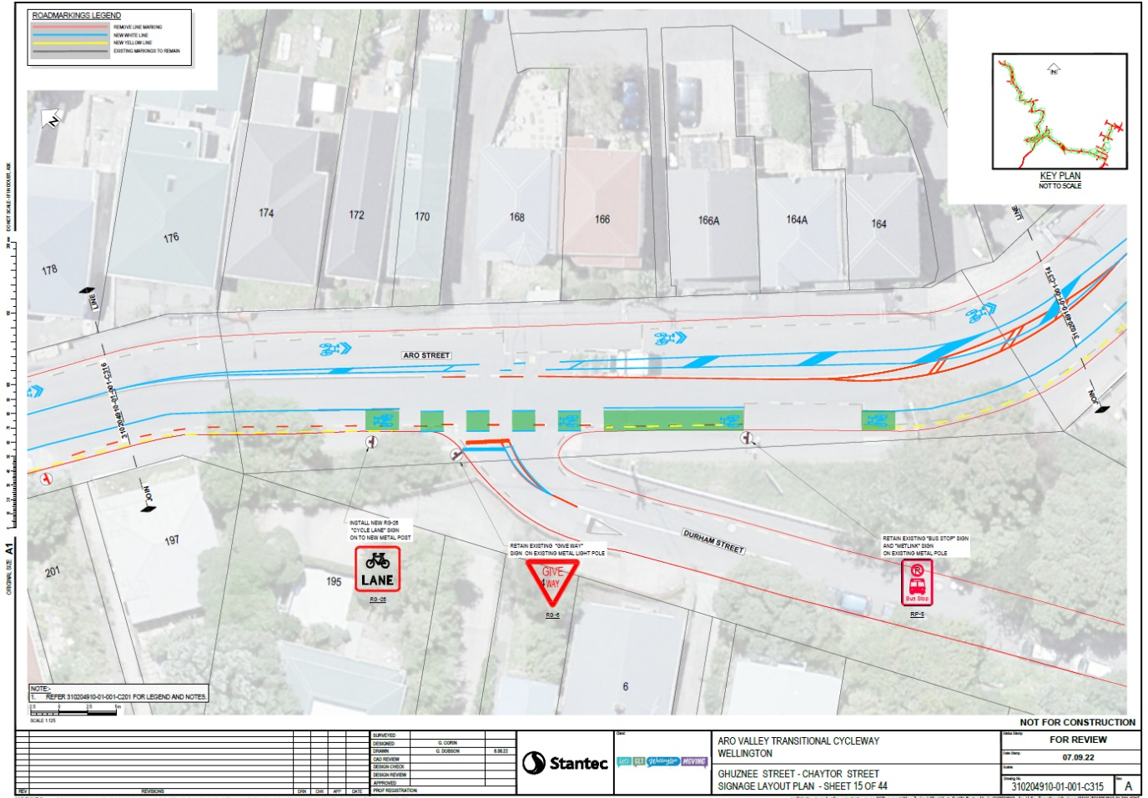

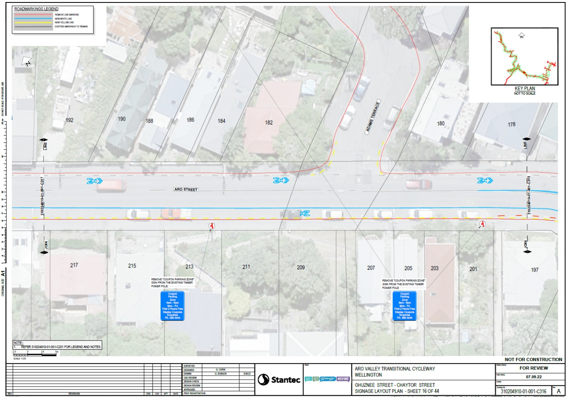

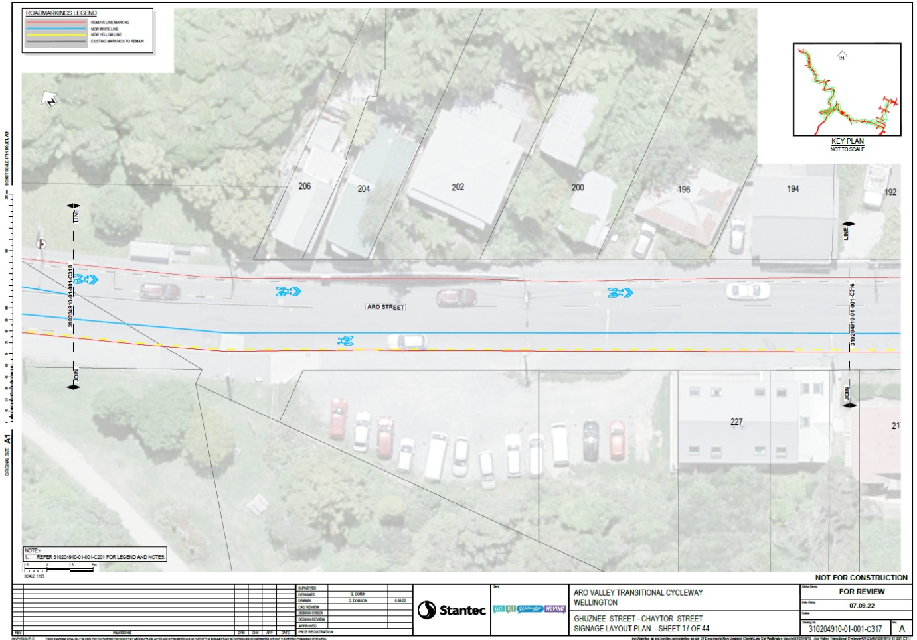

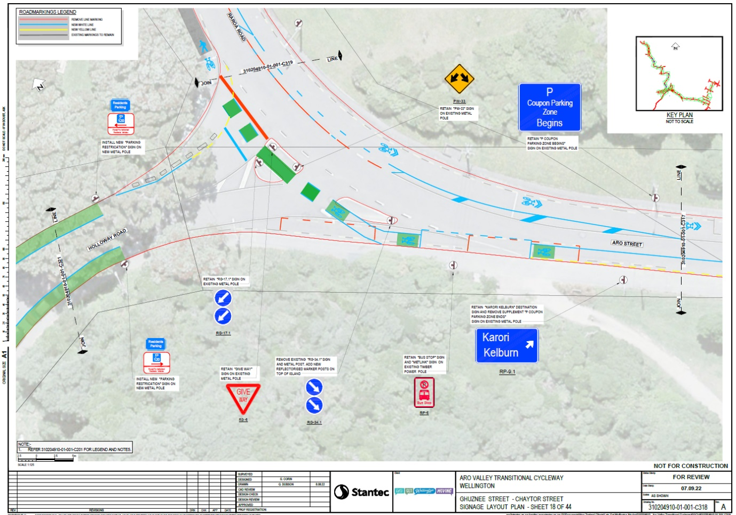

Road Marking plans for Aro Street showing extent of Stages 1, 2 and 3.

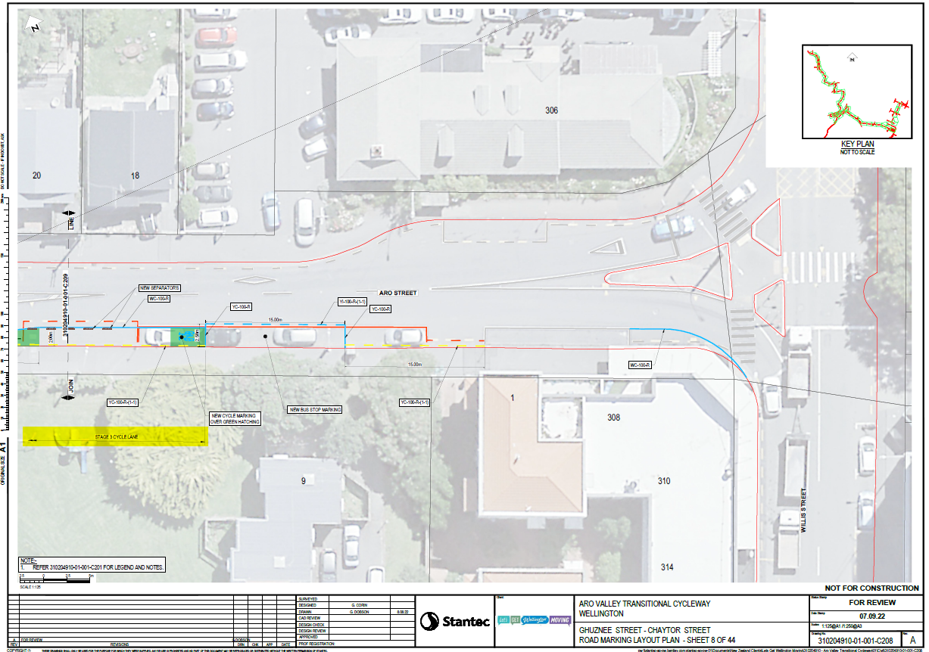

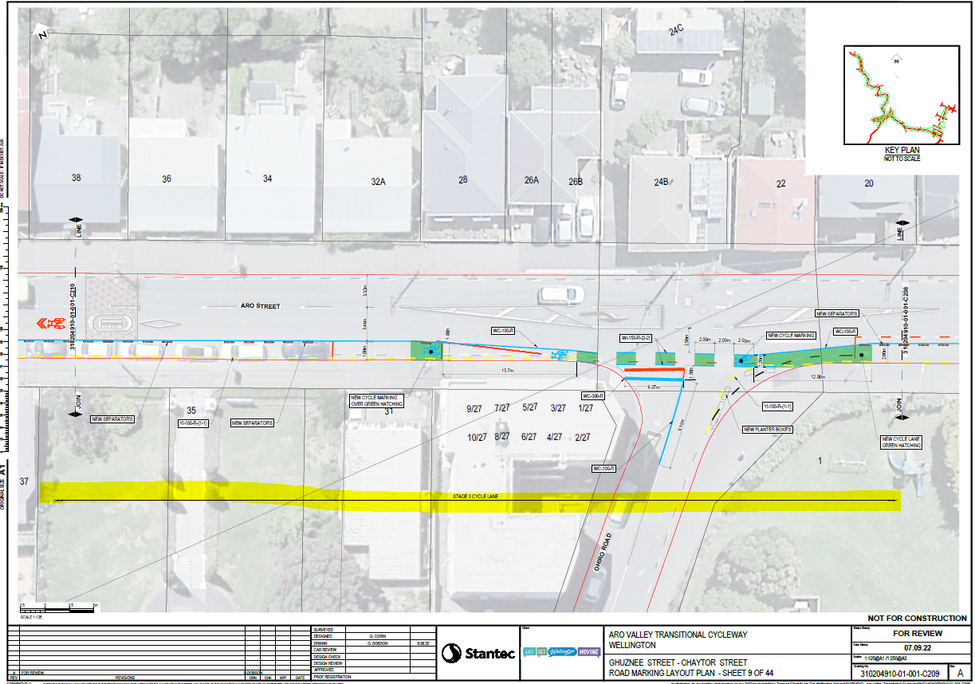

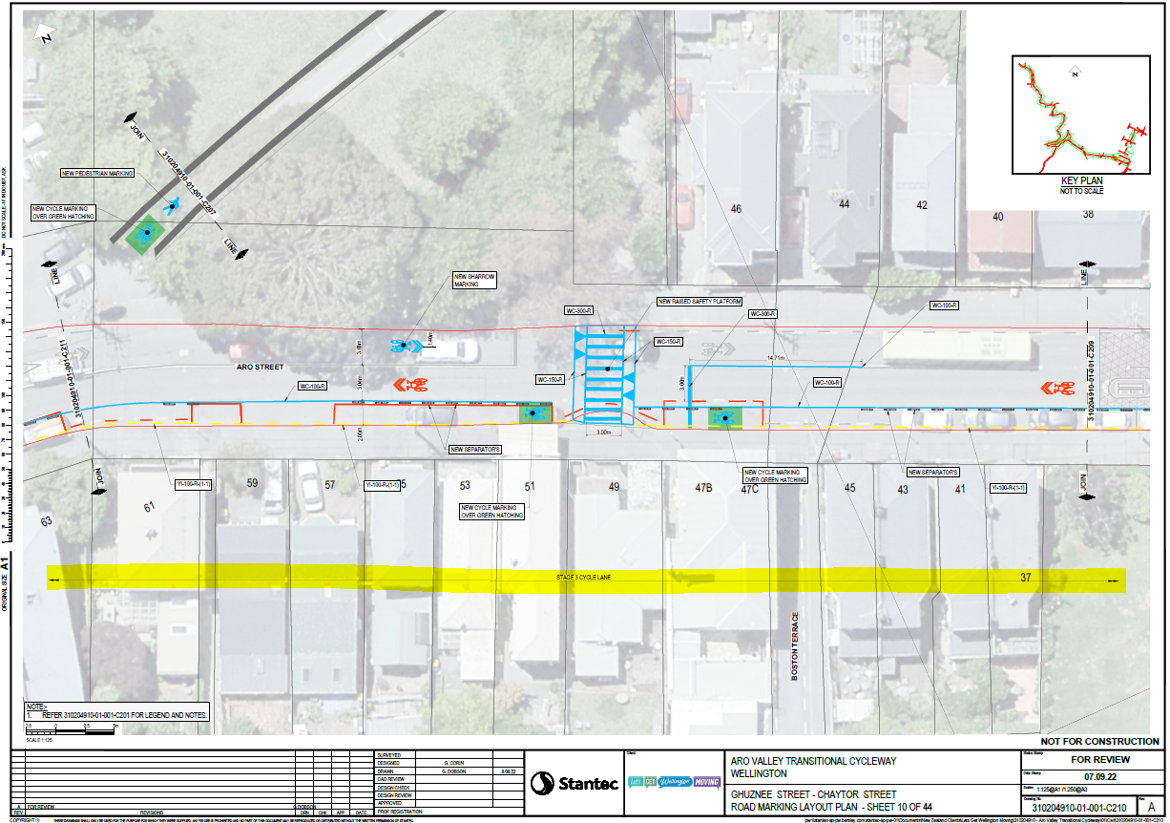
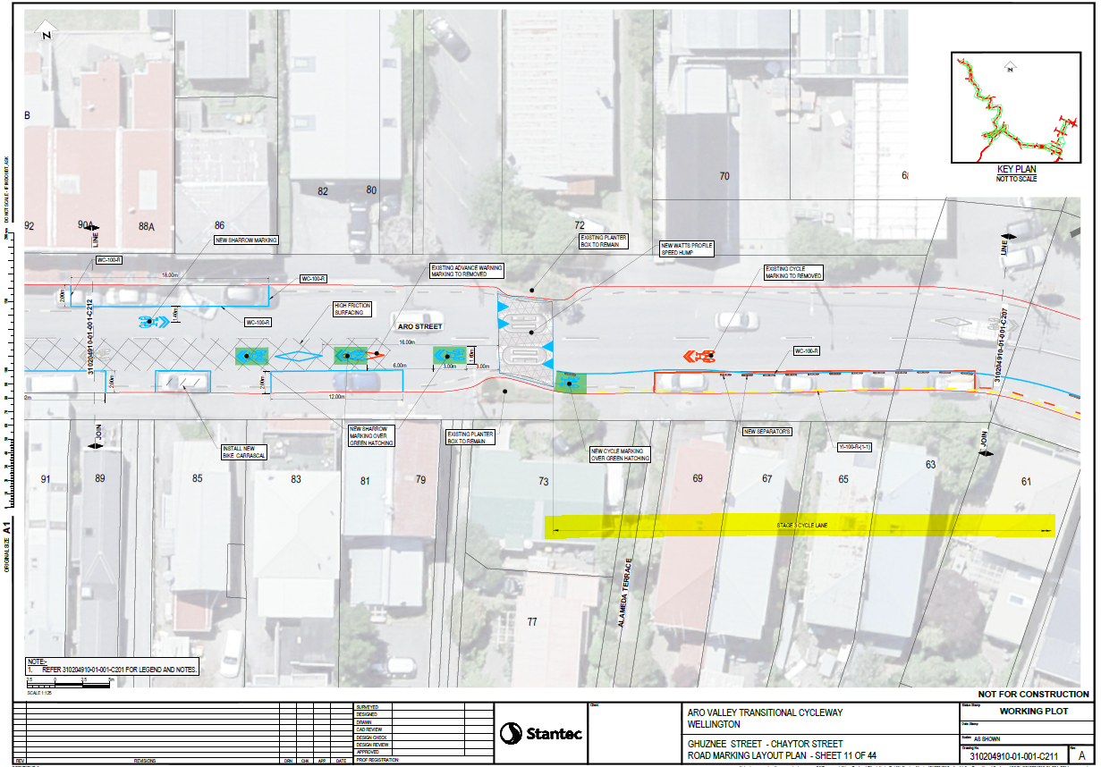
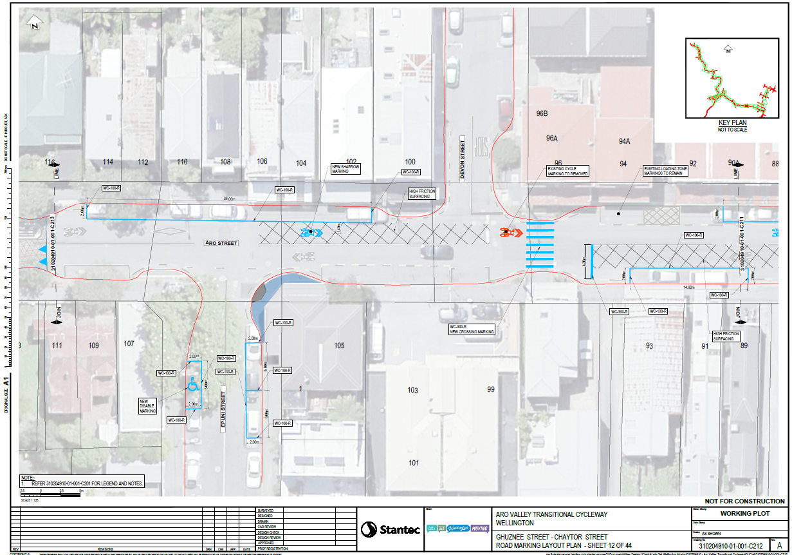

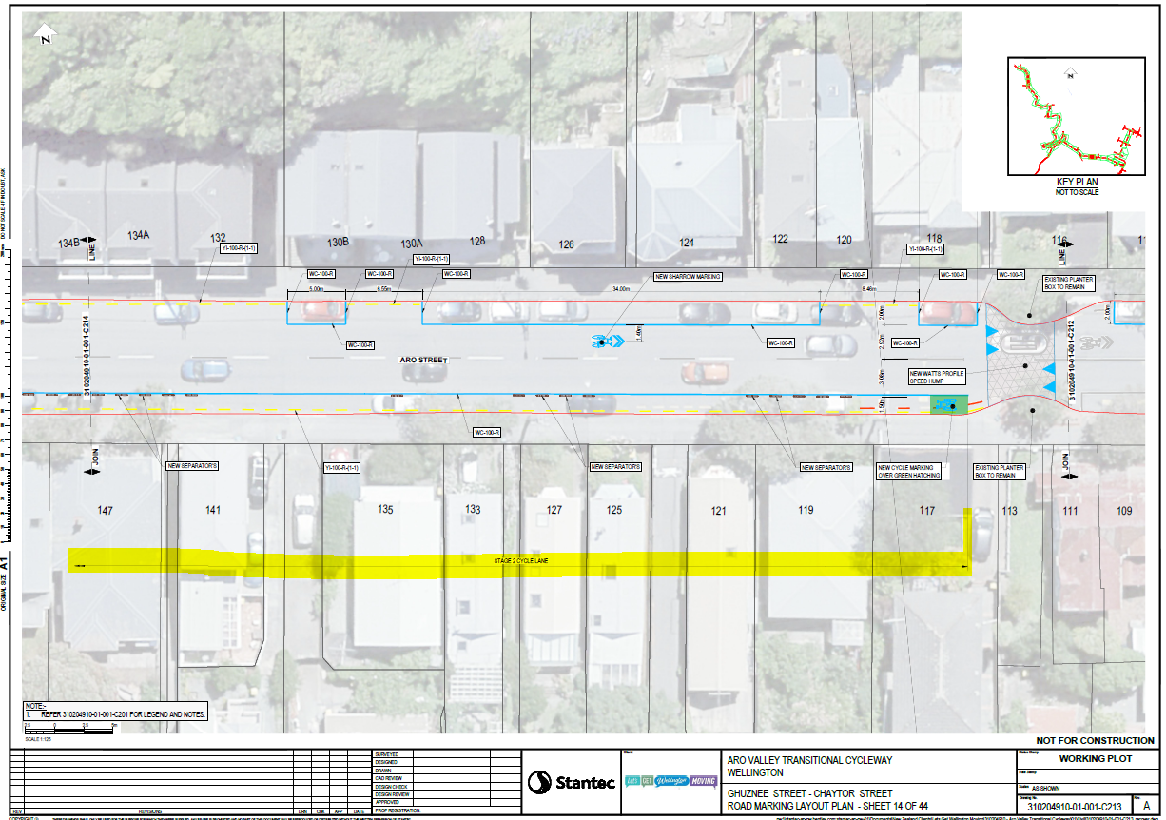

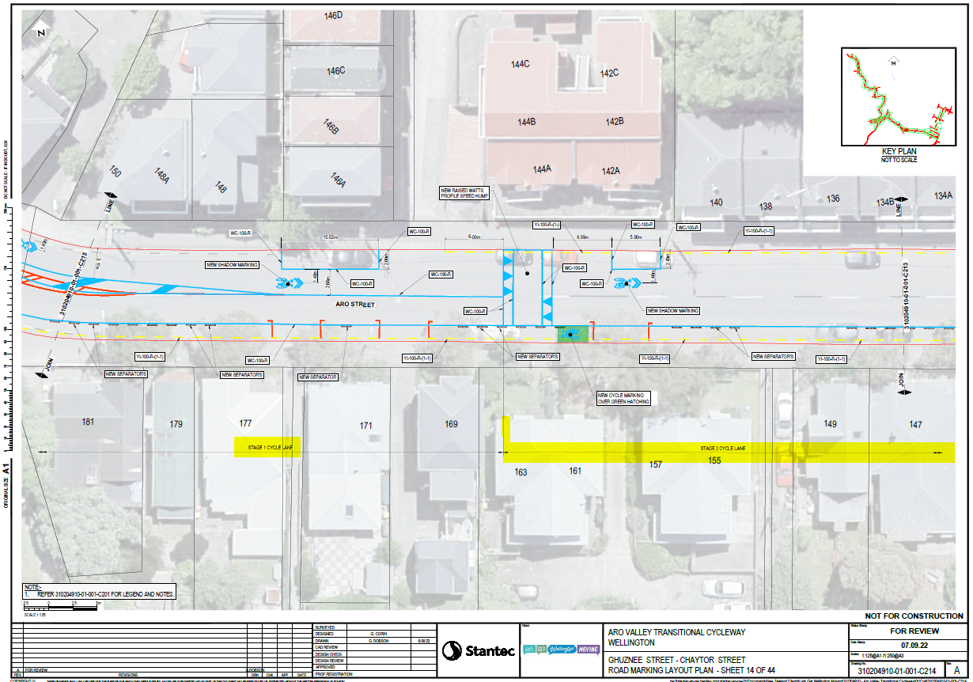

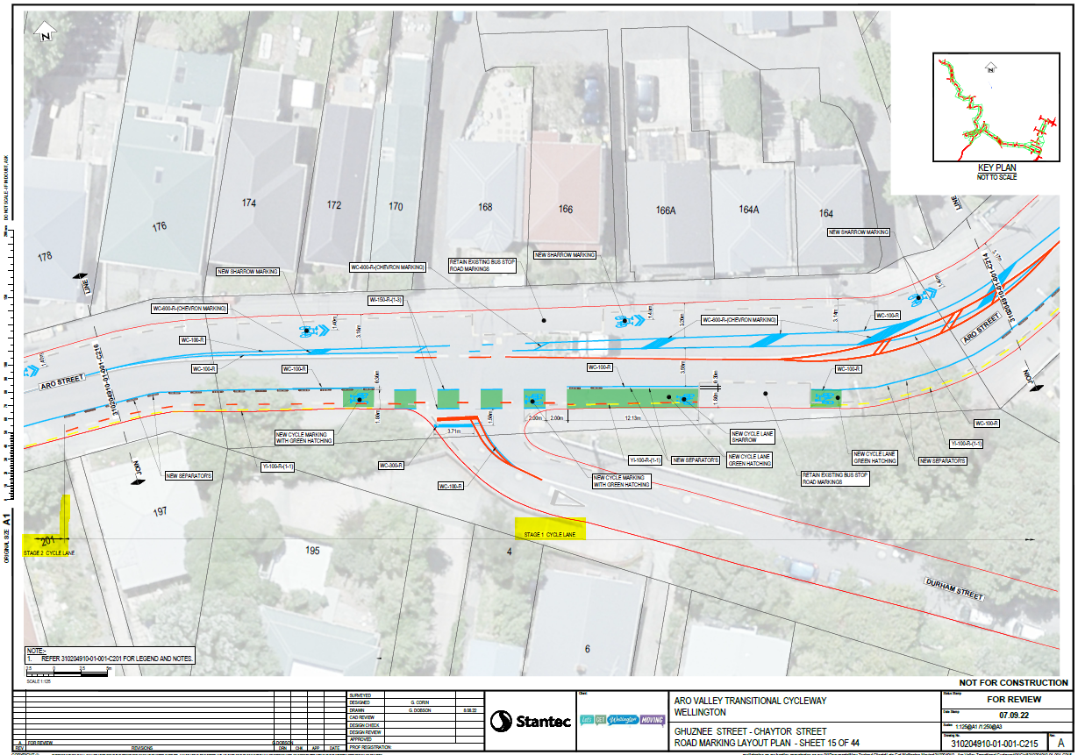

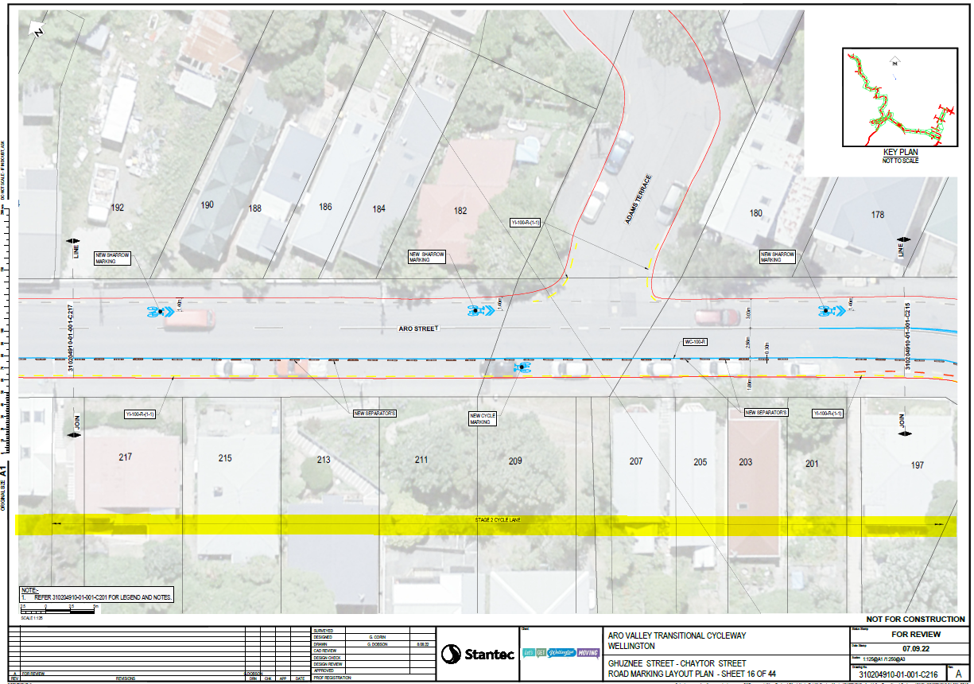

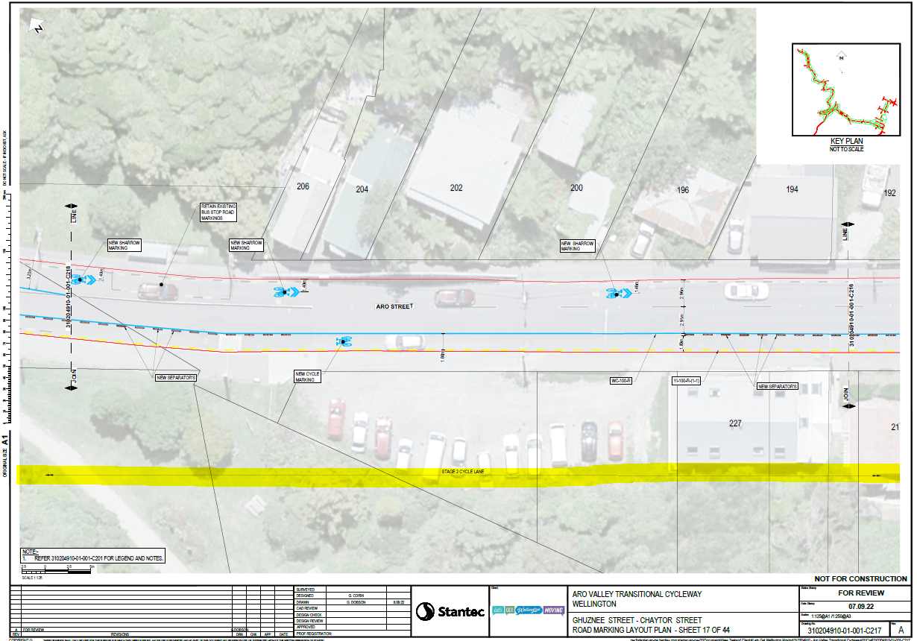

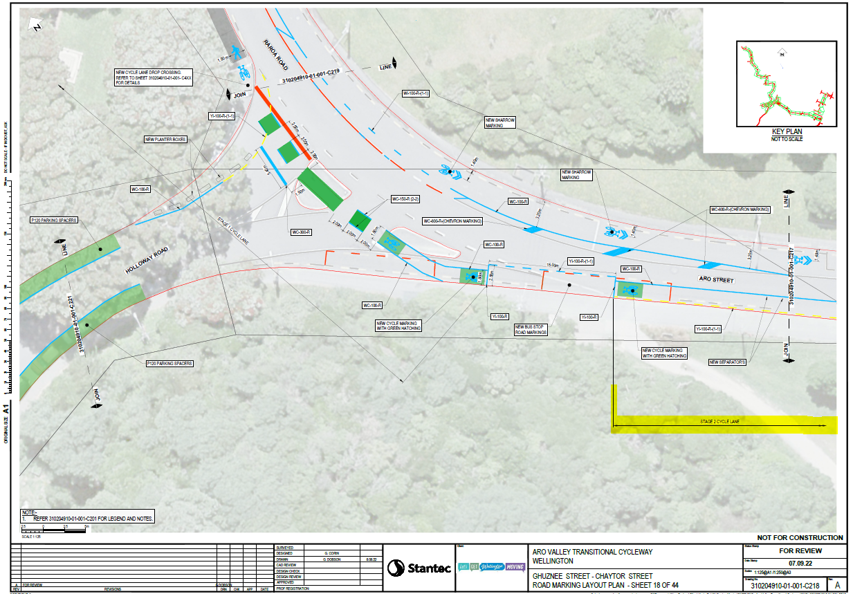

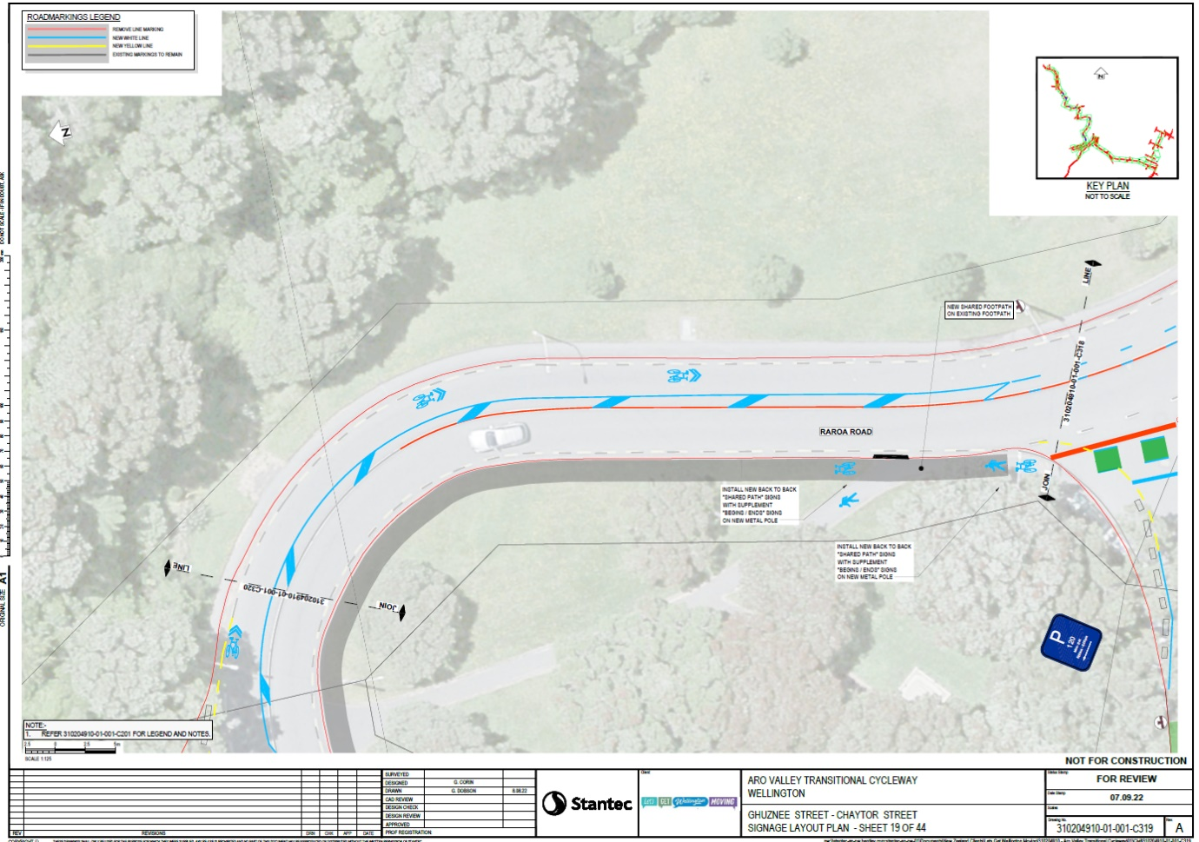

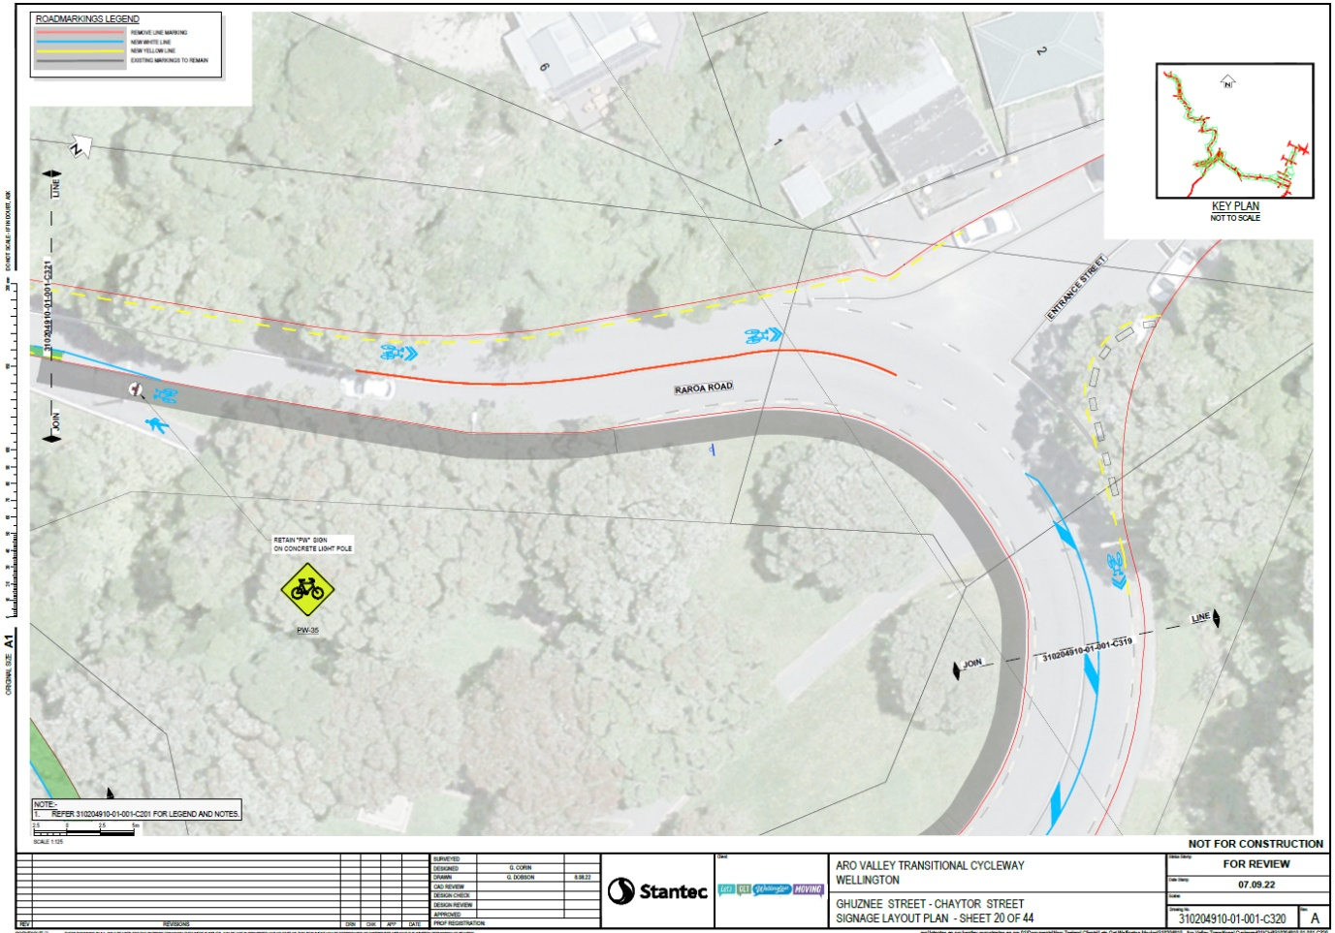

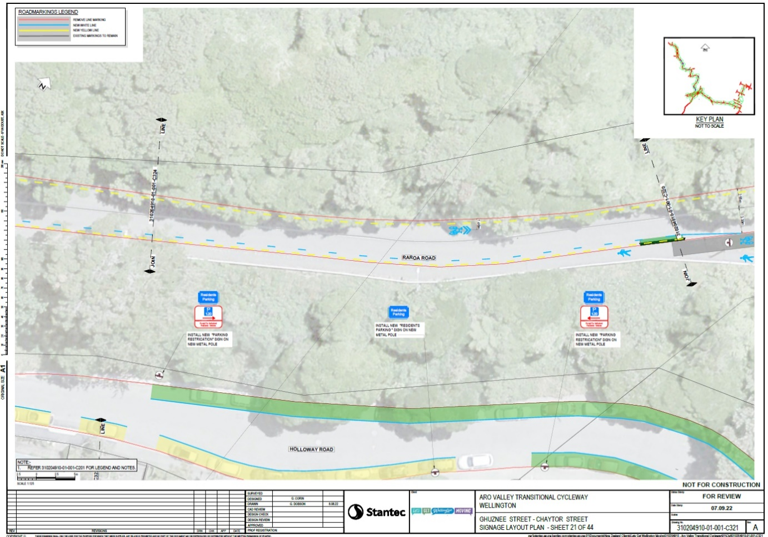

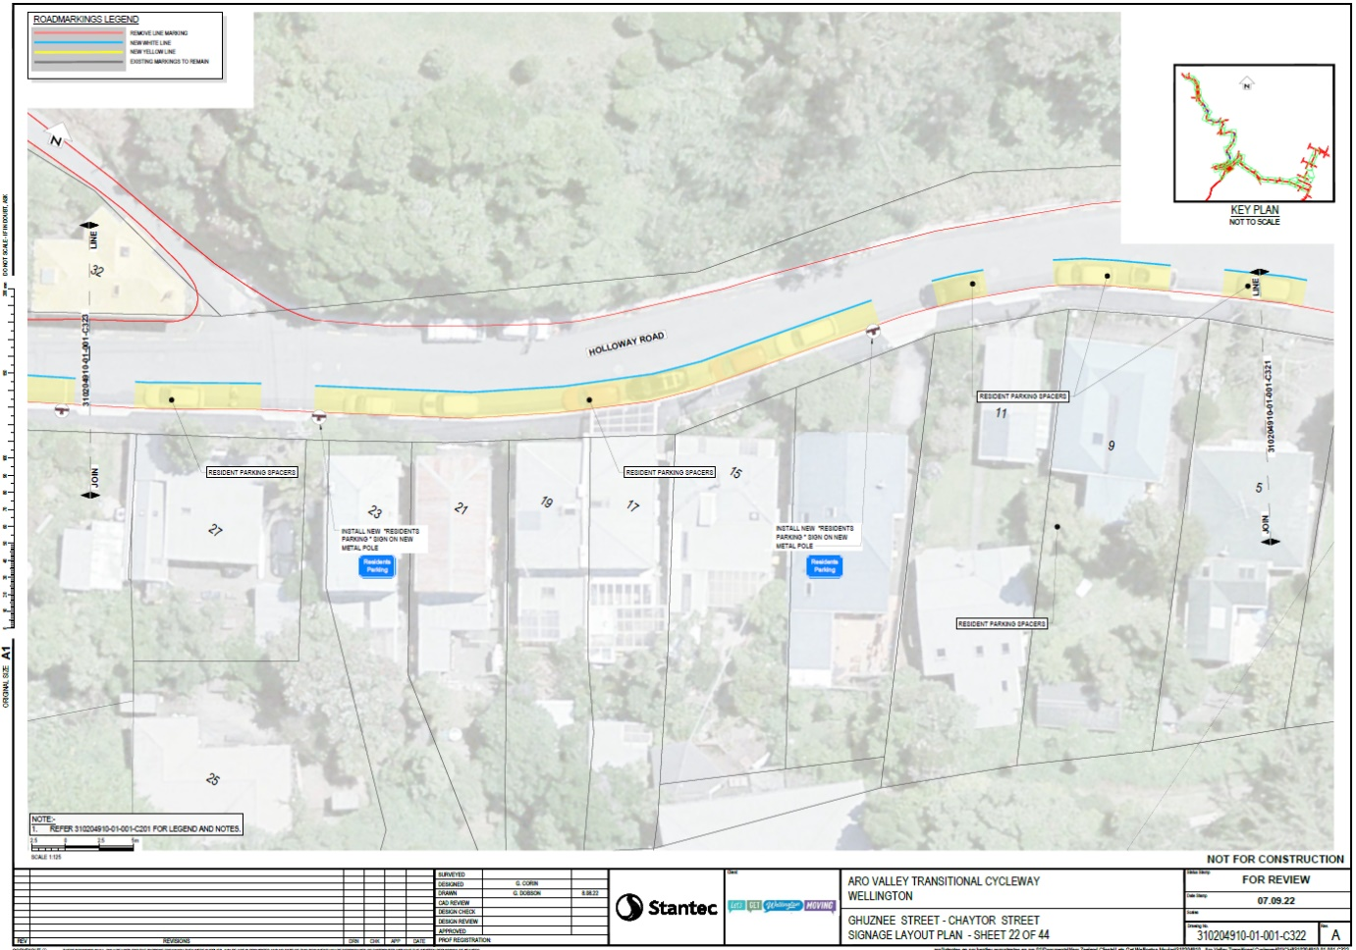

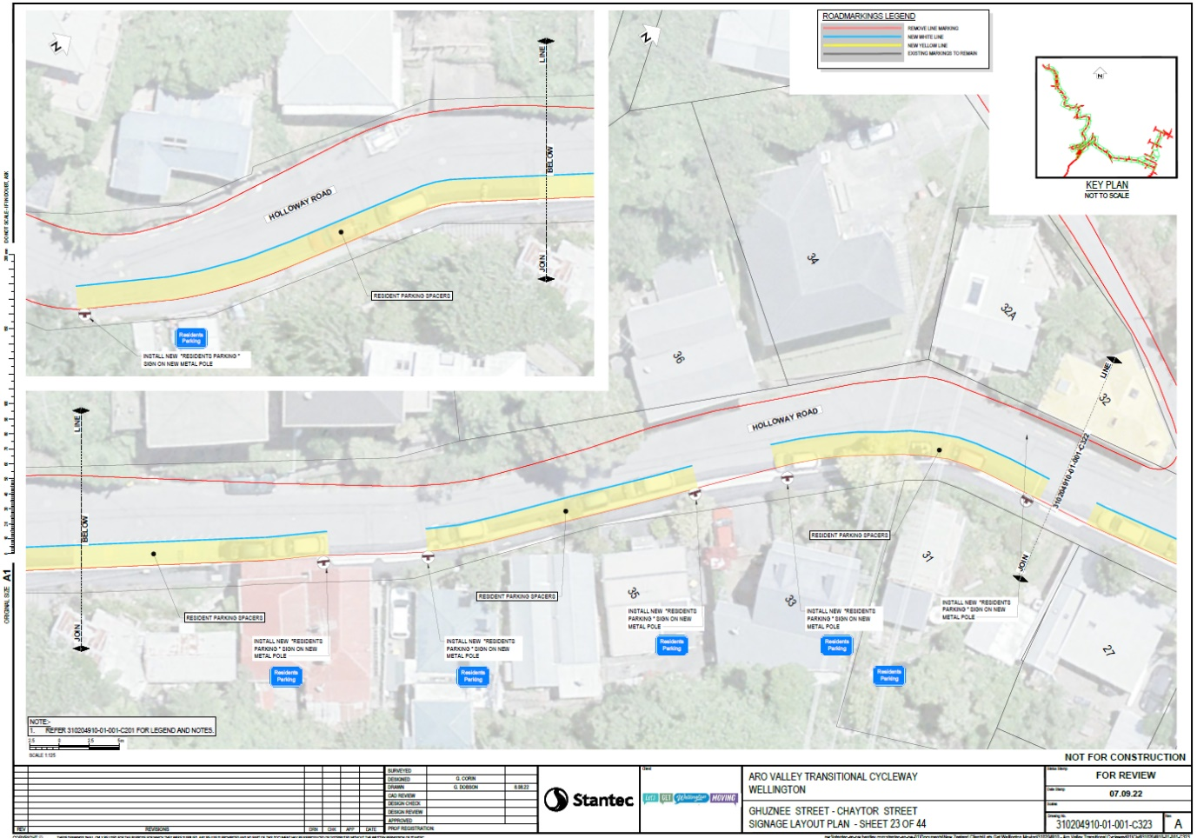

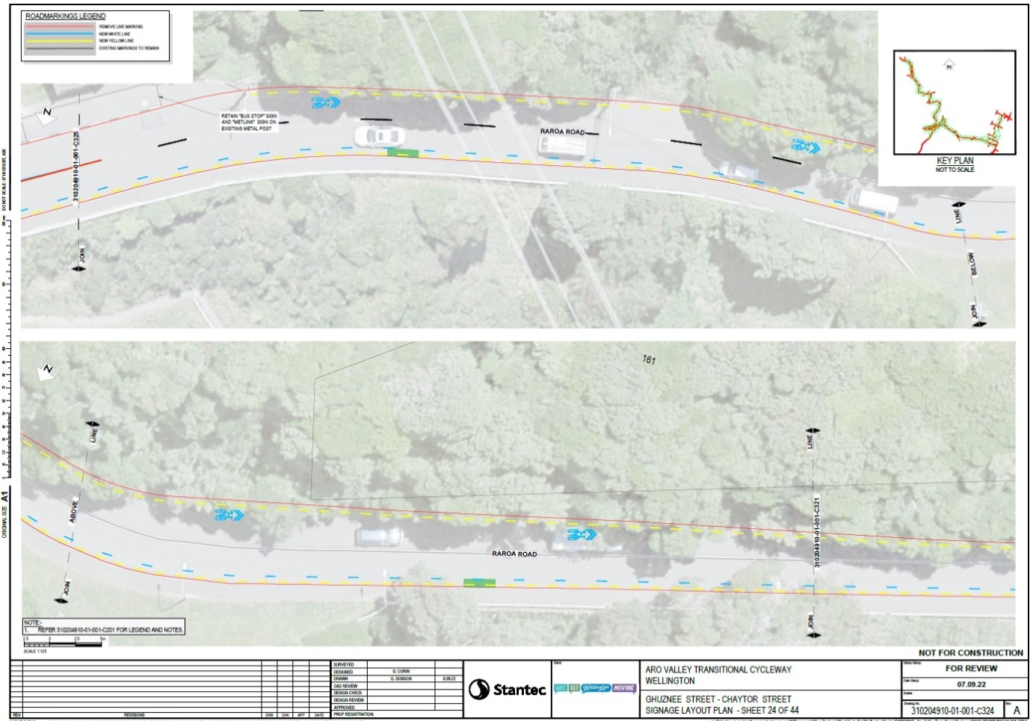

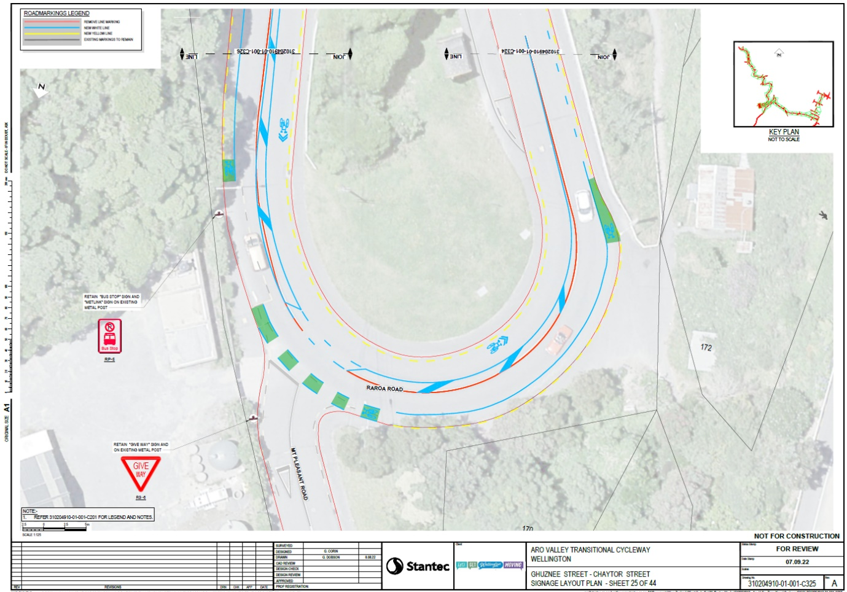

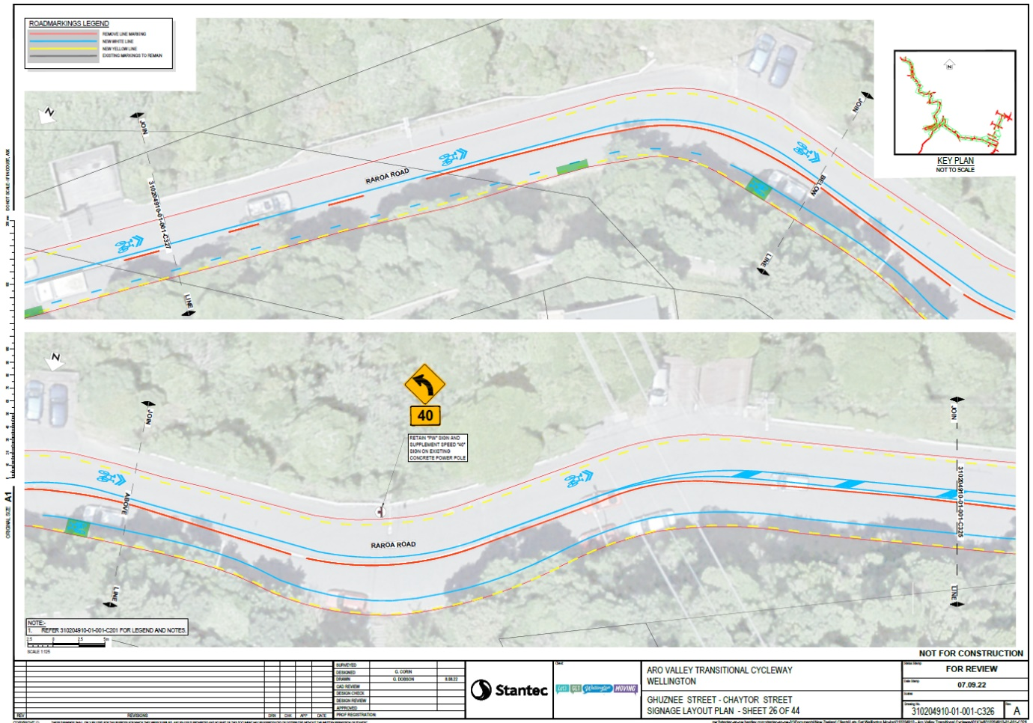

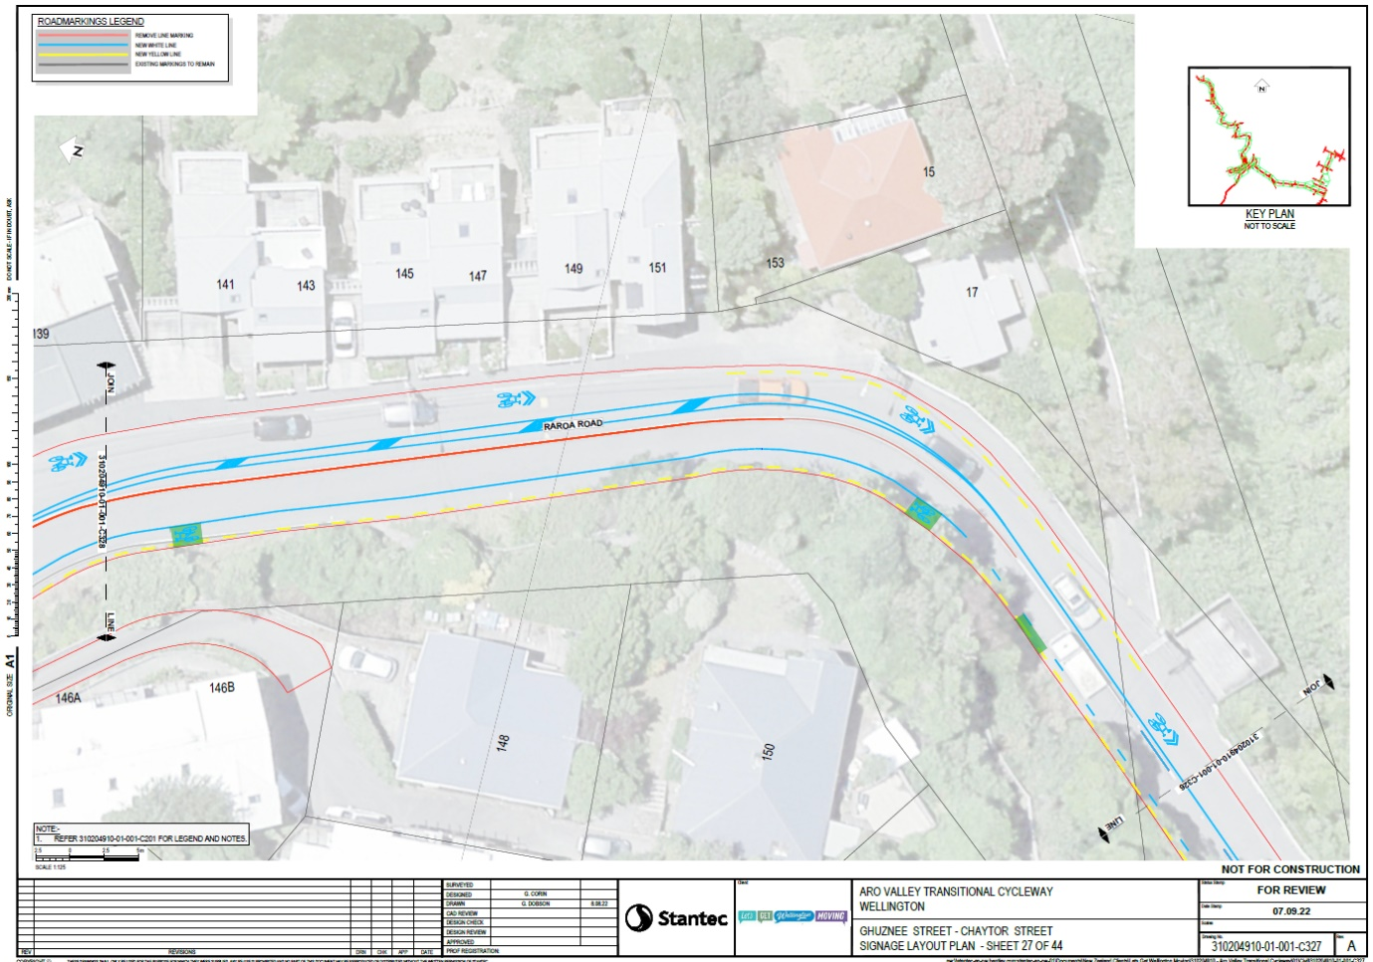

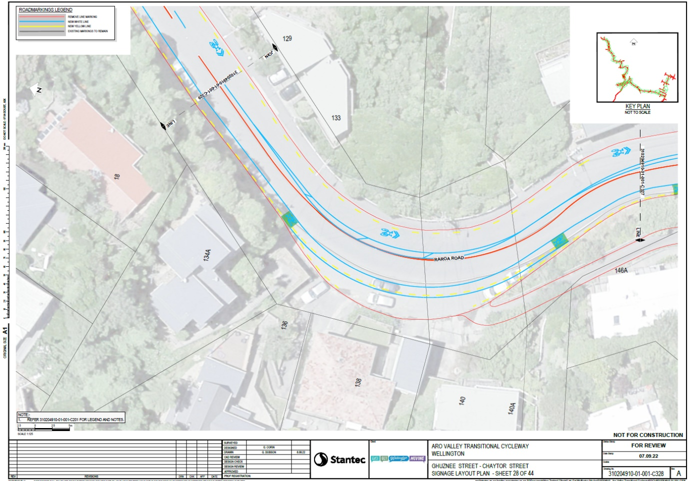

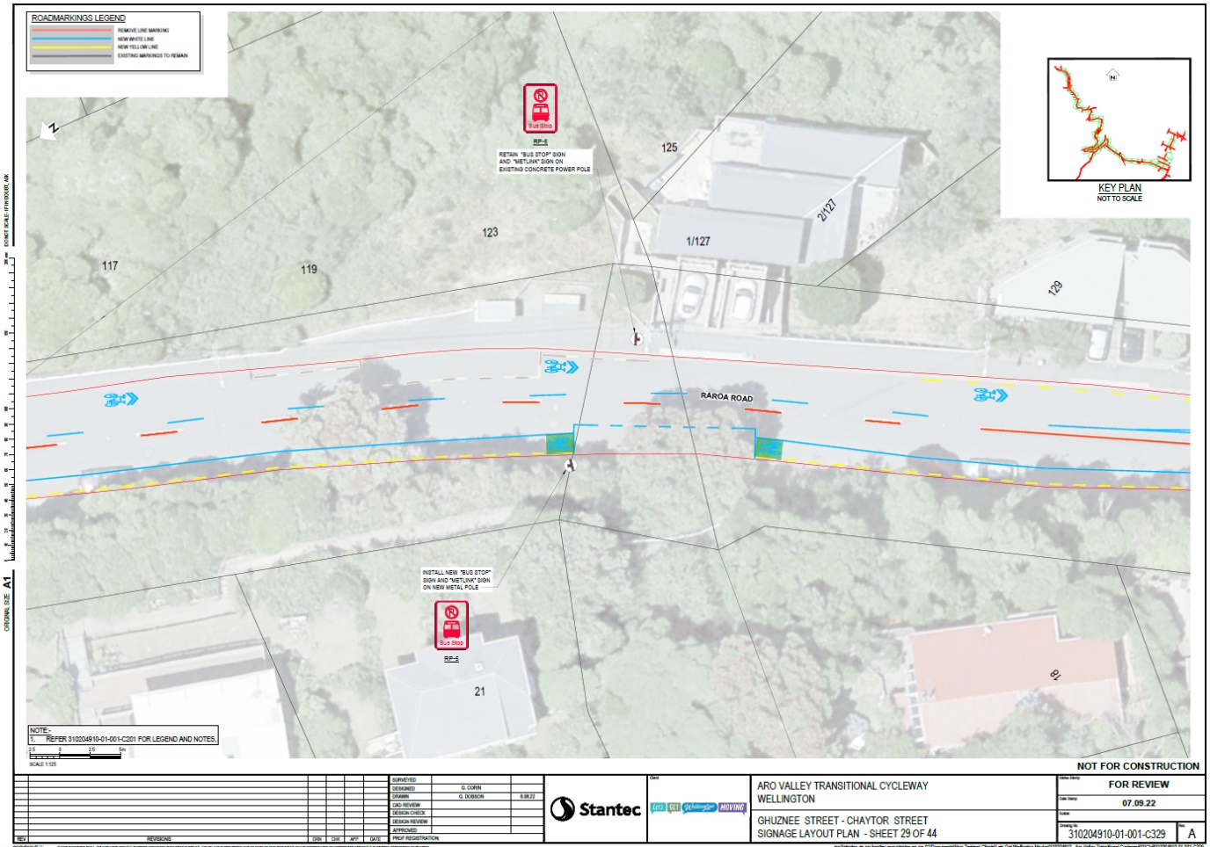

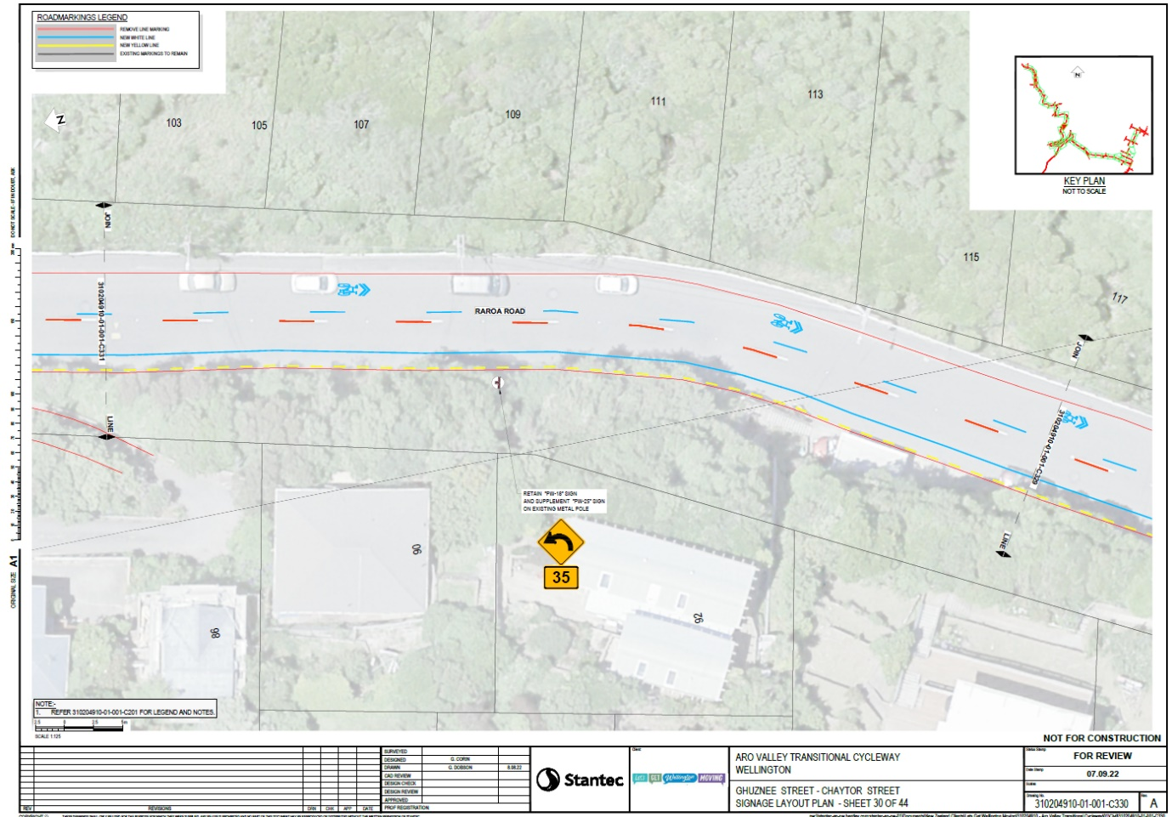

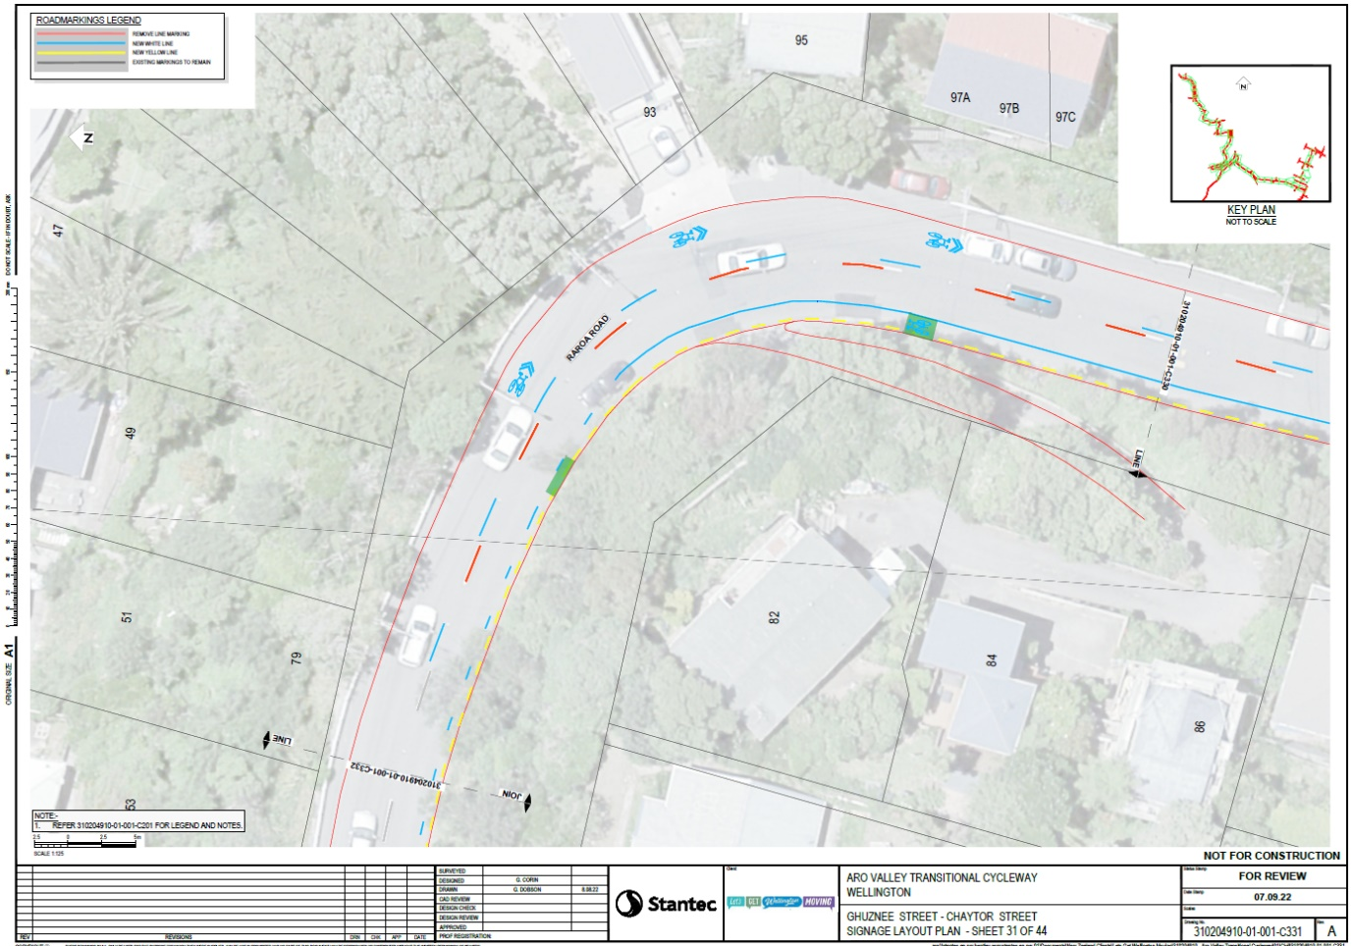

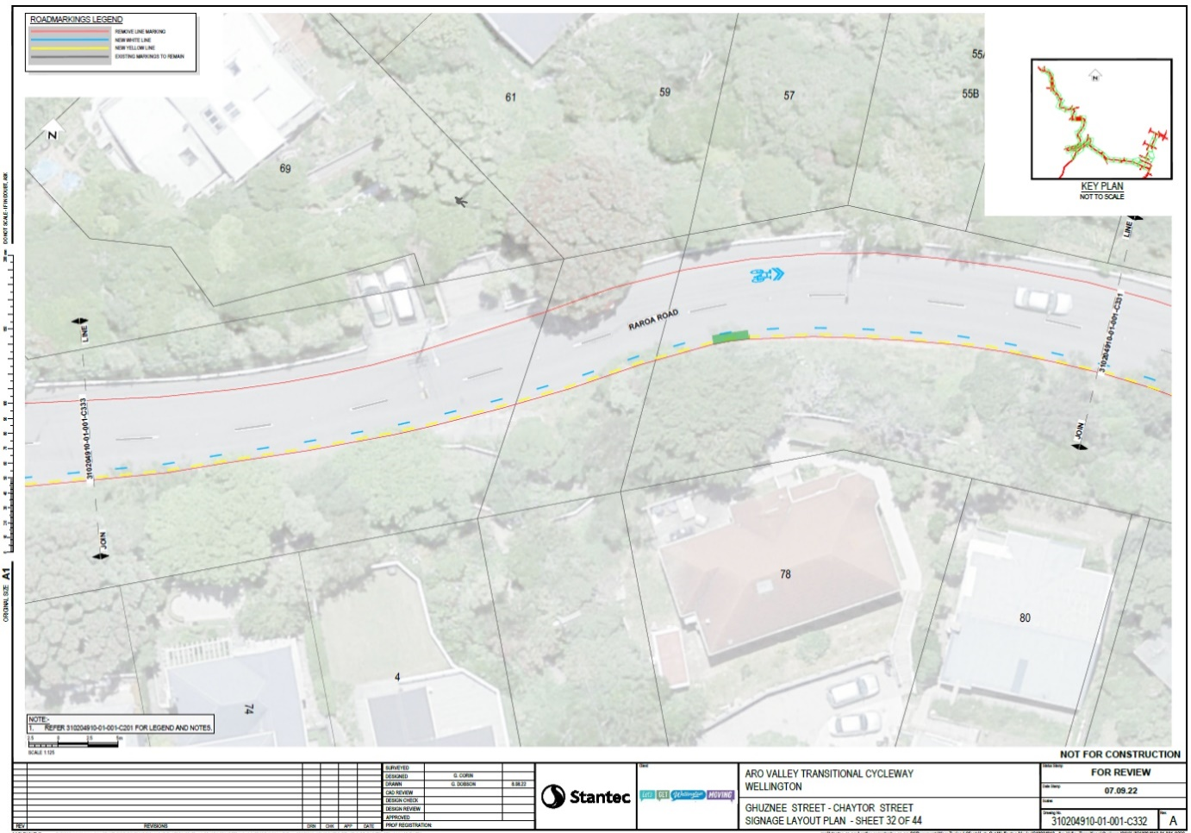

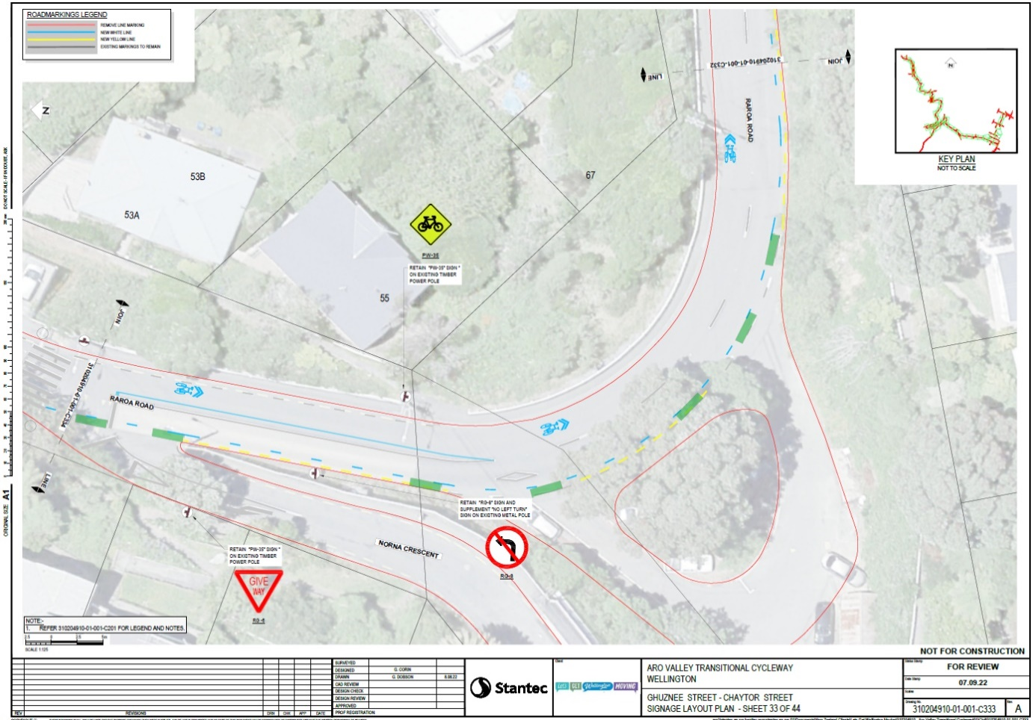

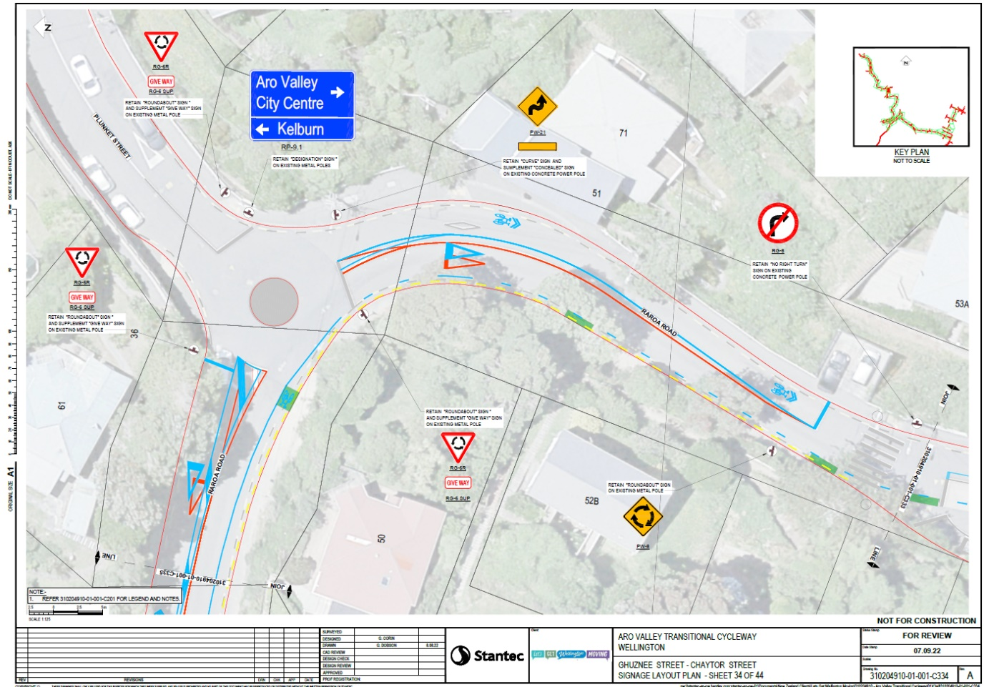

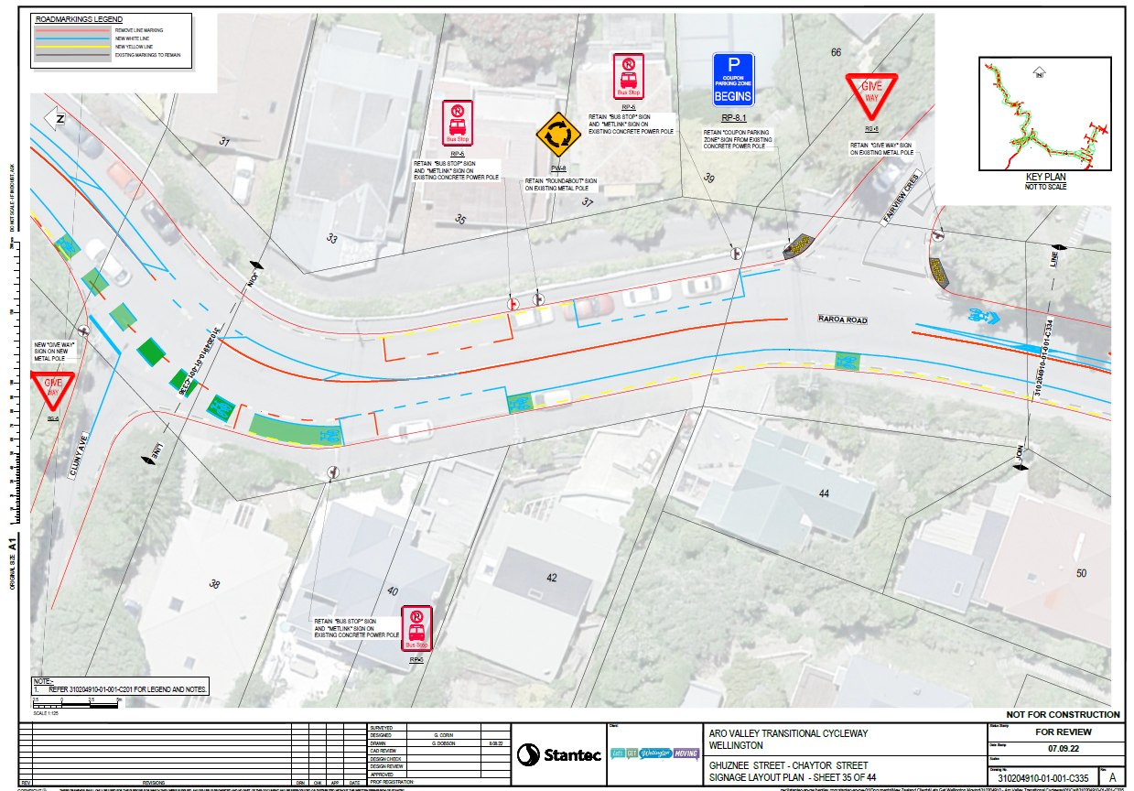
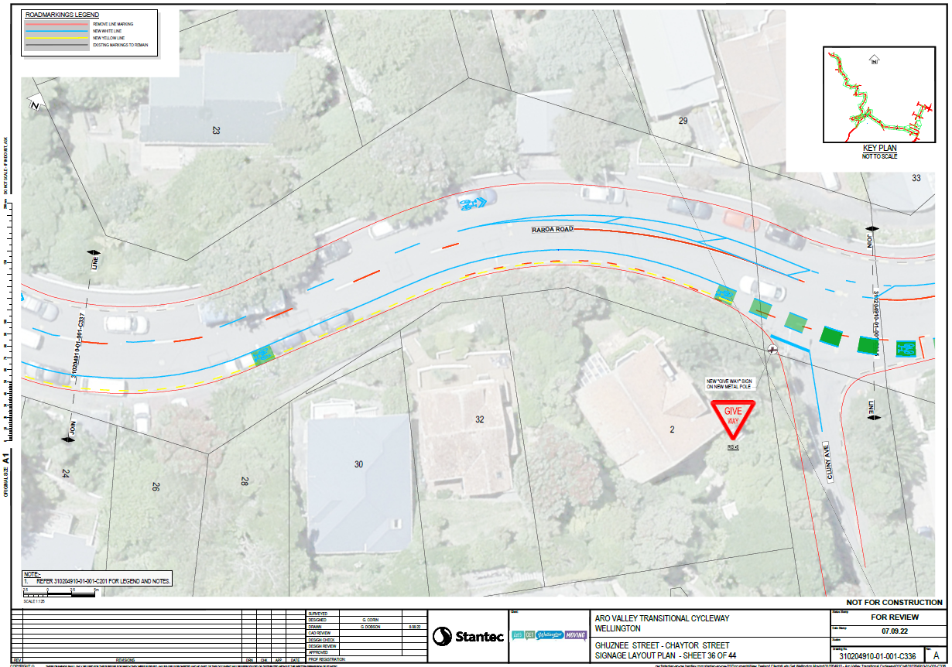

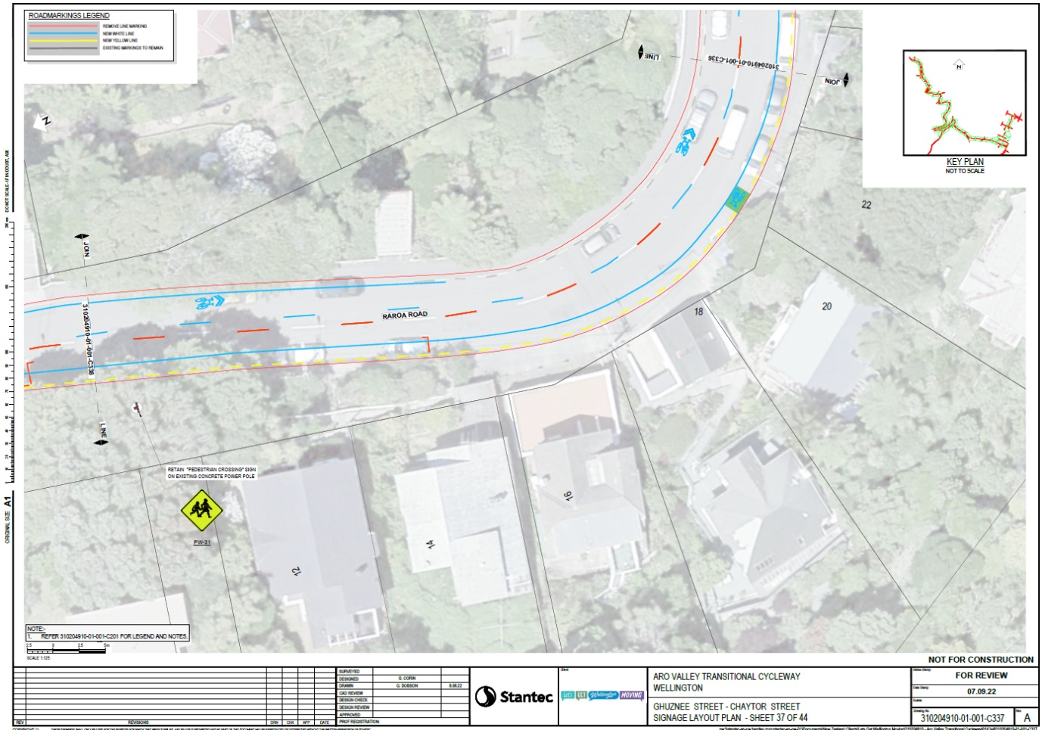

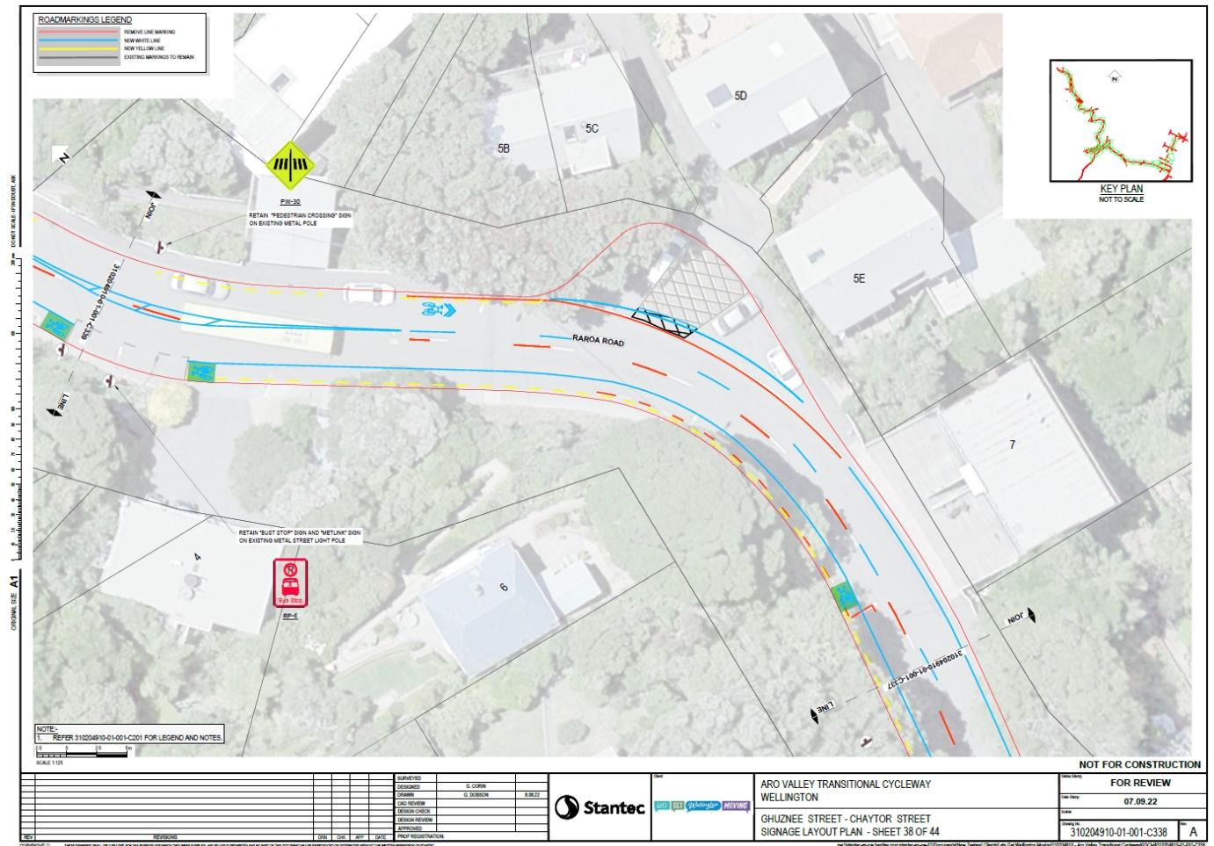

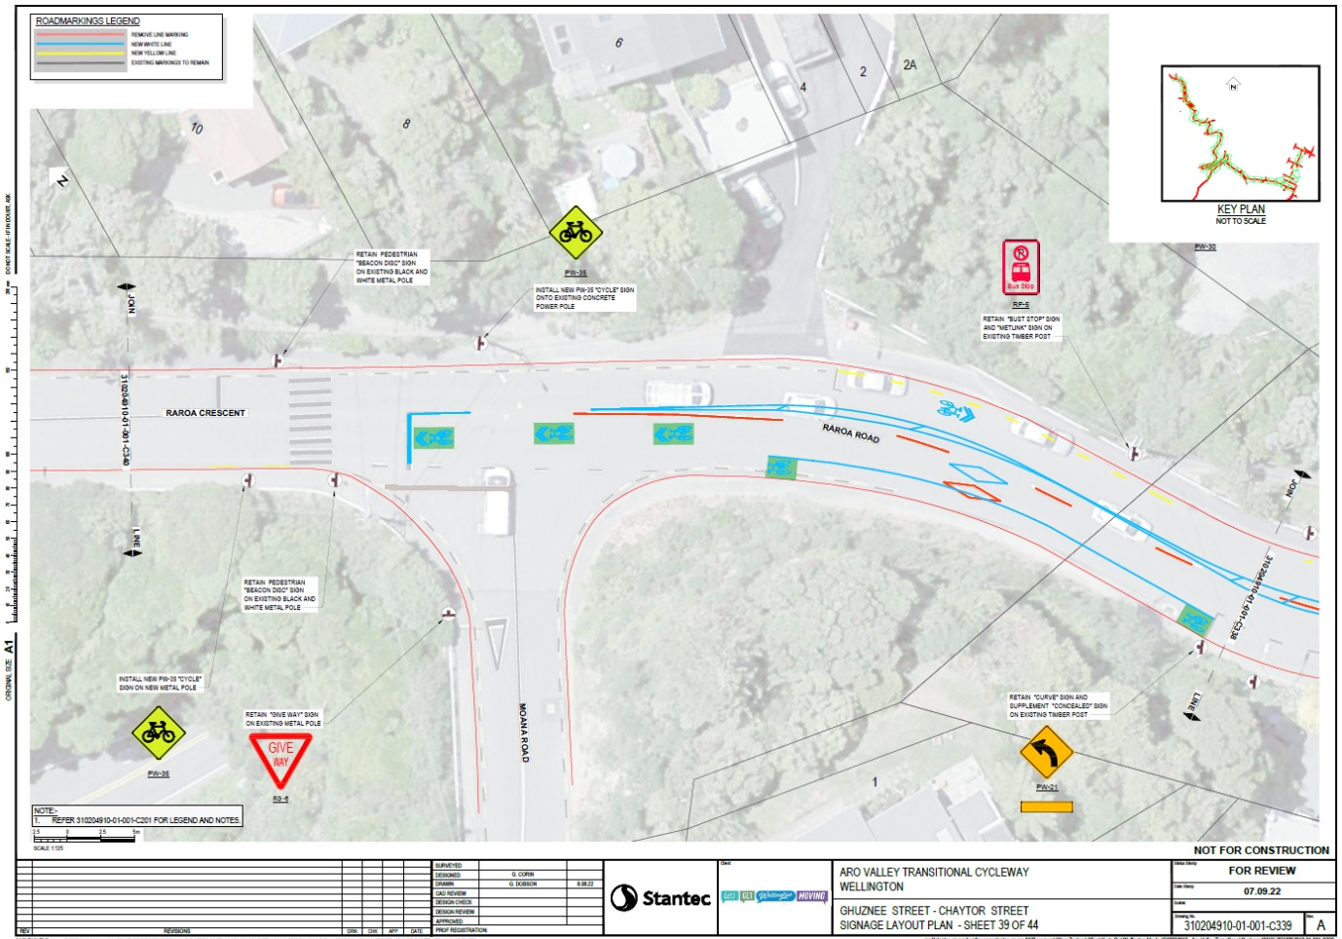

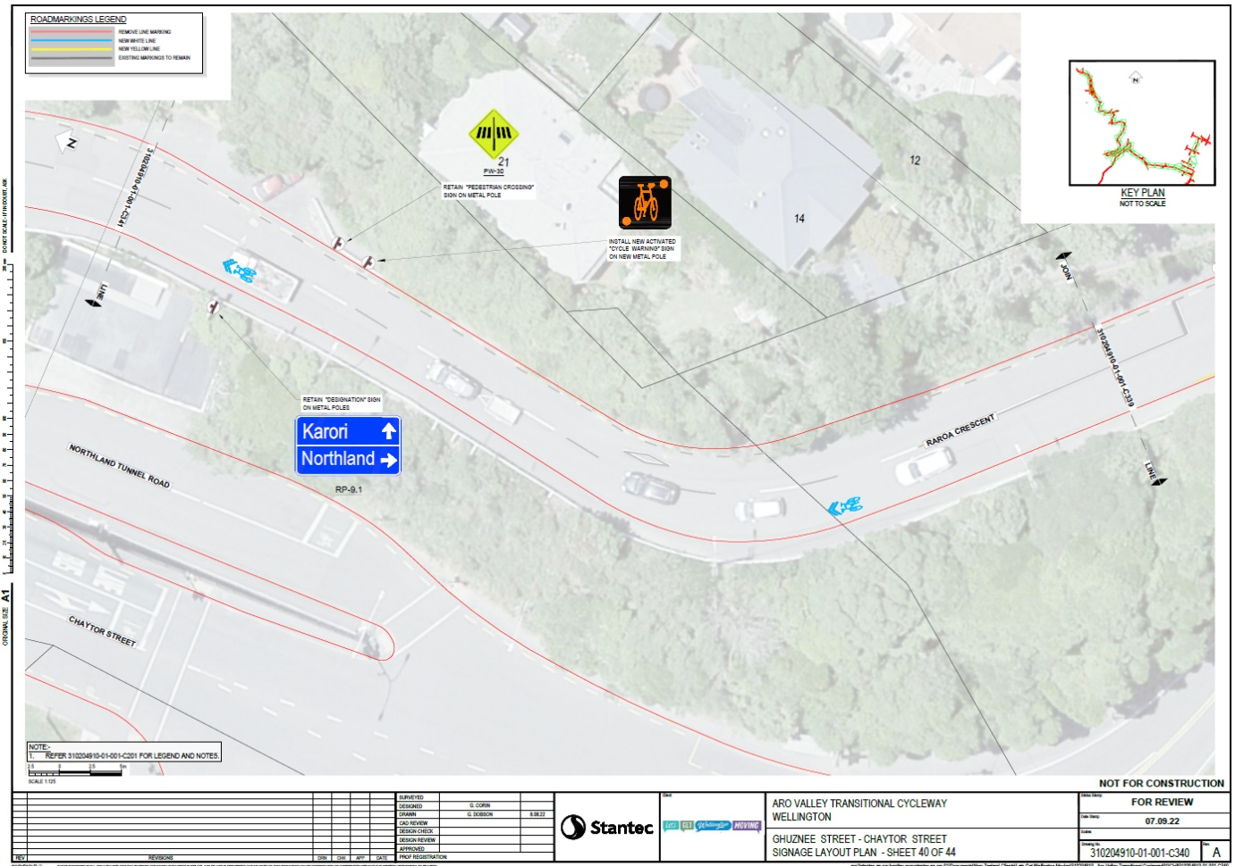

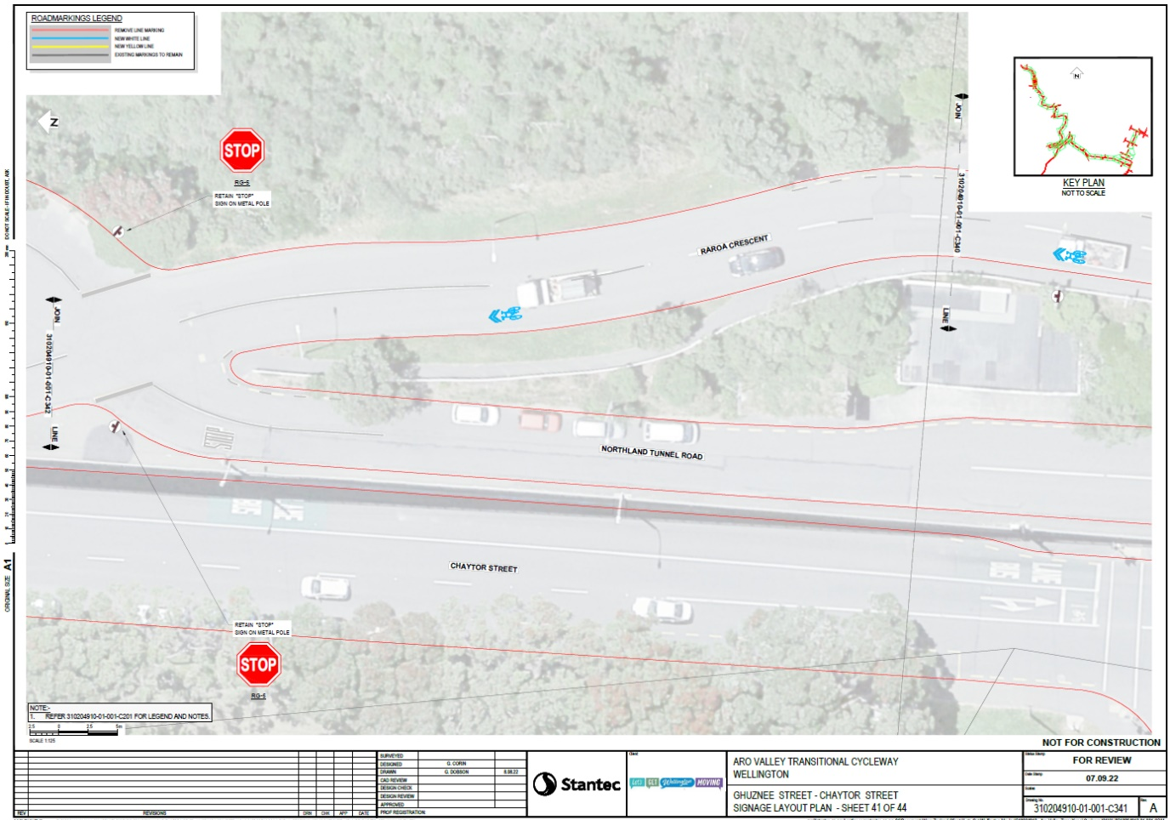

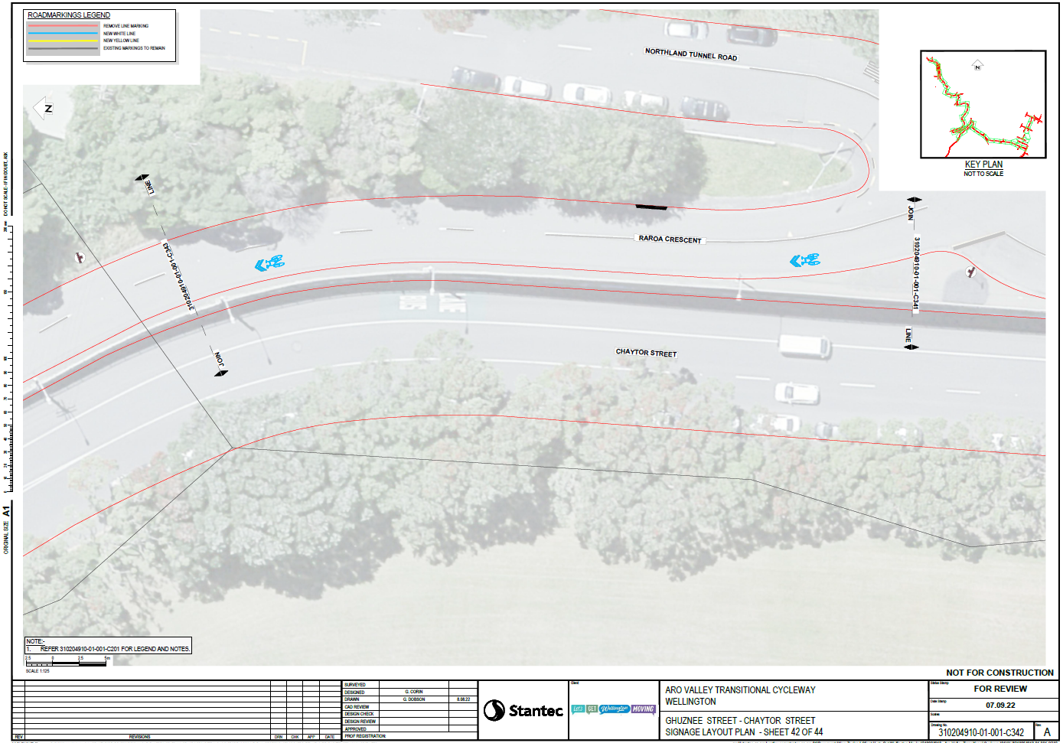

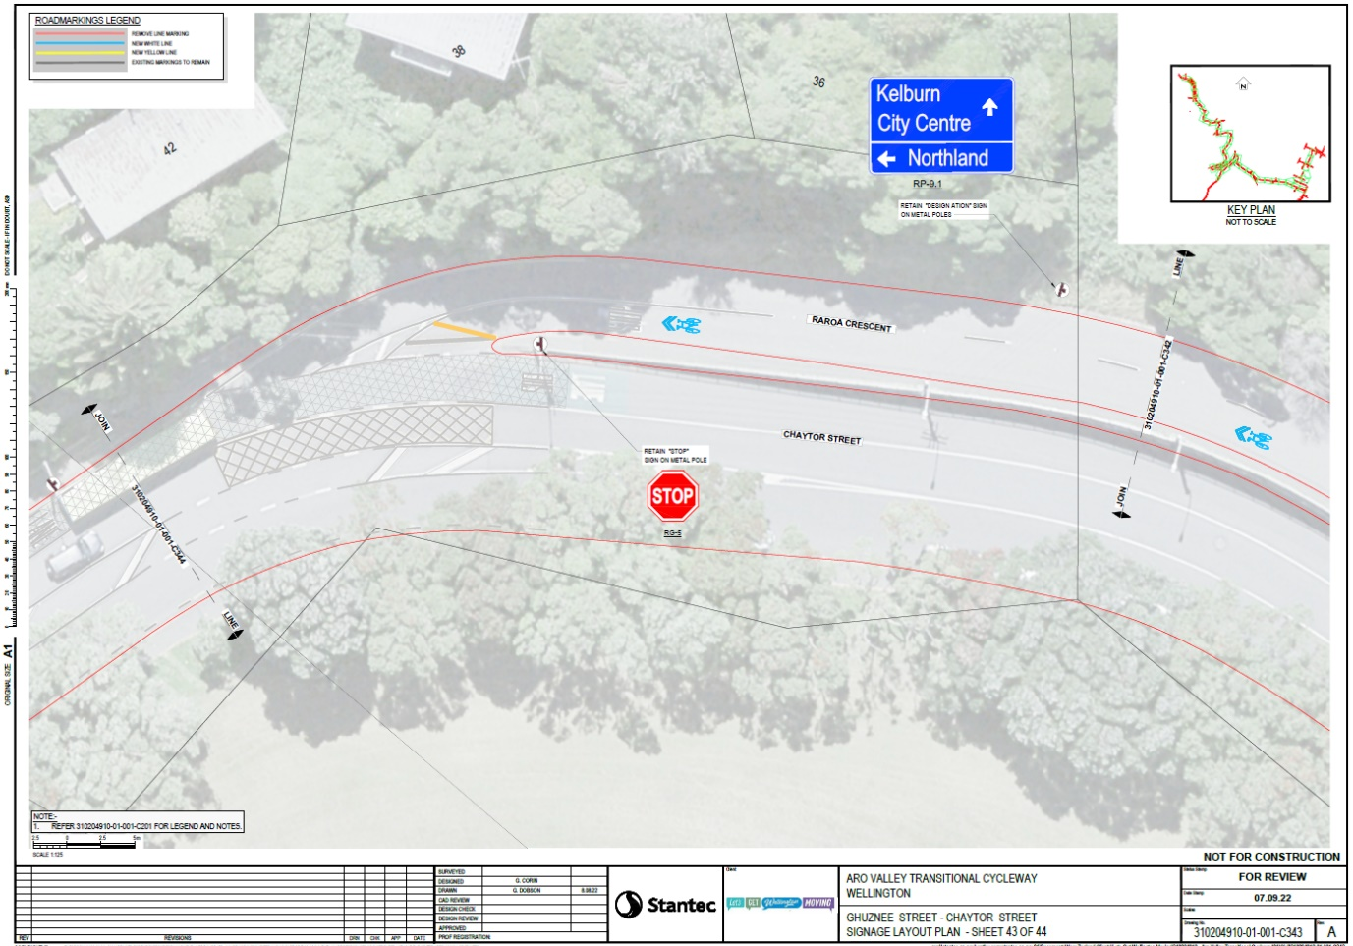

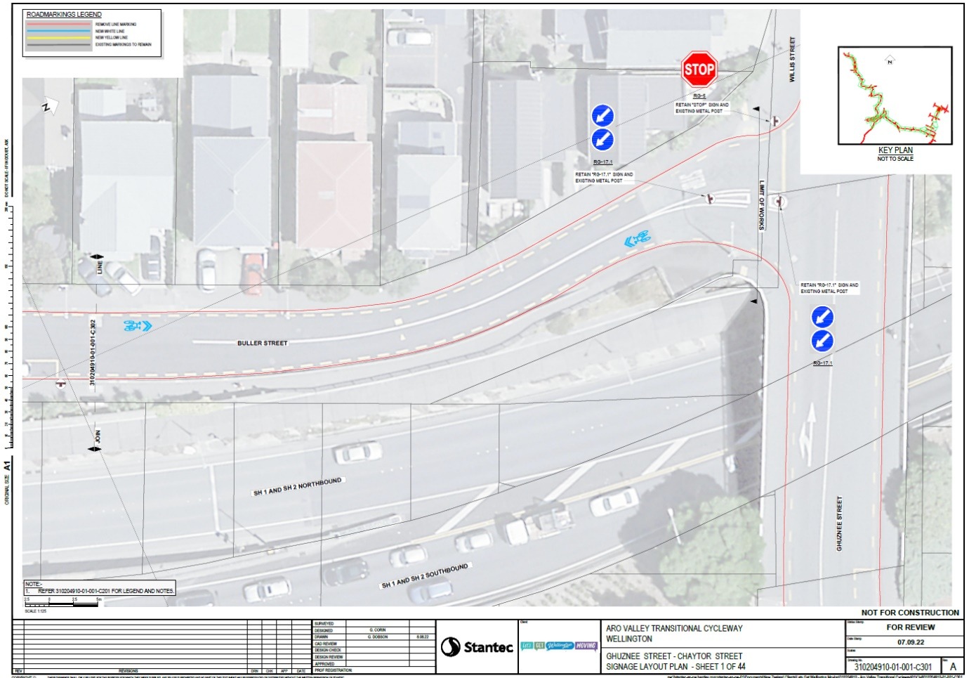
Back route from Buller Street to Aro Valley

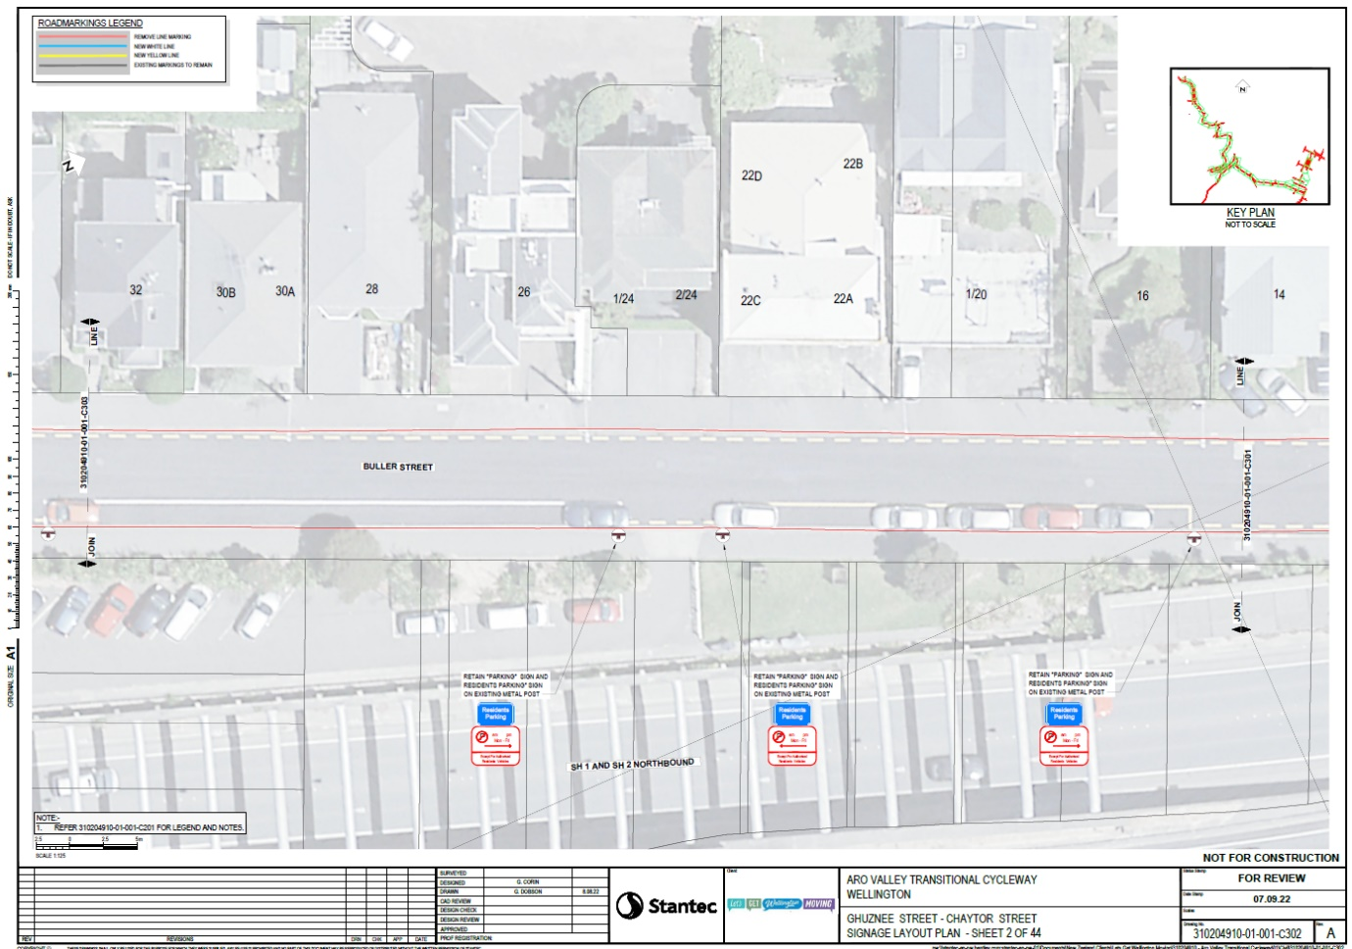

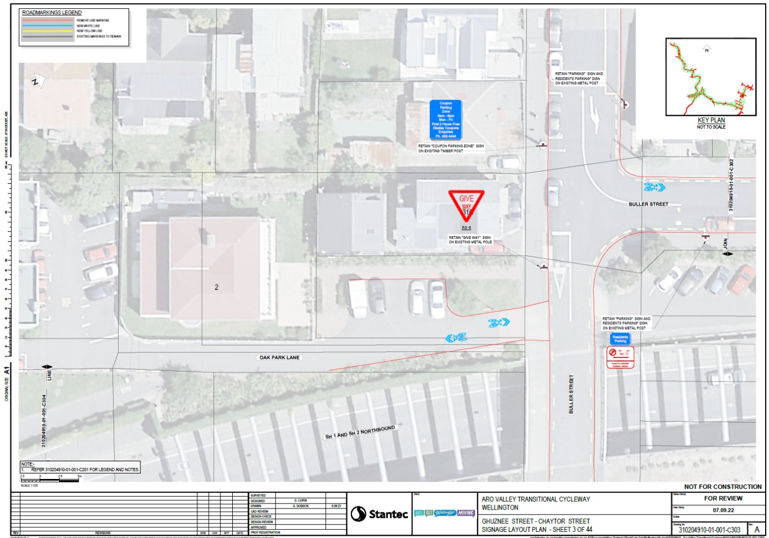

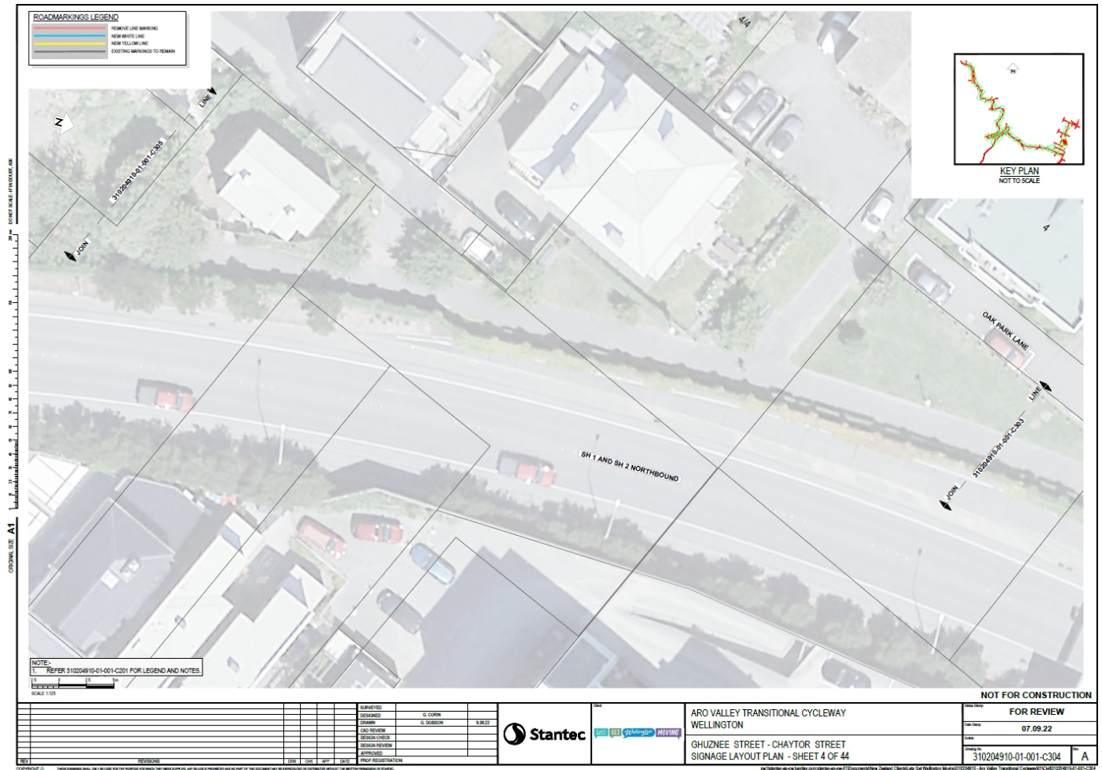

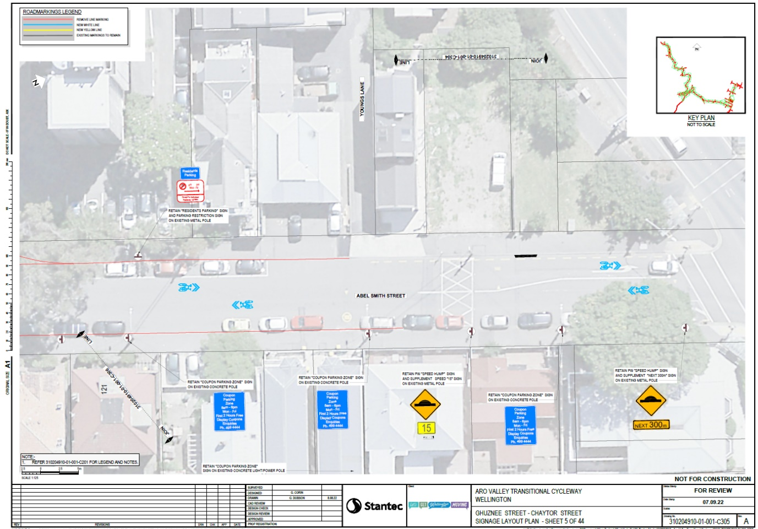

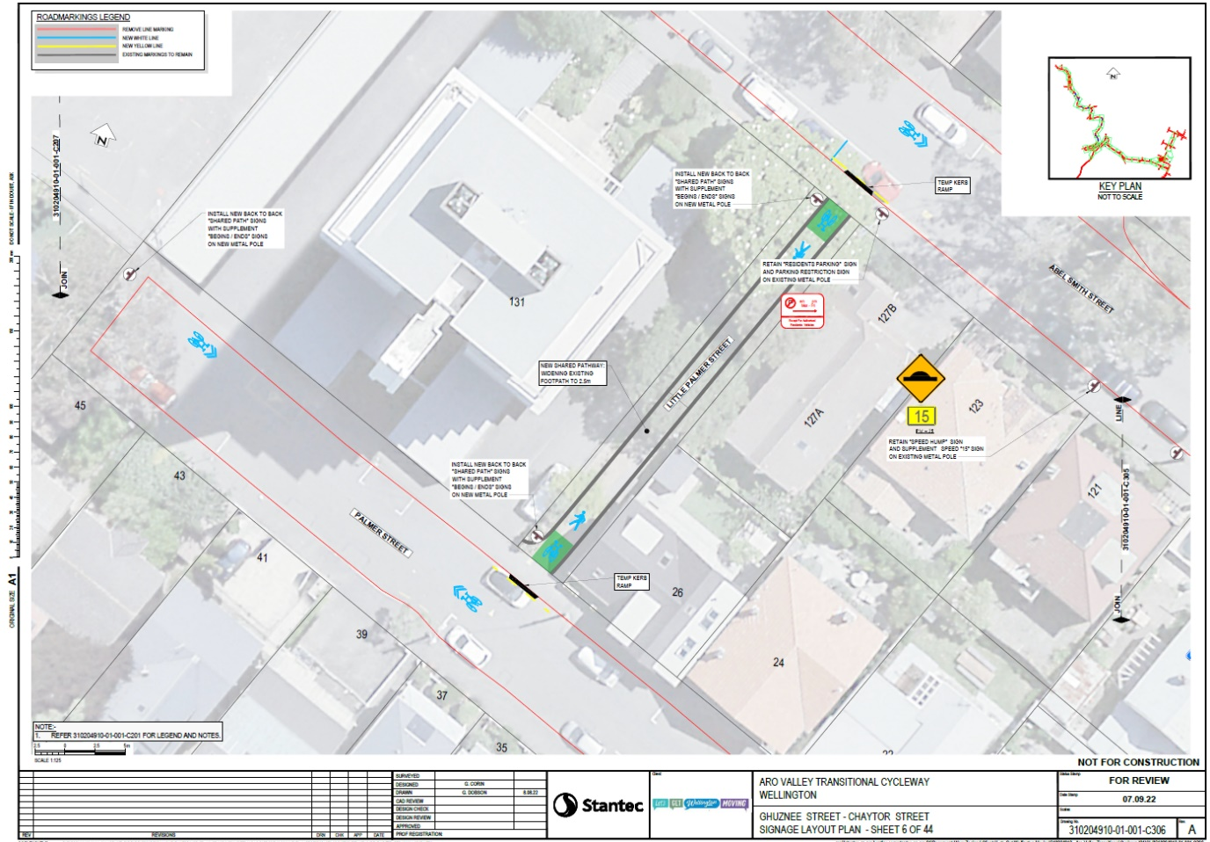

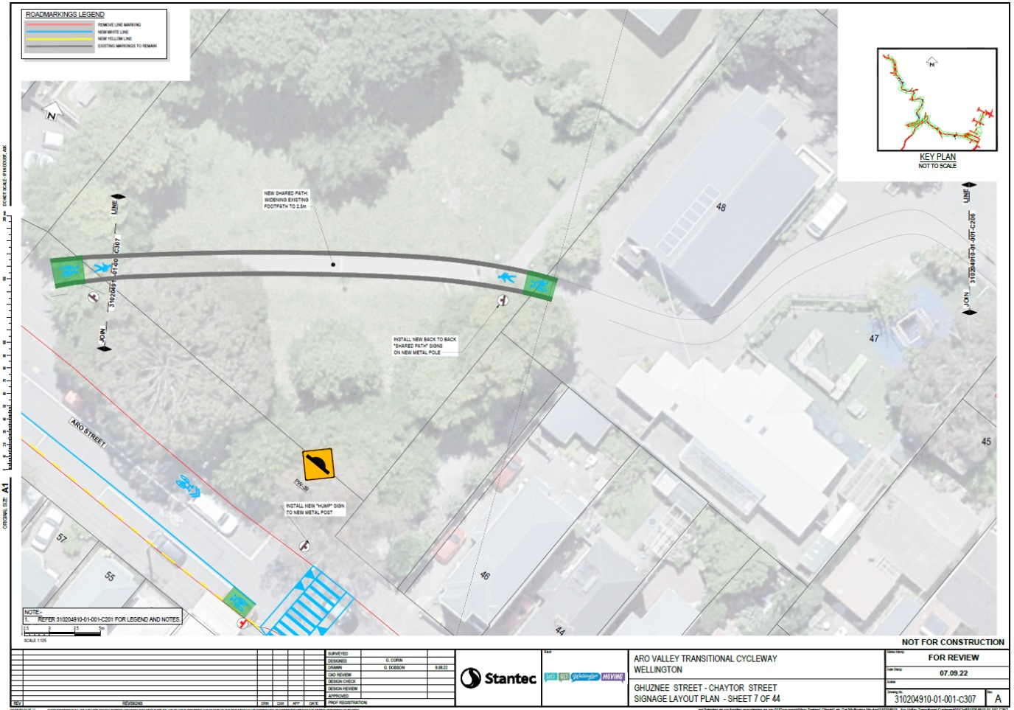

Te Aro Parking Zone
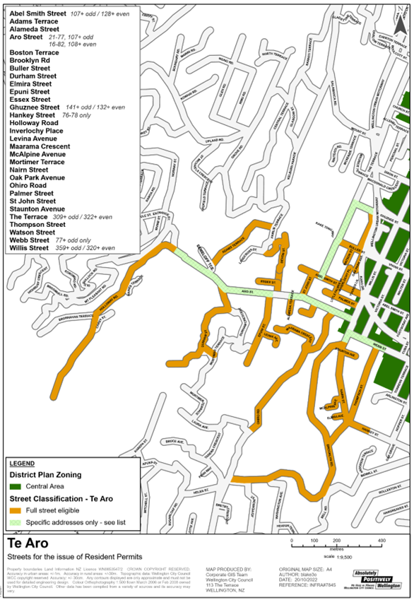

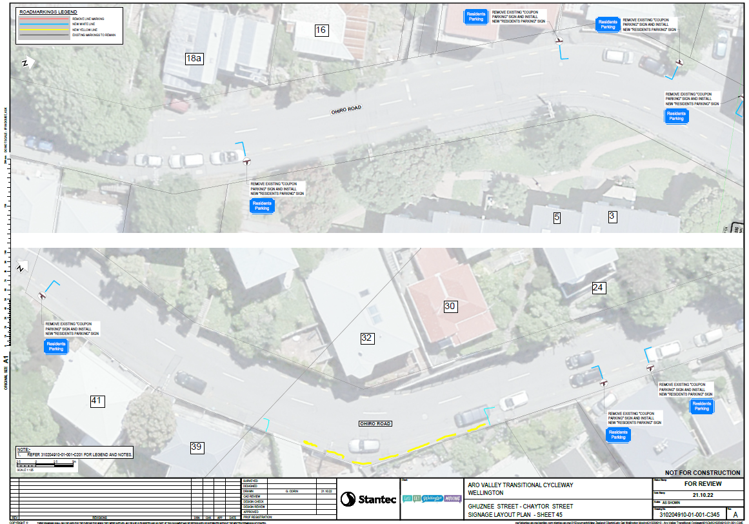

Legal Description:

Add to Schedule A (Time Limited Parking) of the Traffic Restrictions Schedule

Column One | Column Two | Column Three
Aro Street | “P20 8:00am – 6:00pm” | Southern side, commencing 93 m east from its intersection with Devon Street (grid coordinates (X = 1747969.68 m Y = 5426944.24 m) and extending in a westerly direction following the southern kerb line for 12 m (2 parallel parks)
Aro Street | “P20 8:00am – 6:00pm” | Southern side, commencing 66 m east from its intersection with Devon Street (grid coordinates (X = 1747942.76 m Y = 5426946.65 m) and extending in a westerly direction following the southern kerb line for 14.9 m (3 parallel parks)
Aro Street | “P20 8:00am – 6:00pm” | Southern side, commencing 33 m east from its intersection with Devon Street (grid coordinates (X = 1747910.16 m Y = 5426949.94 m) and extending in a westerly direction following the southern kerb line for 5 m (1 parallel parks)
Aro Street | “P20 8:00am – 6:00pm” | Southern side, commencing 12 m west from its intersection with Devon Street (grid coordinates (X = 1747864.86 m Y = 5426954.60 m) and extending in a westerly direction following the southern kerb line for 8 m (1 parallel parks)
Aro Street | “P20 8:00am – 6:00pm” | Northern side, commencing 30m east from its intersection with Devon Street (Grid Coordinates X= 1747939.46m Y=5426954.51m) and extending in an easterly direction following the northern kerb for 18 metres (3 parallel parks)
Aro Street | “P20 8:00am – 6:00pm” | Northern side, commencing 9m west from its intersection with Devon Street (Grid Coordinates X= 1747897.42m Y=5426958.61m) and extending in a westerly direction following the northern kerb for 37 metres. (6 parallel parks)
Aro Street | “Coupon Parking Zone”  8:00am - 6:00pm Monday-Friday | Northern side, commencing 57m west from its intersection with Devon Street (Grid Coordinates X= 1747848.89m Y=5426963.79m) and extending in a westerly direction following the northern kerb for 6 metres. (1 parallel park)

Aro Street | “Coupon Parking Zone”  8:00am - 6:00pm Monday-Friday | Northern side, commencing 68m west from its intersection with Devon Street (Grid Coordinates X= 1747839.02m Y=5426964.78m) and extending in a westerly direction following the northern kerb for 36 metres. (6 parallel parks)
Aro Street | “Coupon Parking Zone”  8:00am - 6:00pm Monday-Friday | Northern side, commencing 111m west from its intersection with Devon Street (Grid Coordinates X= 1747795.30m Y=5426969.14m) and extending in a westerly direction following the northern kerb for 5 metres. (1 parallel park)
Aro Street | “Coupon Parking Zone”  8:00am - 6:00pm Monday-Friday | Northern side, commencing 157m west from its intersection with Devon Street (Grid Coordinates X= 1747749.15m Y=5426973.32m) and extending in a westerly direction following the northern kerb for 5 metres. (1 parallel park)
Aro Street | “Coupon Parking Zone”  8:00am - 6:00pm Monday-Friday | Northern side, commencing 185m west from its intersection with Devon Street (Grid Coordinates X= 1747716.15m Y=5426976.99m) and extending in a westerly direction following the northern kerb for 10 metres. (2 parallel park)
Holloway Road | “P120 parking”  8:00am – 6:00pm Monday to Sunday | Northern side, commencing 92m east from its intersection with Old Bullock Road (Grid Coordinates X= 1747352.76m Y= 5427129.83m) and extending in a northerly direction following the northern kerb for 95 metres. (16 parallel parks)
Holloway Road | “P120 parking”  8:00am – 6:00pm Monday to Sunday | Southern side, commencing 50m west from its intersection with Raroa Road (Grid Coordinates X= 1747391.96m Y= 5427158.46m) and extending in a northerly direction following the northern kerb for 35 metres. (6 parallel parks)

Delete from Schedule A (Time Limited Parking) of the Traffic Restrictions Schedule

Column One | Column Two | Column Three
Aro Street | “P20 8:00am – 6:00pm Monday - Saturday” | Southern Side, commencing 93 m east from its intersection with Devon Street (grid coordinates (X = 1747969.68 m Y = 5426944.24 m) and extending in a westerly direction following the southern kerb line for 12 m (2 parallel parks)

Aro Street | “P20 8:00am – 6:00pm Monday - Saturday” | Southern Side, commencing 82 m east from its intersection with Devon Street (grid coordinates (X = 1747952.26 m Y = 5426945.83 m) and extending in a westerly direction following the southern kerb line for 5 m (1 parallel park)
Aro Street | “P20 8:00am – 6:00pm Monday - Saturday” | Southern Side, commencing 66 m east from its intersection with Devon Street (grid coordinates (X = 1747942.76 m Y = 5426946.65 m) and extending in a westerly direction following the southern kerb line for 14.9 m (3 parallel parks)
Aro Street | “P20 8:00am – 6:00pm Monday - Saturday” | Southern Side, commencing 33 m east from its intersection with Devon Street (grid coordinates (X = 1747910.16 m Y = 5426949.94 m) and extending in a westerly direction following the southern kerb line for 5 m (1 parallel parks)
Aro Street | “P20” | Southern Side, commencing 12 m west from its intersection with Devon Street (grid coordinates (X = 1747864.86 m Y = 5426954.60 m) and extending in a westerly direction following the southern kerb line for 8 m (1 parallel parks)
Aro Street | “P20 8:00am – 6:00pm Monday - Saturday” | Northern side, commencing 30m east from its intersection with Devon Street (Grid Coordinates X= 1747939.46m Y=5426954.51m) and extending in an easterly direction following the northern kerb for 18 metres (3 parallel parks)
Aro Street | “P20 8:00am – 6:00pm Monday - Saturday” | Northern side, commencing 9m west from its intersection with Devon Street (Grid Coordinates X= 1747897.42m Y=5426958.61m) and extending in a westerly direction following the northern kerb for 36 metres. (6 parallel parks)
Aro Street | “Coupon Parking Zone”  8:00am - 6:00pm Monday-Friday | Southern Side, commencing 52m west from its intersection with Ohiro Road (Grid Coordinates X= 1748104.45m Y=5426900.26m) and extending in a westerly direction following the southern kerb for 20 metres. (3 parallel parks)
Aro Street | “Coupon Parking Zone”  8:00am - 6:00pm Monday-Friday | Southern Side, commencing 30m west from its intersection with Epuni Street (Grid Coordinates X= 1747839.11m Y=5426955.63m) and extending in a westerly direction following the southern kerb for 147 metres. (25 parallel parks)

Aro Street | “Coupon Parking Zone”  8:00am - 6:00pm Monday-Friday | Southern Side, commencing 35m west from its intersection with Durham Street (Grid Coordinates X= 1747620.44m Y= 5427032.70m) and extending in a westerly direction following the southern kerb for 185 metres. (31 parallel parks)

Add to Schedule B (Class Restricted) of the Traffic Restrictions Schedule

Column One | Column Two | Column Three
Aro Street | “Bus Stop At All Times” | Southern side, commencing 44m west from its intersection with Wills Street (Grid Coordinates X= 1748205.44 Y= 5426855.45m) and extending in an easterly direction following the southern kerb for 15 metres.
Raroa Road | “Bus Stop At All Times” | Western side, commencing at 127A Raroa Road (Grid Coordinates X= 1747320.07m Y= 5427355.50) and extending in a northerly direction following the western kerb for 15 metres.
Raroa Road | “Bus Stop At All Times” | Eastern side, commencing 8m east from its intersection with Fairview Crescent (Grid Coordinates X= 1747179.04m Y= 5427652.61m) and extending in a northerly direction following the eastern kerb for 15 metres.
Raroa Road | “Bus Stop At All Times” | Western side, commencing 15m west from its intersection with Cluny Avenue (Grid Coordinates X= 1747160.45m Y= 5427638.89m) and extending in a northerly direction following the western kerb for 15 metres.
Aro Street | Class restricted cycle stand | Southern side, commencing 82 m east from its intersection with Devon Street (grid coordinates (X = 1747952.26 m Y = 5426945.83 m) and extending in a westerly direction following the southern kerb line for 5 m (1 parallel park)
Epuni Street | “Disability Parking Space” At All Times | Western side, commencing 11m south from its intersection with Aro Street (Grid Coordinates X= 1747871.03m Y= 5426944.90m) and extending in a southerly direction following the western kerb for 6 metres. (1 parallel park)
Epuni Street | “Car Share Zone” At All Times | Eastern side, commencing 10m south from its intersection with Aro Street (Grid Coordinates X= 1747880.31m Y= 5426945.38) and extending in a southerly direction following the eastern kerb for 12 metres. (2 parallel park)

Delete from Schedule B (Class Restricted) of the Traffic Restrictions Schedule

Column One | Column Two | Column Three
Aro Street | “Bus Stop At All Times” | Southern side, commencing 66m west from its intersection with Wills Street (Grid Coordinates X= 1748185.58m Y=5426865.53m) and extending in a westerly direction following the southern kerb for 15 metres.
Aro Street | “Bus Stop At All Times” | Southern side, commencing 90m west from its intersection with Ohiro Road (Grid Coordinates X= 1748076.26m Y=5426914.43m) and extending in an easterly direction following the southern kerb for 15 metres.
Raroa Road | “Bus Stop At All Times” | Eastern side, commencing 28m east from its intersection with Fairview Crescent (Grid Coordinates X= 1747159.27m Y= 5427647.53m) and extending in a northerly direction following the eastern kerb for 15 metres.
Raroa Road | “Bus Stop At All Times” | Western side, commencing 42m west from its intersection with Fairview Crescent (Grid Coordinates X= 1747149.26m Y= 5427635.64m) and extending in a northerly direction following the western kerb for 15 metres.

Add to Schedule C (Direction) of the Traffic Restrictions Schedule

Column One | Column Two | Column Three
Little Palmer Street (between Palmer Street and Abel Smith Street) | Shared path, at all  times. Pedestrians  have priority. | Western side, commencing from its intersection with palmer street (Grid Coordinates X= 1748165.34m Y= 5426954.75m) and extending in a northerly direction following the western kerb for 39 metres.
Raroa Road | Shared path, at all  times. Pedestrians  have priority. | Western side, commencing at the intersection Holloway Road (Grid Coordinates X= 1747447.58m Y= 5427181.50m) and extending in a northerly direction following the western kerb for 14 metres.
Aro Park | Shared path, at all  times. Pedestrians  have priority. | Eastern side, commencing 236m west from its intersection with Willis Street (Grid Coordinates X= 1748031.45m Y= 5426947.52m) and extending in a north-easterly direction following the eastern kerb for 51 metres.

Add to Schedule D (No Stopping) of the Traffic Restrictions Schedule

Column One | Column Two | Column Three
Abel Smith Street | “No stopping at all times” | South side, commencing 111.0 metres west of its intersection with Willis Street (Grid Coordinates X=1748185.51m Y=5426990.93m) and extending in a westerly direction following the southern kerb for 6 metres.
Palmer Street | “No stopping at all times” | North side, commencing 111.0m west from its intersection with Willis Street (Grid Coordinates X= 1748165.34m Y= 5426954.75m) and extending in a westerly direction following the northern kerb for 6 metres.
Aro Street | “No stopping at all times” | South side, commencing 60.0 metres west of its intersection with Willis Street (Grid Coordinates X= 1748197.82m Y= 5426859.41m) and extending in a westerly direction following the southern kerb for 38 metres.
Aro Street | “No stopping at all times” | South side, commencing from its intersection with Ohiro Road (Grid Coordinates X=1748148.75m Y=5426880.87m) and extending in a westerly direction following the southern kerb for approximately 168 metres.
Aro Street | ‘No stopping at all times’ | North side, commencing 63.0 metres west of its intersection with Devon Street (Grid Coordinates X= 1747844.58m Y= 5426964.24m) and extending in a westerly direction following the northern kerb for approximately 8m.
Aro Street | ‘No stopping at all times’ | South side, commencing 28m west from its intersection with Epuni Street (Grid Coordinates X= 1747844.71m Y= 5426955.04m) and extending in a westerly direction following the southern kerb for approximately 180m.
Aro Street | ‘No stopping at all times’ | North side, commencing 105.0 metres west of its intersection with Devon Street (Grid Coordinates X= 1747801.58m Y= 5426968.31m) and extending in a westerly direction following the northern kerb for approximately 7m.
Aro Street | ‘No stopping at all times’ | North side, commencing 117.0 metres west of its intersection with Devon Street (Grid Coordinates X= 1747789.03m Y= 5426969.91m) and extending in a westerly direction following the northern kerb for approximately 42m.

Aro Street | ‘No stopping at all times’ | North side, commencing 164.0 metres west of its intersection with Devon Street (Grid Coordinates X= 1747743.96m Y= 5426973.96m) and extending in a westerly direction following the northern kerb for approximately 6m.
Aro Street | ‘No stopping at all times’ | South side, commencing 27m east from its intersection with Durham Street (Grid Coordinates X= 1747661.83m Y= 5426989.59m) and extending in a westerly direction following the southern kerb for approximately 240m.
Adams Terrace | ‘No stopping at all times’ | Eastern side, commencing 55m metres west of its intersection with Durham Street (Grid Coordinates X=1747612.10m Y= 5427054.20m) and extending in a southerly direction following the eastern kerb for approximately 6m.
Adams Terrace | ‘No stopping at all times’ | Eastern side, commencing 63m metres west of its intersection with Durham Street (Grid Coordinates X=1747605.17m Y= 5427059.61m) and extending in a southerly direction following the eastern kerb for approximately 6m.
Raroa Road | ‘No stopping at all times’ | Eastern side, commencing at the intersection with Entrance Street (Grid Coordinates X= 1747432.06m Y=1747432.06m) and extending in a South-easterly direction following the eastern kerb for approximately 15m.
Raroa Road | ‘No stopping at all times’ | Northern side, commencing at the intersection with Entrance Street (Grid Coordinates X= 1747418.37m Y=5427250.45m) and extending in a north-westerly direction following the northern kerb for approximately 270m.
Raroa Road | ‘No stopping at all times’ | Southern side, commencing at the intersection with Entrance Street (Grid Coordinates X= 1747419.53m Y= 5427233.03) and extending in a north-westerly direction following the southern kerb for approximately 300m.
Raroa Road | ‘No stopping at all times | Northern side, commencing 330m northwest of its intersection with Entrance Street (Grid Coordinates X= 1747176.10m Y=5427098.07m) and extending in a north-westerly direction following the northern kerb for approximately 180m.
Raroa Road | ‘No stopping at all times’ | Northern side, commencing 55m east from its intersection with Mt Pleasant Road (Grid Coordinates X= 1747182.28m Y= 5427145.97m) and extending in a northerly direction following the western kerb for approximately 460m.

Raroa Road | ‘No stopping at all times’ | South side, commencing 370m north from its intersection with Mt Pleasant Road (Grid Coordinates X= 1747327.88m Y= 5427365.14m) and extending in a northerly direction following the western kerb for approximately 168m.
Raroa Road | ‘No stopping at all times’ | West side, commencing from the Roundabout at Raroa Road and Plunket Street (Grid Coordinates X= 1747226.33m Y= 5427637.37m) and extending in a northerly direction following the western kerb for approximately 77m.
Raroa Road | ‘No stopping at all times’ | West side, commencing from the intersection at Cluny Avenue and Raroa Road (Grid Coordinates X= 1747134.65m Y= 5427636.65m) and extending in a northerly direction following the western kerb for approximately 260m.
Raroa Road | ‘No stopping at all times’ | West side, commencing 42 metres south from Moana Road (Grid Coordinates X= 1747027.76m Y= 5427817.78m) and extending in a northerly direction following the western kerb for approximately 30m.
Raroa Road | ‘No stopping at all times’ | East side, commencing 200m north from its intersection with Mt Pleasant Road (Grid Coordinates X= 1747319.21m Y= 5427200.28m) and extending in a northerly direction following the eastern kerb for approximately 32m.
Raroa Road | ‘No stopping at all times’ | East side, commencing 265m north from its intersection with Mt Pleasant Road (Grid Coordinates X= 1747309.22m Y= 5427278.49) and extending in a northerly direction following the eastern kerb for approximately 85m.
Raroa Road | ‘No stopping at all times | East side, commencing 20m north from Fairview Crescent (Grid Coordinates X= 1747164.42m Y= 5427649.06m) and extending in a northerly direction following the eastern kerb for approximately 18m.
Raroa Road | ‘No stopping at all times | East side, commencing 260m north from its intersection with Fairview Crescent (Grid Coordinates X=1747059.21 Y= 5427786.77m) and extending in a northerly direction following the eastern kerb for approximately 12m.
Raroa Road | ‘No stopping at all times | East side, commencing 280m north from its intersection with Fairview Crescent (Grid Coordinates X= 1747043.08m Y= 5427806.13m) and extending in a northerly direction following the eastern kerb for approximately 15m.

Raroa Road | ‘No stopping at all times | East side, commencing 20m south from Moana Road (Grid Coordinates X= 1747037.57m Y= 5427816.98m) and extending in a northerly direction following the eastern kerb for approximately 27m.

Add to Schedule E (Resident Parking) of the Traffic Restrictions Schedule

Column One | Column Two | Column Three
Holloway Road | “Resident Parking”  At All Times | Southern side, commencing 165m from its intersection with Brosnahan Terrace (Grid Coordinates X=1747226.34m Y=5426963.13) and extending in a northerly direction following the southern kerb for 63 metres. (11 parallel parks)
Holloway Road | “Resident Parking”  At All Times | Southern side, commencing 237m from its intersection with Brosnahan Terrace (Grid Coordinates X= 1747254.76m Y= 5427030.98) and extending in a northerly direction following the southern kerb for 24 metres. (4 parallel parks)
Holloway Road | “Resident Parking”  At All Times | Southern side, commencing 268m from its intersection with Brosnahan Terrace (Grid Coordinates X= 1747263.67m Y= 5427054.75m) and extending in a northerly direction following the southern kerb for 25 metres. (4 parallel parks)
Holloway Road | “Resident Parking”  At All Times | Southern side, commencing 298m from its intersection with Brosnahan Terrace (Grid Coordinates X= 1747281.03m Y= 5427074.43m) and extending in a northerly direction following the southern kerb for 10 metres. (2 parallel parks)
Holloway Road | “Resident Parking”  At All Times | Southern side, commencing 313m from its intersection with Brosnahan Terrace (Grid Coordinates X= 1747292.64m Y= 5427081.75m) and extending in a northerly direction following the southern kerb for 42 metres. (7 parallel park)
Holloway Road | “Resident Parking”  At All Times | Southern side, commencing 360m from its intersection with Brosnahan Terrace (Grid Coordinates X= 1747326.13m Y= 5427112.85m) and extending in a northerly direction following the southern kerb for 5 metres. (1 parallel park)

Holloway Road | “Resident Parking”  At All Times | Southern side, commencing 370m from its intersection with Brosnahan Terrace (Grid Coordinates X= 1747332.03m Y= 5427118.78m) and extending in a northerly direction following the southern kerb for 9 metres. (2 parallel park)
Holloway Road | “Resident Parking”  At All Times | Southern side, commencing 384m from its intersection with Brosnahan Terrace (Grid Coordinates X= 1747343.23m Y= 5427125.15m) and extending in a northerly direction following the southern kerb for 6 metres. (1 parallel park)
Holloway Road | “Resident Parking”  At All Times | Southern side, commencing 395m from its intersection with Brosnahan Terrace (Grid Coordinates X= 1747343.23m Y= 5427125.15m) and extending in a northerly direction following the southern kerb for 40 metres. (7 parallel park)
Ohiro Road | “Resident Parking”  At All Times | West side commencing 9.58 metres south from its intersection with Aro Street (Grid coordinates X= 1748167.04m, Y= 5426872.56m) and extending in a southernly direction following the Western kerb line for 16 metres. (3 Parallel parks)
Ohiro Road | “Resident Parking”  At All Times | West side commencing 35 metres south from its intersection with Aro Street (Grid coordinates X= 1748167.04m, Y= 5426872.56m) and extending in a southernly direction following the western kerb line for 15 metres. (3 Parallel parks)
Ohiro Road | “Resident Parking”  At All Times | East side commencing 101.3 metres from its intersection with Aro Street (Grid coordinates X= 1748167.04m, Y= 5426872.56m) and extending in a southernly direction following the Eastern kerb line for 36 metres. (6 Parallel parks)
Ohiro Road | “Resident Parking”  At All Times | East side commencing 143 metres south from its intersection with Aro Street (Grid coordinates X= 1748167.04m, Y= 5426872.56m) and extending in a southernly direction following the Eastern kerb line for 16 metres. (3 Parallel parks)
Ohiro Road | “Resident Parking”  At All Times | East side commencing 189.4 metres south from its intersection with Aro Street (Grid coordinates X= 1748167.04m, Y= 5426872.56m) and extending in a southernly direction following the Eastern kerb line for 32 metres. (5 Parallel parks)

Delete from Schedule E (Resident Parking) of the Traffic Resolution Schedule

Column One | Column Two | Column Three
Aro Street | “Resident Parking”  8:00am - 6:00pm Monday-Friday | Southern Side, commencing 36m west from its intersection with Wills Street (Grid Coordinates X= 1748212.94m Y=5426851.99m) in a westerly direction following the southern kerb for 30 metres. (5 parallel parks)
Aro Street | “Resident Parking”  8:00am - 6:00pm Monday-Friday | Southern Side, commencing 30m west from its intersection with Ohiro Road (Grid Coordinates X= 1748125.12m Y=5426892.00m) and extending in a westerly direction following the southern kerb for 22 metres. (4 parallel parks)
Aro Street | “Resident Parking”  8:00am - 6:00pm Monday-Friday | Southern Side, commencing 102m west from its intersection with Ohiro Road (Grid Coordinates X= 1748059.77m Y= 5426920.81m) and extending in a westerly direction following the southern kerb for 20 metres. (3 parallel parks)
Aro Street | “Resident Parking”  8:00am - 6:00pm Monday-Friday | Southern Side, commencing 168m west from its intersection with Ohiro Road (Grid Coordinates X= 1747719.11m Y= 5426967.16m) and extending in a easternly direction following the southern kerb for 30 metres. (5 parallel parks)
Aro Street | “Resident Parking”  8:00am - 6:00pm Monday-Friday | Southern Side, commencing 127m west from its intersection with Ohiro Road (Grid Coordinates X= 1748016.87m Y= 5426938.08m) and extending in a westerly direction following the southern kerb for 5 metres. (1 parallel parks)
Aro Street | “Resident Parking”  8:00am - 6:00pm Monday-Friday | Southern Side, commencing 127m west from its intersection with Ohiro Road (Grid Coordinates X= 1748016.87m Y= 5426938.08m) and extending in a westerly direction following the southern kerb for 5 metres. (1 parallel parks)

Add to Schedule G (Give-way & Stop) of the Traffic Restrictions Schedule

Column One | Column Two | Column Three
Cluny Avenue | “Give-way control” | Northbound approach to its intersection with Raroa Road.

Add to Schedule I (Cycleway) of the Traffic Restrictions Schedule

Column One | Column Two | Column Three
Aro Street | Cycleway, at all times | South side, commencing 60m west from its intersection with Wills Street (Grid Coordinates X=1748195.71m Y=5426859.76m) and extending in a westerly direction following the southern kerb for approximately 148m.
Aro Street | Cycleway, at all times | South side, commencing 102m west from its intersection with Ohiro Road (Grid Coordinates X= 1747971.47m Y=5426941.99m) and extending in a westerly direction following the southern kerb for approximately 74m.
Aro Street | Cycleway, at all times | South side, commencing 28m west from its intersection with Epuni Street (Grid Coordinates X= 1747844.71m Y= 5426955.04m) and extending in a westerly direction following the southern kerb for approximately 180m.
Aro Street | Cycleway, at all times | South side, commencing 27m east from its intersection with Durham Street (Grid Coordinates X= 1747661.83m Y= 5426989.59m) and extending in a westerly direction following the southern kerb for approximately 240m.
Raroa Road | Cycleway at all times | South side, commencing 30m east from its intersection with Holloway Road (Grid Coordinates X= 1747458.58m Y= 5427093.10m) and extending in a northerly direction for approximately 50m.
Raroa Road | Cycleway, at all times | South side, commencing 55m east from its intersection with Mt Pleasant Road (Grid Coordinates X= 1747182.28m Y= 5427145.97m) and extending in a northerly direction following the western kerb for approximately 190m.
Raroa Road | Cycleway, at all times | West side, commencing 210m north from its intersection with Mt Pleasant Road (Grid Coordinates X= 1747322.12m Y= 5427216.43m) and extending in a northerly direction following the western kerb for approximately
Raroa Road | Cycleway, at all times | West side, commencing 370m north from its intersection with Mt Pleasant Road (Grid Coordinates X= 1747327.88m Y= 5427365.14m) and extending in a northerly direction following the western kerb for approximately 168m.
Raroa Road | Cycleway, at all times | West side, commencing from the Roundabout at Raroa Road and Plunket Street (Grid Coordinates X= 1747226.33m Y= 5427637.37m) and extending in a northerly direction following the western kerb for approximately 77m.
Raroa Road | Cycleway, at all times | West side, commencing from the intersection at Cluny Avenue and Raroa Road (Grid Coordinates X= 1747134.65m Y= 5427636.65m) and extending in a northerly direction following the western kerb for approximately 260m.
Raroa Road | Cycleway, at all times | West side, commencing 42 metres south from Moana Road (Grid Coordinates X= 1747027.76m Y= 5427817.78m) and extending in a northerly direction following the western kerb for approximately 30m.

Prepared By | Jonathan Kennett (WCC) | (Transitional Programme– Project lead)
Approved By: | Brad Singh | (Manager Transport & Infrastructure)
Date: | 28/10/2022

