17 April 2025

**ADVANCE NOTICE: UPCOMING WORK IN YOUR AREA**   
To nearby residents, businesses and building owners,

This notice is to advise you that work to revitalise Courtenay Place as part of the Golden Mile upgrade is about to start. This work includes construction of new pedestrian and cycleway crossings, weather shelters and footpath improvements. You can read more about this project at **transportprojects.org.nz/courtenay**

**WHERE** Intersection of Courtenay Place and Kent and Cambridge Terraces  
**START**  4 May 2025  
**END** 30 November 2025

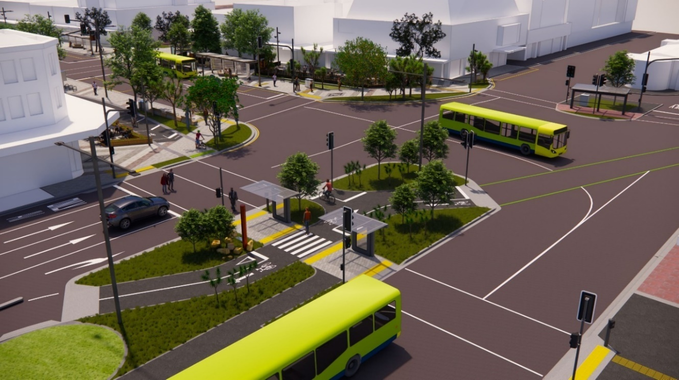

**WHAT TO EXPECT:**

In order to minimise disruption to nearby residents, the majority of this work has been planned to be undertaken during the day. However, where necessary we may undertake some isolated areas on nightshift to avoid disruption to transport routes and businesses.

Dayshift work will be undertaken **between the hours of 7am to 5pm Mondays - Saturdays**, **with Traffic Management impacting lanes between 9am to 4pm.**

Nightshift work to be undertaken between **8pm and 6am Sundays to Thursdays**.

**TIMELINE**

**May** **2025 –** **Temporary cycleway installed (Nightworks)**

* We’ll be realigning the current cycleway to temporarily divert it around the upcoming construction
* This will involve installing asphalt ramps and signs near the statue of Queen Victoria to allow switching from Cambridge Terrace to Kent Terrace and vice versa.
* This work will take place as night work to reduce disruption.

**May** **2025 –** **Centre Island Redevelopment (Nightworks)**

* A new kerb will be installed on the eastern side of the centre island.
* This work will also take place at night to reduce disruption to Kent Terrace

**May-October 2025 – Centre Island redevelopment (Dayworks)**

* Work to construct the centre island in the middle of Kent & Cambridge Terraces.
* The existing pedestrian crossing will typically remain open, however we may need to direct people to the nearest open crossing at certain times during these works.
* The main construction will be undertaken from the righthand side, north-bound lane of Cambridge Terrace to reduce the impact on the cycle lane and help with busses that need to turn right from Courtenay Place onto Kent Terrace.
* To enable these works, the following road areas will be closed:
  + The Cambridge Terrace righthand turning lane onto Marjoribanks Street.
  + The Cambridge Terrace right straight through lane will be closed. (The left straight through lane will remain open.)
  + The bus layby on Kent Terrace.
* Kent Terrace will remain open, as will the temporary cycleway and the existing pedestrian crossing (aside from short pedestrian diversions as needed).

**September – October 2025 – Embassy footpath (Dayworks)**

* Construction of the new crossing point and footpath outside The Embassy will take place during the day.
* The existing pedestrian crossing will typically remain open, however we may need to direct people to the nearest open crossing at certain times during these works.
* The south-bound left-hand lane on Kent Terrace will be closed while we improve this footpath.

**October 2025 – Cycleway finalised (Nightworks)**

* Once the new cycleway through the centre island is completed, the temporary cycleway will be removed, and signage will be installed to direct cyclists down the new cycleway.

**October – November 2025 – Utility works completed and centre island finished (Nightworks)**

* Installation of the underground utilities going across Kent & Cambridge Terrace.
* This work will take place at night to reduce disruption.
* During these works, one lane will be closed while works are completed, progressively completing one lane each night.
* One traffic lane will remain open on nightshift for through traffic. All lanes will remain open during the day.

**OUR COMMMITMENT TO YOU**  
We will aim to minimise the impact of noise, dust, vibration and congestion on residents, businesses and traffic while work is carried out. Traffic management will be in place to safely maintain vehicle flow through the worksite. Temporary fencing will surround work areas. There will always be sign-posted, safe ways to get around. This mahi will be disruptive so we appreciate your cooperation, patience and understanding as we work to improve our city.  
  
**CONTACT US**If you have any questions about construction, please contact BPC/JFC in the first instance.

* **BPC/JFC**

021 180 3463

[gmconstruction@jfcltd.co.nz](mailto:gmconstruction@jfcltd.co.nz)

* **Wellington City Council**

04 499 4444

[Courtenay@wcc.govt.nz](mailto:Courtenay@wcc.govt.nz)