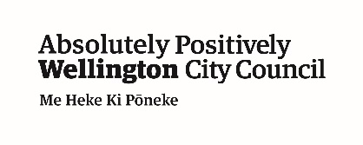
Shelly Bay Road - Have your Say
Kia ora,
Wellington City Council is seeking feedback on a planned upgrade of Shelly Bay Road, between Shelly Bay and Miramar Avenue.
Visit the webpage www.transportprojects.org.nz/current/shelly-bay-road/ to learn about the considerations, constraints and opportunities that would be involved in improving this narrow coastal area.
You'll be asked for your comments and thoughts, then we'll ask a bit about you. You are also welcome to provide any relevant photos, sketches, or documents to support your feedback.
It usually takes about 5-10 minutes to complete, depending how much you want to tell us. Feel free to skip questions, you don't have to answer them all.
You can email us at ShellyBayRoadUpgrade@wcc.govt.nz if you have any questions or if you need help filling out a submission.
The closing date for feedback is 5pm, Friday 27 May 2022.
About you
Why do we collect information about you?
Personal information is used for the administration of the feedback process including informing you of the outcome of this engagement. All information collected will be held by Wellington City Council, 113 The Terrace, Wellington, with submitters having the right to access and correct personal information.
Full name:
Email address:
Are you providing this feedback:
as an individual
on behalf of an organisation
Please enter the name of your organisation’s name:
Which suburb do you live in? If you live outside of Wellington please leave blank.

Please choose the gender that best identifies you:

Male Female

Gender diverse/gender non-binary Prefer not to say
Do you live with a disability or accessibility issues?
Yes No Prefer not to say
Please choose the ethnicity group/s you identify with. You can select more than one.

NZ European/Pakeha Māori European

Pacific Peoples Asian

Middle Eastern/Latin American/African Other (please specify)

Tell us what you think
Thinking about the opportunities to make improvements that don't require widening the road, what considerations do you think are most important?

Thinking about the opportunities to make improvements that would require significant road widening, what considerations do you think are most important?

Do you have any specific suggestions for how we could improve the area? Your comment and your name will appear on the website.

How you use Shelly Bay
What are all the ways you travel on Shelly Bay Road? Select as many as you like:

Car/van Motorbike Truck

Walk/run Bike Skateboard or scooter

Wheelchair or mobility aid Other (please specify)
What is the main way you travel on Shelly Bay Road? Select one:

Car/van Motorbike Truck

Walk/run Bike Skateboard or scooter

Wheelchair or mobility aid Other (please specify)
What is the main way you travel around the city? Select one:

Car/van Motorbike Truck

Walk/run Bike Skateboard or scooter

Wheelchair or mobility aid Other (please specify)
What is your primary relationship to the Shelly Bay Road area?

I live on Shelly Bay Road I live in one of the surrounding suburbs
I travel through the area
I visit the area (e.g. to see friends or businesses)
I do recreational activities in the area (e.g. running, fishing etc.)
My work/business is in the area I live in Wellington
If you use this area for recreation, what kind of activities do you do?
Walking, running, cycling dog-walking etc
Water-sports (e.g. sailing, kayaking, boating, fishing etc)
Swimming and/or using the beach
I don't use the area for recreational activities
Other (please specify

First fold here – fasten here once folded

Second fold here

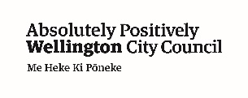
Free Post Authority Number 2199

FREEPOST 2199
Deputy Electoral Officer – Shelly Bay Road Upgrade
Wellington City Council
PO Box 2199
Wellington 6140

